**The Verificationator**

­

**Group No.** **02**

*Faculty of Technology and Bionics*

**Submitted by:**

**Abhinav Kothari, 33349**

*Mechatronics Systems Engineering*

**Ahmad Zeaiter, 33946**

*Mechanical Engineering*

**Justin Julius Chin Cheong, 34140**

*Mechatronics Systems Engineering*

**Okan Can Meral, 31684**

*Industrial Engineering*

**Wasim Ahmed Mohammed Al Asbahi, 31090**

*Electrical Engineering*

**Submission Date**

12th January, 2026

# Executive Summary

The Verificationator project is focused on the design of a highly portable, robust, and user-friendly solution that allows technicians to verify and calibrate hardness testers directly in the field. The project’s scope spans from the concept design to the project documentation and the design of an interactive brochure. The project spanned from October 5th, 2025, to January 13th, 2026. Five engineering students make up the interdisciplinary design team and the project was completed under the guidance of Hochschule Rhein-Waal professors and scientific staff.

Initial market analysis revealed that the market for hardness testers is growing and ready for such a portable verification kit. The initial concept proposed a fully integrated system which can operate safely in factory environments, has an ergonomic HMI and can automatically identify and operate with Innovatest load cell models ranging from 10 gf to 3,000 kgf. The production budget was set to €4,000 per unit ensuring competitiveness on the market.

From a mechanical standpoint, the device uses an IP-67 rated rugged pelican case with an aluminium chassis mounted inside to house the electronics. Medium density foam inserts surround this chassis to provide shock absorption and padding. Load cells are stored in dedicated foam compartments on the opposite side of the case, allowing secure transport without damage or misalignment. A complete 3D model was constructed to demonstrate all mechanical connections, fasteners, sealants and other features to create a device that is suited for harsh factory environments. To document the entire mechanical design, a technical assembly drawing was done according to DIN 406.

On the electrical side of the design, a complete schematic diagram and preliminary PCB were designed to match all functionality requirements with the upmost precision and speed. An advanced measurement chain was designed to process the load cell signals and gives a noise free resolution of 17 bits, classifying as a Class A measuring device by OIML. The design also incorporates high performance components such as the ESP32-P4 allowing for incredible signal processing and input responsiveness. The control, power management and battery management circuits were designed to give a battery life of 9.16 hours and advanced features such as switching between 5V and 10V excitation and real-time graphing. The complete program logic of the microcontroller is documented in a programming flow chart to illustrate the main settings, interrupts and other processes.

After a Make or Buy analysis was performed, the pelican case and electrical components were specified in the requirements manual and the custom-made aluminium and foam interior’s manufacturing techniques were defined. A complete BOM was then done after careful selection of components. After which, the complete production and assembly plan was defined revealing a takt time of 756 min/unit and total production time of 1032 min/unit suggesting parallel manufacturing or outsourcing may be required. The assembly time on the other hand was found to be only 142 min/unit.

Finally, the costs of all the materials, labour, manufacturing and overheads were considered to calculate a production cost of €3990.15. Accounting for business overheads, profit and commission, the final offer price was found to be €7018.28.

**Keywords:**

Mobile Force Verification · Innovatest/Innovatech · Hardness Tester Calibration · IP67 · Industrial Durability · Portability

# Contents

Executive Summary 2

Contents 3

Table of Figures 7

Table of Tables 9

1. Project Plan 11

1.1. Project Constraints 11

1.1.1. Project Scope 11

1.1.2. Project Schedule 12

1.1.3. Project Resources 12

1.2. Responsibility Assignment Matrix 12

1.3. Work Breakdown Structure 14

1.4. Gantt Chart 14

2. Market Analysis 18

2.1. Industry Context 18

2.1.1. Market Overview 18

2.1.2. Competitor Analysis 18

2.1.3. Market Drivers 19

2.1.4. Market Size 19

2.2. Target Buyer Analysis 21

2.2.1. Overview 21

2.2.2. Primary Target Buyer 21

2.2.3. Secondary Target Buyer 22

2.3. Basic Marketing Approach (4P Analysis) 23

2.3.1. Product 23

2.3.2. Price 24

2.3.3. Place (Distribution) 24

2.3.4. Promotion 25

3. Overall Product Concept 26

3.1. Requirements List 26

3.1.1. Functional Requirements 26

3.1.2. User Interface (UI) & Display Requirements 26

3.1.3. Mechanical Requirements 26

3.1.4. Electrical Requirements 27

3.1.5. Software Requirements 27

3.1.6. Reliability & Lifecycle Requirements 27

3.1.7. Economic Requirements 27

3.2. Abstraction to Identify the Essential Problems 28

3.3. Working Structure 29

3.3.1. Morphological Box 29

3.3.2. Solution Evaluation 30

3.4. Preliminary Bill of Materials 31

3.5. Concept Design Sketch 33

3.6. Overall Product Concept Description 34

3.6.1. Structure 34

3.6.2. Power 34

3.6.3. Sensor Interface 34

3.6.4. Signal Processing 34

3.6.5. User Interface 34

3.6.6. Cell Detection Concept 35

4. Functional Structure 36

4.1. Key Functions 36

4.2. System Boundaries and Interactions 36

4.3. Functional Structure Diagram (FSD) 38

5. Human Machine Interface 39

5.1. Human Machine Interface Overview 39

5.2. Inputs and Outputs 39

5.3. Control Elements 41

5.4. Safety Aspects 42

5.4.1. Data Safety 42

5.4.2. Operational Safety 42

5.4.3. Hardware and Environmental Safety 42

5.4.4. User Safety 43

5.5. Control Elements Arrangement 43

5.6. User Interface Design Description 44

5.7. Ergonomics Aspects Considered 44

6. Design-Failure Mode and Effect Analysis (D-FMEA) 46

6.1. D-FMEA Rating Scheme 46

6.2. D-FMEA Table 48

7. 3D Model 50

7.1. Protective Case 50

7.2. HMI 51

7.3. Interior 51

7.4. Load Cell Connector 52

8. Technical Drawing of Main Assembly 53

9. Measurement Chain 55

9.1. Architecture 55

9.2. Schematic 56

9.3. Design of Signal Conditioning Stages 56

9.3.1. Excitation Conditioning 56

9.3.2. Passive Low Pass Filtering 56

9.3.3. Instrumentation Amplification 57

9.3.4. Precision Variable Gain Amplification 57

9.3.5. Analogue to Digital Conversion 59

9.3.6. Digital Filtering 59

9.4. Component Specifications 60

10. Circuit Design 63

10.1. Simplified Schematic Diagram 64

10.2. Full Schematic Diagram 65

10.3. Schematics of Subsystems 66

10.3.1. Main Controller 66

10.3.2. Power Regulation 67

10.3.3. Measurement Chain 68

10.3.4. Battery Management 69

10.4. Load Cell Identification 70

10.5. Battery Life Estimate 70

10.6. Noise Performance 72

10.6.1. Noise Components 72

10.6.2. Peak-to-Peak Noise 72

10.6.3. Noise Free Resolution 73

10.7. Component Specifications 74

10.8. Preliminary PCB Design 79

11. Programming Flow Chart 80

12. Make or Buy Decision 83

12.1. Criteria for Make or Buy Decision 83

12.2. List of Make and Buy Parts 83

13. Technology Selection for Make Parts 86

13.1. Make Parts Table 86

13.2. Modifications to Buy Parts 92

13.3. Assembling Individual Parts 93

13.4. Assembly of Entire Product 104

14. Requirements Manuals for Buy Parts 105

14.1. Requirements Manual for Electrical Parts 105

14.2. Requirements Manual for Mechanical Parts 110

15. Bill of Materials 112

15.1. Electrical Bill of Materials 112

15.2. Mechanical Bill of Materials 120

16. Production Planning 122

16.1. Production Inputs 122

16.1.1. Production Assumptions 122

16.1.2. Production Target 122

16.1.3. Working days 122

16.1.4. Takt Time 123

16.2. Equipment Outline 124

16.2.1. List of Machinery 124

16.2.2. Machinery Calculations 128

16.3. Part Production Time 128

16.4. Machine Allocation 130

16.5. Assembly 131

16.5.1. Assembly Stations 131

16.5.2. Assembly Line 134

16.6. Workforce Requirements 135

17. Cost Calculations 137

17.1. Material Costs 137

17.2. Manufacturing Costs 138

17.2.1. Labour Costs 138

17.2.2. Machinery Costs 138

17.2.3. Utility Costs 140

17.2.4. Factory Rent 141

17.3. Production Costs 141

17.4. Overheads 141

17.5. Cost of Goods Sold (COGS) 141

17.6. Offer Price 141

17.6.1. Profit and Selling Price 141

17.6.2. Commission 142

17.6.3. Final Offer Price 142

17.7. Cost Calculation Summary 142

18. Bibliography 143

19. Appendices 146

19.1. Appendix A: Work Breakdown Structure 146

19.2. Appendix B: Preliminary Battery Life Calculations 154

19.3. Appendix C: Dimensioning of Measurement Chain 155

19.3.1. Low Pass RC Filters 155

19.3.2. Amplification Gain 156

19.4. Appendix D: Production Planning Calculations 157

Statement of Originality 158

# Table of Figures

Figure 1: Gantt Chart for Milestone 1 15

Figure 2: Gantt Chart for Milestone 2 16

Figure 3: Gantt Chart for Milestone 3 17

Figure 4: Market Size Chat 21

Figure 5: Customer Segmentation Report 23

Figure 6: Product Preview Image 24

Figure 7: Freehand Sketch according to ISO 129 using First Angle Projection 33

Figure 8: Load cell identification concept 35

Figure 9: Functional Structure Diagram of the Product 38

Figure 10:Arrangement of control elements (extracted from Freehand Sketch in Section 3.5) 43

Figure 11: Protective Carrying Case Model 50

Figure 12: Isometric View of Complete 3D Model 50

Figure 13: Top View of Complete 3D Model showing HMI 51

Figure 14: Interior of Complete 3D Model showing PCB, Battery and Aluminium Frame 51

Figure 15: Connectors on the Complete 3D Model for Load Cells and Charing 52

Figure 16: Main Assembly Drawing 53

Figure 17: Bill of Materials for Assembly Drawing 54

Figure 18: Functional Structure Diagram of Measurement Chain 55

Figure 19: Simplified Schemaic Diagram 64

Figure 20: Full Detailed Schematic Diagram 65

Figure 21: Processing, Memory and Display System Schematic Diagram 66

Figure 22: Power Regulation System Schematic Diagram 67

Figure 23: Measurement Chain System Schematic Diagram 68

Figure 24: Schematic diagram of battery management 69

Figure 25: Schematic Diagram of Voltage Divider inside M12 Load Cell Connector 70

Figure 26: Full Programming Flow Chart 80

Figure 27: Interrupt Flow Chart 81

Figure 28: Settings Flow Chart 82

Figure 29: **Printed** **Circuit** **Board** (PCB) 86

Figure 30: Routing on Front Side of PCB 86

Figure 31: Routing on Back Side of PCB 86

Figure 32: **PCB Mount** – hold the PCB in place 87

Figure 33: PCB Mount top view 87

Figure 34: PCB Mount 3D printer view with supports and bridging 87

Figure 35:**Battery Cradle** – To house the battery 87

Figure 36: Battery Cradle with Support for Manufacturing 87

Figure 37: **Panel frame** 88

Figure 38: Top view of panel frame 88

Figure 39: Orientations for 4-axis milling 88

Figure 40: Angled side view of side with holes 88

Figure 41: **Load Cell Compartment** – to house the load cells 89

Figure 42: Orientation for CNC Router (Start with orientation image on left and change to the right image orientation afterwards) 89

Figure 43**: Aluminium Box Foam** - To keep it stable inside the case 89

Figure 44: Aluminium Box Foam Front view 89

Figure 45: Aluminium box Side view 89

Figure 46: **Basin** - to house all the electronics 90

**Figure 47: Aluminium Frame** 90

Figure **48**: Side view for manual cutting 90

Figure 49: **Panel** 91

Figure 50: Front view of Panel 91

Figure 51: Top View (Above) and Bottom view (Below) 91

Figure52**: Cable tray** 91

Figure 53:Cable tray side view 91

**Figre 54: Foam Cut-out for the Top of Case** 92

Figure 55: **Lower Pelican Case** modifications 92

Figure 56: Side view of modifications 92

Figure 57: Drawing shown modification of **M12** 93

Figure 58: PCB and Components Exploded View 93

Figure 59: Battery Cradle Assembly Exploded View (left), assembled with Battery Ghost View(right) 94

Figure 60: Screwing PCB in PCB Mount 94

Figure 61: **PCB Mount Assembly** - Completed 94

Figure 62: Welding assembly (Left), Welded Assembly (Right) 95

Figure 63: Insertion of Buttons, LED and USB-A Port 95

Figure 64: Completed Top Panel Assembly top view (left) and bottom view (right) 95

Figure 65: Section Isometric View for Battery Cradle Assembly (Cradle made translucent for visibility) 96

Figure 66: Battery cradle assembled 96

Figure 67: PCB Mount Assembly, Isometric 96

Figure 68: Full Basin Assembled 97

Figure 69: Assembly of M12 port into the Basin (PCB Mount hidden for clarity) 97

Figure 70: Assembled port - Basin made translucent for better view (PCB Mount hidden for clarity) 97

Figure 71: Battery into the cradle 97

Figure 72: Gasket assembly 98

Figure 73: Exploded view of assembling 8 and A8 together 98

Figure 74: Assembling A10 onto A5 – Through TIG welding 98

Figure 75: Correct Orientation of A5 to be welded onto A10 99

Figure 76: Assembly the Screen and Seal onto Basin and Panel 99

Figure 77: Section view to show LCD Screen Orientation for assembl from bottom viewy 99

Figure 78: Assembly of USB C port into Pelican Case (Hidden top panel and handle for simplicity) 100

Figure 79: Zoomed Front View USB-C Port 100

Figure 80: Panel frame and Rivets assembly 100

Figure 81: Foam Assembly into Pelican case ports assembly 100

Figure 82: Assembly of Panel Frame with rivets 101

Figure 83: Top view of assembly 101

Figure 84: Exploded view of final electronics assembly into pelican case 102

Figure 85: Final assembly with load cells 103

Figure 86: Exploded View of Entire Assembly 104

Figure 87: Assembly sequence flowchart 134

# Table of Tables

Table 1: Responsibility Distribution Table 12

Table 2: Responsibility Assignment Matrix for Each Deliverable 13

Table 3: Comparison of Competitors in The Mobile Force Verification Kit Market 18

Table 4: Abstraction of essential problems 28

Table 5: Morphological Box for Selection of Solutions 29

Table 6: Solution Evaluation Table 30

Table 7: Preliminary Bill of Materials 31

Table 8: Input/Output Interactions of Product with User 39

Table 9: Selection of control elements 41

Table 10: Rating Scheme for Severity (S) 46

Table 11: Rating Scheme for Occurrence (O) 46

Table 12: Rating Scheme for Detection (D) Probability 47

Table 13: Design Failure Mode and Effect Analysis of the Product 48

Table 14: Required Gains and Gain Error for Each Load Cell for 5V Excitation (Using OPA188 and MCP41U83) 58

Table 15: Required Gains and Gain Error for Each Load Cell for 10V Excitation (Using OPA188 and MCP41U83) 58

Table 16: List of Components and Specifications for Measurement Chain 60

Table 17: Resistor Values for Each Load Cell for Identification 70

Table 18: Typical and Specified Supply Current Values for Electronic Components 71

Table 19: Noise Free Measurement Resolution of the Each Load Cell 74

Table 20: List of Electronic Components in the Electronic System 74

Table 21: Make and Buy Decisions for Each Component 83

Table 22: List of Make Parts and Manufacturing Technology 86

Table 23: Modifications to Buy Parts 92

Table 24: Assembly of Individual Parts 93

Table 25: Requirements Manual for Electrical Parts 105

Table 26: Requirements Manual for Mechanical Parts 110

Table 27: Electrical Bill of Materials 112

Table 28: Mechanical Bill of Materials 120

Table 29: Production targets for three years 122

Table 30: Target production per unit time calculations 123

Table 31: Machine Selection for Production 124

Table 32: Machine Efficiencies and Available Time 128

Table 33: Production Times per Part 129

Table 34: Machine Number Estimation 130

Table 35: List of Assembly Stations 131

Table 36: Workforce Requirements for Production Processes 135

Table 37: Workforce Requirements for Assembly Processes 136

Table 38: Direct Material Costs of Buy Parts 137

Table 39: Raw Material Costs for Make Parts 138

Table 40: Machinery Depreciation Costs 139

Table 41: Machine Utility Costs 140

Table 42: Summary of Cost Calculation 142

# Project Plan

## Project Constraints

### Project Scope

The overall scope of this project is the design of the Verificationator and relevant product documents. To achieve this, the following deliverables must be produced:

1. Concept Design
   1. Project Plan
   2. Market Analysis
   3. Overall Product Concept
   4. Functional Structure
   5. Human Machine Interface
   6. D-FMEA
   7. Concept Design Close-out
2. Product Design
   1. Complete 3D Model
   2. Measurement Chain
   3. Circuit Diagram
   4. Technology Selection for “Make” Parts
   5. Requirements Manual for “Buy” Parts
   6. Product Design Close-out
3. Project Documentation
   1. Technical Drawings for Main Assembly
   2. Program Flow Chart
   3. Bill of Material
   4. Production Planning
   5. Cost Calculation
   6. Specification Sheet
   7. User Manual
   8. Interactive Brochure
   9. Project Documentation Close-out
4. Project Close-out

It should be noted that some important aspects for the success of the Verificationator are outside of the scope of this project such as:

* Competitive Pricing Strategy
* Product Launch Schedule
* Development of Functioning Prototype

### Project Schedule

The project will adhere to a schedule consisting of 3 milestones that coincide with the main deliverables of the project. These milestones are as follows:

1. Concept Design: 2025-10-28
2. Product Design: 2025-12-02
3. Project Documentation: 2026-01-13

### Project Resources

The project team is comprised of five engineering students and responsibilities were distributed based on their degree program and experience as shown in Table1.

Table 1: Responsibility Distribution Table

|  |  |  |  |
| --- | --- | --- | --- |
| Name | Mat No. | Responsibilities | Degree Program |
| Abhinav Kothari | 33349 | * HMI * System Logic * Specification Sheet * Project Management (Process Verification and Coordination) | Mechatronics Systems |
| Ahmad Zeaiter | 33946 | * Concept Design * Mechanical Design * Technical Drawings * Graphic Design of Brochure | Mechanical |
| Justin Chin Cheong | 34140 | * Project Management (Planning and Framework setup) * System Design and Integration * Signal Processing | Mechatronics Systems |
| Okan Can Meral | 31684 | * Market and Industry Analysis * Financial Analysis * User Manual | Industrial |
| Wasim Ahmed Mohammed Al Asbahi | 31090 | * D-FMEA * Electrical Design * Manufacturing Technology Selection * Production Planning | Electrical |

## Responsibility Assignment Matrix

To distribute the work with greater precision, a responsibility assignment matrix was created to illustrate the responsibilities of all team members.

Key: X - responsible, + - support, * - approval

Table 2: Responsibility Assignment Matrix for Each Deliverable

|  |  |  |  |  |  |  |
| --- | --- | --- | --- | --- | --- | --- |
| **ID** | **Deliverable** | **Wasim** | **Okan** | **Justin** | **Abhinav** | **Ahmad** |
| 1.1 | Project Plan | + * | + * | X | + * | + * |
| 1.2 | Market Analysis |  | X | * |  |  |
| 1.3 | Overall Product Concept | + * |  | + | + | X |
| 1.4 | Functional Structure |  |  | X | * |  |
| 1.5 | HMI |  |  |  | X | * |
| 1.6 | D-FMEA | X | * | + | + | + |
| 1.7 | Concept Design Close-out | X | X | X | X | X |
| 2.1 | Complete 3D Model | + * |  |  |  | X |
| 2.2 | Measurement Chain | + |  | X | * |  |
| 2.3 | Circuit Diagram | X |  | + * | + |  |
| 2.4 | Technology Selection for “Make” Parts | X | * | + |  |  |
| 2.5 | Requirements Manual for “Buy” Parts |  | X | * |  | + |
| 2.6 | Product Design Close-out | X | X | X | X | X |
| 3.1 | Technical Drawings for Main Assembly | + * |  |  | + | X |
| 3.2 | Program Flow Chart |  |  | + | X | * |
| 3.3 | Bill of Materials | + |  | X | * | + |
| 3.4 | Production Planning | X | * | * | + |  |
| 3.5 | Cost Calculation |  | X | * |  |  |
| 3.6 | Specification Sheet | + |  | * | X | + |
| 3.7 | User Manual |  | X | + | + | * |
| 3.8 | Interactive Brochure | * | * | + | + | X |
| 3.9 | Project Documentation Close-out | X | X | X | X | X |
| 4.0 | Project Close-out | X | X | X | X | X |

## Work Breakdown Structure

A complete work breakdown structure can be found in 19.1 Appendix A detailing each work package and its contributors, schedule, dependencies and type.

## Gantt Chart

The following pages show the Gantt chart[1] for the project, highlighting each work package along with its resources, schedule, and dependencies. The Gantt chart is split across the three milestones. A complete Gantt chart with all three milestones at once can be found on [Sciebo](https://hochschule-rhein-waal.sciebo.de/f/197025147)[2].

Key:

|  |  |
| --- | --- |
|  | Abhinav Kothari |
|  | Ahmad Zeaiter |
|  | Justin Julius Chin Cheong |
|  | Okan Can Meral |
|  | Wasim Ahmed Mohammed Al Asbahi |
|  | Milestone |

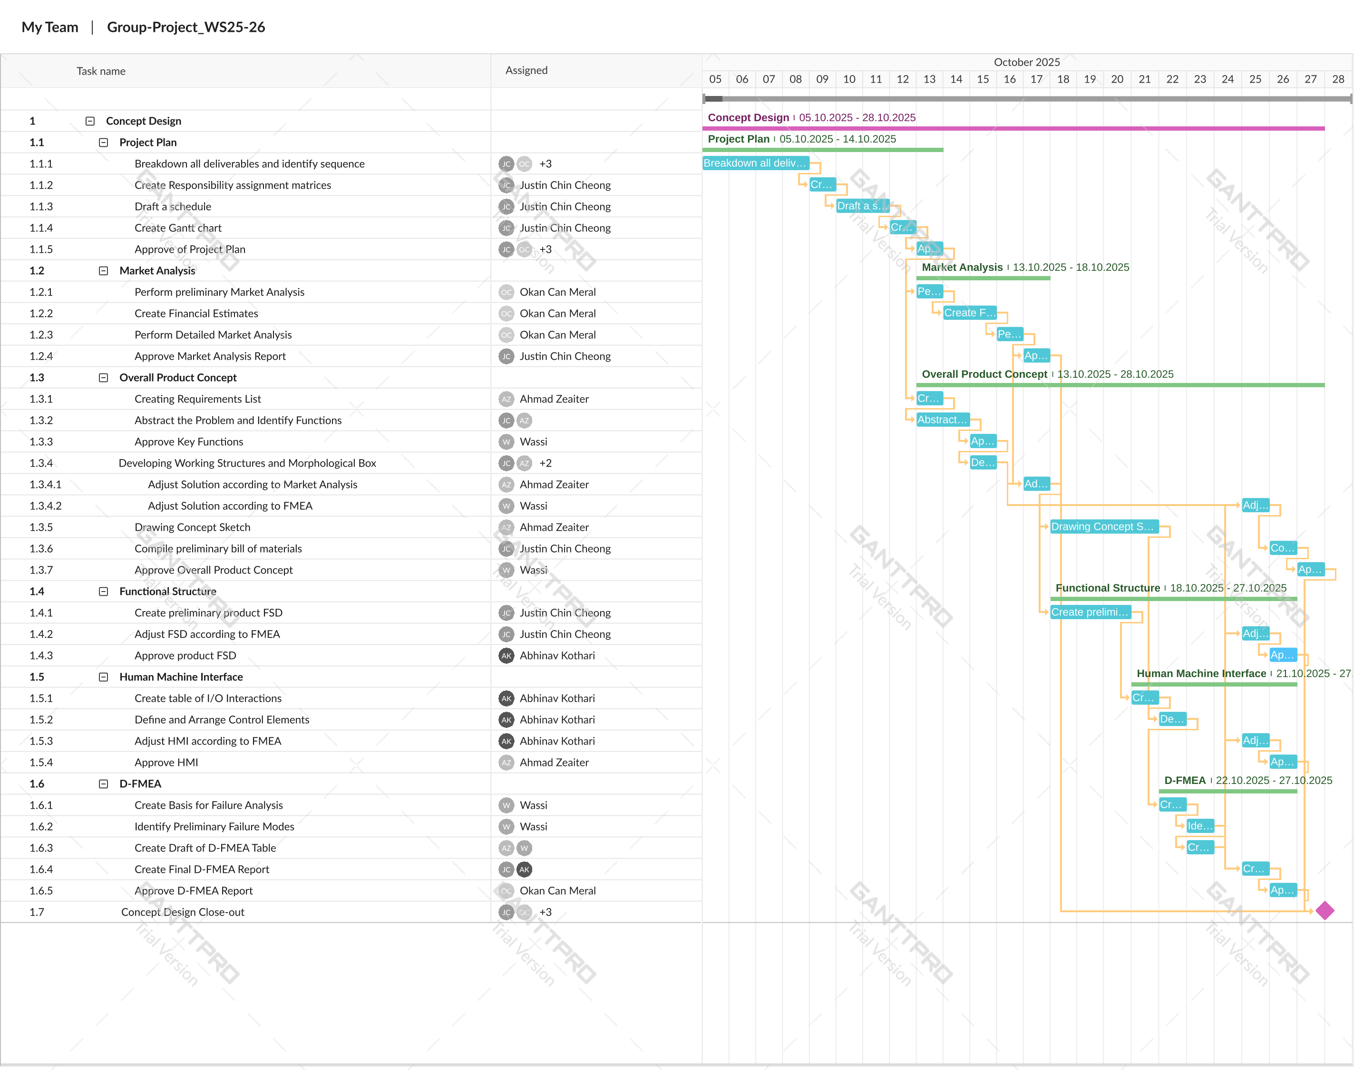

Figure 1: Gantt Chart for Milestone 1

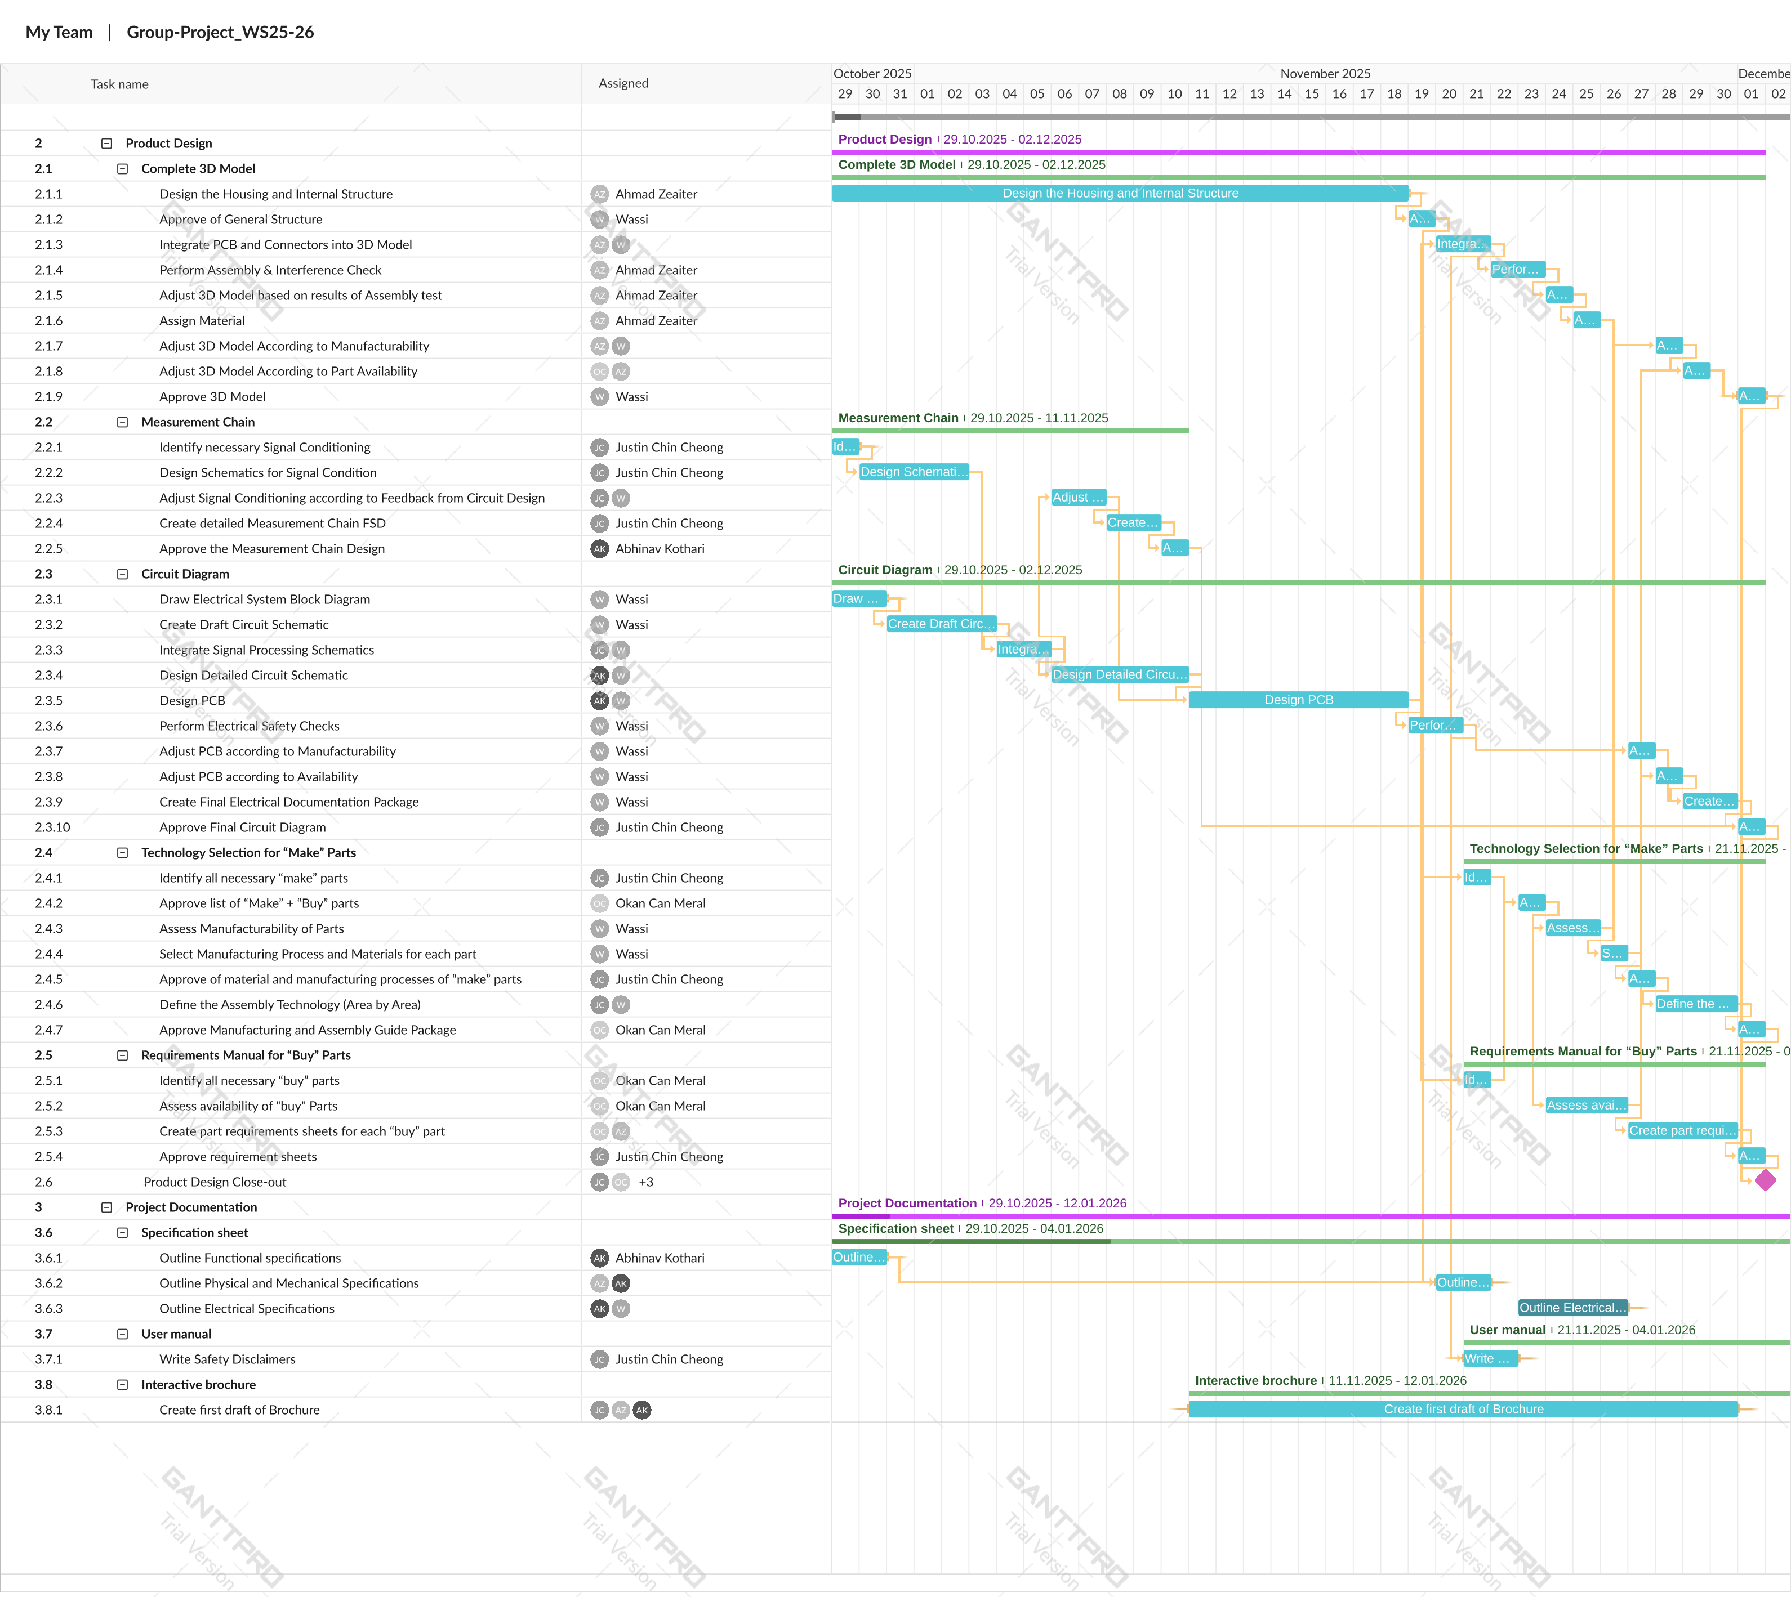

Figure 2: Gantt Chart for Milestone 2

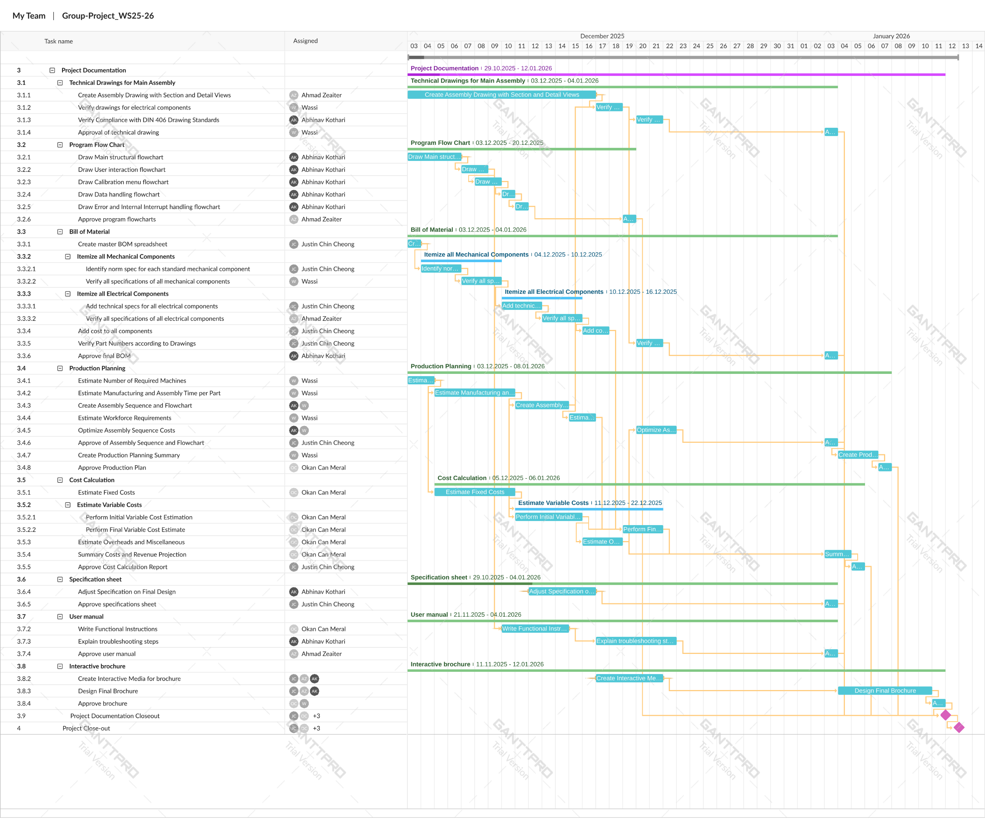

Figure 3: Gantt Chart for Milestone 3

# Market Analysis

## Industry Context

### Market Overview

This analysis aims to determine the Verificationator's market potential, competitors, potential users, and emerging trends in force measurement and calibration systems. The basic marketing strategy and product placement will also be determined by the results.

Hardness testers and other mechanical measurement equipment are extremely pervasive in major sectors such as manufacturing, aerospace, automotive, and materials science. The global hardness testing market itself was valued at USD 274 million in 2025 according to Intel Market Research (2025) and by 2032, it is projected to reach USD 353 million. As the market grows, so does the need for precise calibration and verification equipment. Thus, there is a growing market for portable, reliable, and accurate verification kits that companies can use to evaluate and calibrate their equipment in the field. This is the exact market the Verificationator seeks to fill.

### Competitor Analysis

The range of solutions for a mobile force verification kit currently on the market is quite sparse. However, there exists some products that can be used for force verification and calibration and could potentially be competition for the Verificationator. These products and their companies are outlined in Table 3: Comparison of Competitors in The Mobile Force Verification Kit Market.

Table 3: Comparison of Competitors in The Mobile Force Verification Kit Market

|  |  |  |  |
| --- | --- | --- | --- |
| Competitor | Price Range [€] | Product Description | Region |
| Morehouse Instrument Company | 6000 - 8000 | A 5-in-1 force verification system is kit that includes a load cell, minicomputer with custom software for processing and a load cell cable stored inside of a custom. | USA |
| Sun-Tec Corporation | 150 - 600 | A set of standard hardness samples of known hardness which can be tested against the hardness tester’s reading. | USA |
| Tovey Engineering Innovation | 10000 - 60000 | A portable calibration system comprised of load cells, dead weights, a laptop computer, and load cell simulator. It can be in the form of a pushcart or carry case. | USA |
| Interfaceforce | 20000 - 35000 | An inspection kit with a force transducer, testing machine and measuring device which connects to a Windows computer. | Germany |

Table 3: Comparison of Competitors in The Mobile Force Verification Kit Market shows that the other solutions on the market are portable, reliable and precise. However, there are some clear shortcomings. The Sun-Tec Hardness Samples requires incredibly careful handling and can only verify an extremely specific hardnesses per sample. On the other hand, the Morehouse, Tovey Engineering, and Interfaceforce products are sets of several different components that must be connected. The Interfaceforce even requires an additional computer for processing.

The Verificationator aims to overcome such faults by providing a verification system that is compact and completely integrated into the carrying case. This means all functionality is achieved with a single unit and not a series of components. By connecting to load cells of different ranges and precisions also allows the kit to verify the entire force range of the hardness testers with ease.

### Market Drivers

The drivers of the Force Verification market are heavily tied to those of the Hardness Tester market. As precision hardness testers become more widespread, the need for accurate and convenient verification increases.

The main driver of these markets is the recent increase in quality assurance and control procedures in compliance with international standards. To ensure higher safety factors and durability hardness testers will be used more regularly and thus must be checked and monitored consistently. This is most prevalent in sectors such as manufacturing, aerospace, automotive, and material sciences.

Another driver in the market is the growth of the portable hardness tester market. It is projected to have a compound annual growth rate (CAGR) of 5.5% between 2023 and 2033. This coincides with demand for on-site testing which then requires on-site calibration and verification which the Verificationator will capitalise on.

### Market Size

#### Total Addressable Market (TAM)

According to the Intel Market Research (IMR, 2025) report, the global hardness testing machine market is valued at USD 274 million in 2025 and is expected to reach approximately USD 353 million by 2032, with a CAGR of 3.8%. This growth will mainly occur in the automotive, aerospace, and heavy industry sectors, primarily due to the rising need for quality control and material verification. The ongoing automation and digitalization across industries are also significantly increasing the demand for hardness testing systems. This transformation greatly enhances the importance of both stationary laboratory equipment and portable testing devices.

The Future Market Insights (2024) report estimates the global market value at around USD 351 million for 2025, while Intel Market Research (2025) reports USD 274 million for the same year, indicating a consistent growth trend across the market.

#### Serviceable Available Market (SAM)

For the Verificationator, the initial commercialization area is Europe. The region’s large number of industrial testing laboratories, quality control facilities, and advanced production sectors such as automotive and aerospace create a strong foundation for calibration systems.

According to Intel Market Research (2025), Europe accounts for about 30% of the global market, which corresponds to a market value between USD 100 M and 120 M as of 2025. This market includes stationary laboratory devices, as well as portable verification equipment and on-site calibration services.

MarketsandMarkets (2025) highlights that Germany, the Netherlands, Switzerland, and the Scandinavian countries are the regions where hardness testing activities are most concentrated within Europe.

#### Serviceable Obtainable Market (SOM)

When calculating the SOM, one of the most important factors is to fully understand the company’s capacity and capabilities. In Europe, the Verificationator focuses on the portable, field-type calibration systems segment. Due to their ability to save time and increase mobility in quality control processes, there is a growing demand for these solutions.

Sharma (n.d.)states that the global market for such devices is valued at approximately USD 350 million, and it is expected to reach USD 580 million by 2032. This calculation is based on target countries such as Germany, the Netherlands, Switzerland, and the Scandinavian region.

Capturing even 1% of this market would mean about 100–200 units sold during the launch period of 6 months. This demonstrates that the Verificationator effectively addresses the high-quality standards and on-site verification needs of the European market.

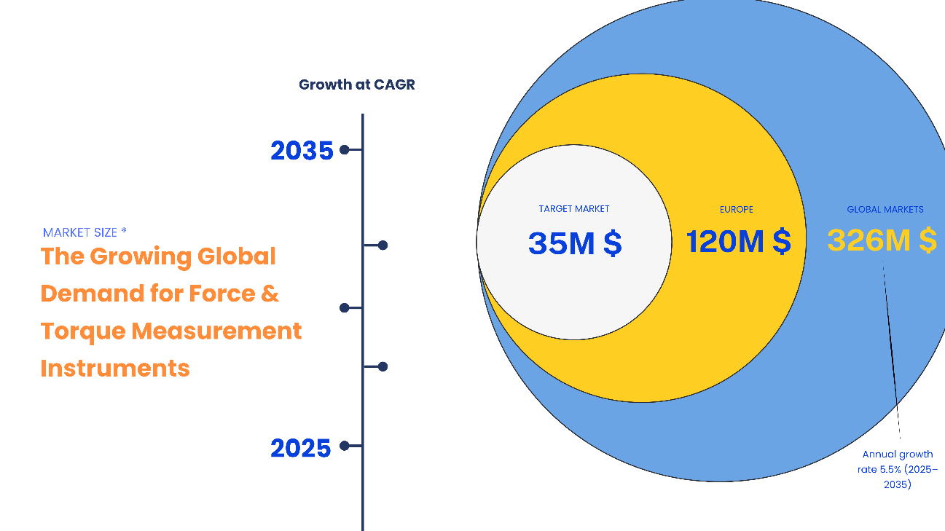

Figure 4: Market Size Chat

## Target Buyer Analysis

### Overview

The Verificationator is an intended to be sold in a business to business (B2B) capacity. It is especially designed for organizations and institutions engaged in quality assurance, metrology, and mechanical testing.

The product addresses a critical gap between laboratory-based calibration systems and practical field verification tools, offering laboratory-level precision in a compact, mobile design.

### Primary Target Buyer

The primary target buyers for the Verificationator are institutions and companies that have already purchased Innovatest Hardness Testers and/or other products. This would include:

* Industrial Quality Assurance Departments
* Research and Development Institutions

#### Industrial Quality Assurance (QA) & Metrology Departments

These departments of larger industrial companies (e.g., automotive, aerospace, and precision manufacturing) require a convenient and reliable way to perform routine checks and internal calibrations.

Some of the key needs met by the product include:

* Compact and rugged design that can be used in the field in harsh conditions.
* Reducing external calibration by enabling in-house functional checks
* Compatibility with multiple Innovatest load cell models
* Integrated data logging for USB export
* Intuitive graphical user interface

#### Research & Development (R&D) and Academic Institutions

Technical universities and research centres need force verification tools to inspect the machines they use to investigate materials, develop prototypes, and train engineers.

They are primarily interested in the research and learning opportunities. Similarly to the QA departments they are required to do checks of their hardness testers. Besides the needs highlighted in 2.2.2.1, the ease of use of the product can make it an excellent educational tool.

### Secondary Target Buyer

#### Machine Manufacturers’ & OEM Partners

There is also potential to sell to other manufacturers of hardness testers for preliminary testing after assembly. This provides and quick and easy alternative to lab testing and can reveal issues before more complicated testing methods are used.

#### Geographical Focus

The initial commercialization phase focuses on Europe, where force calibration activities and standards are well established.

Some key markets include:

* Germany, Netherlands, Switzerland, Scandinavia - High industrial density and quality infrastructure
* France, Belgium, UK - Strong aerospace and research institutions
* Eastern Europe - Emerging demand from cost-sensitive manufacturers

Following successful European deployment, expansion will target North America and Asia-Pacific, driven by industrial modernization and increasing quality regulation.



Figure 5: Customer Segmentation Report

## Basic Marketing Approach (4P Analysis)

### Product

The Verificationator is a compact, portable, and precise measurement device designed to verify the applied forces of hardness testers in both laboratory and field environments.

Developed for Innovatest Europe BV, the product integrates existing Innovatest load cells with a portable digital control unit capable of automatically identifying up to six different load cells, all together covering a force range from 10 gf to 3,000 kgf. Allowing engineers to perform on-site calibration and verification across a wide spectrum of hardness testing machines.

The verification kit is housed in an IP-67 rated Pelican 1500 case, ensuring full protection against dust, water, and shock. The case has a modular interior separating the electronics from a dedicated load cell storage compartment. This modular design simplifies assembly, maintenance, and future upgrades.

With 8-10 hours of battery life, USB-C charging, and a graphical user interface that supports data logging, USB export, and calibration functions, the device ensures efficient and user-friendly operation.

The primary needs that the product aims to meet is portability and ease of use for field engineers. Being encased in rugged and compact carrying case makes it easier to travel with and having everything contained and integrated into the case allows engineers to quickly setup and start measurements.

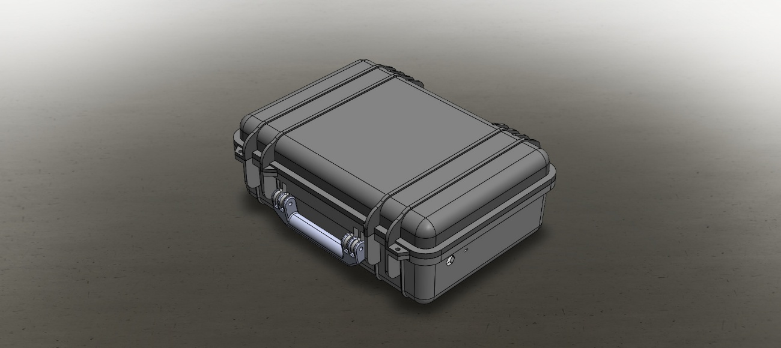

Figure 6: Product Preview Image

### Price

Typical products in this market, as seen from Section 2.1.2, range from €6,000-€60,000, The Verificationator, aims to be produced at a maximum cost price of €4,000. So even after a profit margin of 50%, makes it €6,000, keeping it very competitively priced.

The competitive price comes without compromise on precision and reliability, while also being highly portable.

During the introduction and growth stage, a combination of value-based pricing and cost-plus pricing strategy may be implemented to quickly establish a market presence while ensuring no loss is borne by the company itself.

Example:

Innovatest could look at the competitors from Section 2.1.2 and set the pricing based on what the value the product bares in mind of the customer compared to the already existing customers. This can be done through primary research of the customers perception of the product as well. Special prices can also be offered to already existing customers, to encourage them to stay in the Innovatest ecosystem.

Providing services on top of the product, such as extended warranties, training sessions, can also increase the value of the product in the customers mind, leading to a higher price which the company can charge and justify.

This pricing model combination ensures both market entry and sustainable revenue, as no losses will be borne by the company.

Moreover, as the product life cycle goes forward towards decline stage, prices can be reduced to keep the product relevant and competitive.

### Place (Distribution)

Distribution will primarily follow a B2B model, focusing on direct sales to industrial clients, calibration service providers, and research institutions.  
Initial market entry will target Europe, particularly Germany, the Netherlands, Switzerland, and Scandinavia, due to their established industrial and testing infrastructure.

Distribution channels include:

* Direct sales through Innovatest’s existing dealer network.
* Online sales platform for product demonstration, quotation, and customer support.
* Participation in industrial trade fairs such as *Control Expo Germany* and *Sensor+Test Nürnberg*.
* Partnerships with calibration service providers and testing laboratories for joint demonstrations and pilot installations.

As market demand grows, Innovatest may expand into North American and Asia-Pacific markets through authorized distributors.

### Promotion

Promotion activities will aim to position The Verificationator as a professional, reliable, and portable solution for force verification while maintaining high precision and accuracy.

The marketing department shall highlight:

* IP67 Rating: for incredible durability even in industrial environments
* All day battery life: 8 hours’ worth of uninterrupted usage
* Automatic load cell identification: hassle free cell detection and naming
* HMI: Intuitive UI design and easy to use touch screen display
* Ergonomic + Stylish shape: Pelican case provides ergonomic handles for carrying while maintaining a sleek look
* Portability: The small size and nominal weight design makes it easy to travel with

Much more benefits can also be highlighted in marketing.

Planned promotional strategies may include:

* Technical presentations and webinars for calibration engineers and quality managers.
* E-Newsletters to existing Innovatest customers
* LinkedIn campaigns targeting industrial testing professionals.
* Collaborations with universities and research labs for academic demonstrations.
* After growth rate case studies and customer testimonials can be used to showcase field performance.
* Trade show exhibitions and product brochures emphasizing features and ROI.

During the maturity stage, Innovatest can strengthen its brand visibility through certifications and global reseller partnerships, ensuring long-term market presence and trust.

# Overall Product Concept

## Requirements List

### Functional Requirements

* System can recognize at least six Innovatest load cell models automatically.
* Each load cell is displayed with an intuitive name that can be modified by user.
* System uses a universal port compatible with all supported load cells.
* Device can measure forces from 10gf $-$ 3,000 kgf.
* Measurement results displayed numerically (in gf, kgf, N, kN) and graphically in real-time.
* User can configure numerical formats on digital display.
* Interface includes standard functions such as Tare, Zero, and Peak & Hold.
* Device supports data logging and export via USB, manually triggered by the user.
* System can delete old data with confirmation when storage is full.
* System includes 1 channel for the load measurement signals and 1 channel for cell recognition.
* System can perform basic calibration of load cells using 1 to 5 data points per cell.
* Sampling rate is adjustable.

### User Interface (UI) & Display Requirements

* Display is a 10-inch touchscreen.
* UI is intuitive and responsive, suitable for field operation.
* Display can show real-time force curves.
* Display includes status indicators for battery, connection, and data logging.

### Mechanical Requirements

* Compact, ruggedized housing integrated into a portable protective case.
* Minimum IP65 protection rating with shock absorbing padding.
* Protective compartments for load cells.
* Minimum operating temperature range: 0-60**°**C.
* Minimum humidity tolerance: 10-90% non-condensing.
* Weight: ~5-6 kg.
* Aesthetically refined and ergonomic form factor.

### Electrical Requirements

* Rechargeable power source with a battery life of 8-10 hours.
* Battery voltage range 3.2 V $-$ 4.2 V.
* 3.3 V regulator for microcontroller.
* 5V/10V boost converter for selectable load cell excitation.
* 24-bit ADC for precision measurement.
* Input sensitivity: 4mV/V.
* Low pass and noise filtering on input signals.
* Non-volatile internal storage for measured data.
* USB-A port for data export.
* USB-C port for charging.

### Software Requirements

* Integrated signal to force conversion algorithm.
* Sufficientsampling rate to prevent aliasing.
* Software supports real-time graph plotting of force measurements.
* Calibration data and user preferences are stored persistently.
* Basic troubleshooting instructions/functions.

### Reliability & Lifecycle Requirements

* Expected service life: 8 years.
* System designed for field robustness and electrical protection.
* Firmware supports future software updates.

### Economic Requirements

* Target production cost: $≤$ 4000 EUR per unit.

## Abstraction to Identify the Essential Problems

Table 4: Abstraction of essential problems

|  |  |  |  |
| --- | --- | --- | --- |
| **Requirements** | **Functional Abstraction** | **Generalized Problem** | **Essential Problem Definition** |
| Measurement range: 10 gf $-$ 3000kgf | Ability to detect and quantify force signals of varying magnitudes | Transform electrical signal from load cell into a force measurement | Accurately measure mechanical forces across a wide range |
| Recognize 6 Innovatest load cell models | Interface compatible with multiple sensor types | Establish adaptable communication between sensor and processor | Enable automatic identification and integration of various load cells |
| Numeric and graphical output on display | Visualise real-time data and user parameters | Translate measurement data into interpretable information | Present measurement data clearly |
| Calibration using 1 to 5 points per cell | Adjust system response to known reference loads | Ensure traceable and repeatable force measurements | Maintain measurement accuracy through user calibration |
| Data logging, USB export, deletion function | Store, manage, and transfer data | Maintain organized, retrievable measurement records | Provide reliable data handling |
| Minimum IP65, shock protected, and portable housing | Protect internal components from environment | Maintain functionality under field conditions | Ensure durability and usability in rough environments |
| Programmable sample rate, low-pass, and noise filtering | Adapt signal to different measurement needs | Minimize signal distortion and noise | Deliver accurate and stable readings across different measurement conditions |
| Cost $≤5000$ EUR | Economically feasible design | Optimize material manμFacturing, and components cost | Achieve a balance between performance, manufacturability, and cost |

**The crux of the problem**: to develop a portable and robust system capable of accurately acquiring, processing, and presenting force measurements from multiple load cell types under different field conditions.

## Working Structure

### Morphological Box

Table 5: Morphological Box for Selection of Solutions

|  |  |  |  |  |
| --- | --- | --- | --- | --- |
| Function | Sub-function | Option 1 | Option 2 | Option 3 |
| **Sensor Interface** | Load Cell Interface | 5-pin header Connector | M12 5-pin connector | MIL-Circular Connector |
|  | Load Cell Identification | Resistor-based recognition in connector | 1-wire ID chip embedded in connector | Software-based AI Detection |
|  | Load Cell Excitation Voltage | Fixed 5V output | Selectable 5V/10V output | Software-adjustable voltage |
| **Signal Processing** | Analog Signal Conversion | Delta-Sigma 24-bit ADC | 24-bit SAR ADC | Integrated bridge front-end ICs |
|  | Signal Conditioning | Passive low-pass filter | Instrumentation Amplifier | Programmable gain amplifier (PGA) |
|  | Processing Unit | Micro-controller | Micro-processor | ASIC |
| **User Interface** | Data Display | TFT LCD | OLED | IPS TFT LCD |
|  | HMI | Analogue Buttons | Capacitive Touch Screen | Resistive Touch Screen |
|  | Data Logging Export | USB flash drive storage | MicroSD card slot | Wireless data transfer via  Wi-Fi |
| **Structure** | Power Source | Rechargeable Li-Po Battery | Rechargeable NiMH Battery | Replaceable Li-Po Battery |
|  | Housing Size and Form | Tablet-style Hand-held | Compact, rugged brief case size | Laptop-Style and Size |
|  | Housing Protection Class | IP65 | IP66 | IP67 |

### Solution Evaluation

Table 6: Solution Evaluation Table

|  |  |
| --- | --- |
| Solution | Reasoning |
| M12 5 pin connector | * Standard connector with IP67-IP68 rating * Locking mechanism * Support five pins, 4 for signal transmission and 1 for load cell recognition * Compact footprint [3] |
| Resistor based recognition | * Reasonable * Can do many variations of load cells |
| Selectable 5V/10V output | * Allows for flexibility * Can increase sensitivity or reduce power consumption |
| Delta-Sigma 24-bit ADC | * Good speed * High accuracy |
| Passive low pass filter and instrumentation amplifier | * Blocks high noise * More reliable |
| Microcontroller | * Less heat dissipation * Flexible enough, compared to ASIC |
| TFT LCD | * Less power consumption * No burn-in |
| Resistive touch screen | * Less power consumption * More durable in harsh environments[4] * Can be used with gloves |
| USB Flash Drive Storage | * More common than Micro USB * Faster than most Wi-Fi networks |
| Rechargeable Li-Po batteries | * Higher energy density * Lighter weight * More charge-discharge cycles[5] |
| Compact rugged brief case size | * Can carry load cells as well * Easy to carry |
| IP67 | * Can withstand harsh environments |

## Preliminary Bill of Materials

Table 7: Preliminary Bill of Materials

|  |  |  |  |
| --- | --- | --- | --- |
| **Component** | **Description** | **Quantity** | **Approx. Total Cost [EUR]** |
| **Electrical** | | | |
| Microcontroller (MCU) | Main control unit and processor | 1 | 4 |
| Printed Circuit Board (PCB) | Circuit board upon which all electrical components are mounted and connected via | 1 | 10 |
| Load Cell Connector | Wire that connects the load cell to the verification kit | 1 | 40 |
| Load Cell Interface Port | Port for the load cell connector to interface with verification kit | 1 | 5 |
| Noise and Low-pass Filter | Module that eliminates noise from load cell signal | 1 | 2 |
| Amplifier | Module that amplifies load cell signal for better reading | 1 | 4 |
| Analog to Digital Converter (ADC) Module | Module that converts load cell signal into digital signal that the microcontroller can process | 1 | 10 |
| Cell Excitation Regulator | Power regulator to regulate the excitation voltage of the load cells | 1 | 8 |
| Touchscreen Display | Screen that displays graphical output and allows user input | 1 | 100 |
| Push Button | Reliable button for controlling power to the Kit | 2 | 40 |
| LED light | Light to indicate warnings such as low battery or measurement ongoing | 1 | 0.1 |
| Internal Memory Module | Module that stores measured data within the verification kit | 1 | 3 |
| USB-A Port | Connector for standard USB stick for exporting measured data | 1 | 1 |
| Power Regulator | General power regulator to provide regulated power to components on the PCB | 1 | 4 |
| USB-C Port | Connector for charging cable | 1 | 2 |
| Battery Charging Circuit | Module to regulate incoming power to safely charge battery | 1 | 5 |
| Battery | Storage of electrical energy which provides power to entire verification kit | 1 | 20 |
| Misc | Passives, Wires, Insulation, Pin headers | n./a. | 15 |
| **Mechanical** | | | |
| Protective Carrying Case | Housing for the verification kit that provides IP67 level protection of the exterior | 1 | 200 |
| Foam | Soft foam that provides padding for internal electronics | 1 | 50 |
| 1-Panel Frame | Frame that outlines the HMI of the kit secures it to the protective case and seals it for IP67 | 1 | 30 |
| Internal Aluminium Frame | Aluminium frame inside which electronics and battery are secured and then placed into the protective case | 1 | 150 |
| Misc | Screws, Fasteners, O-rings, Mounting brackets | n./a. | 50 |
| **Estimated Total of control unit** | | | 753.1 |
| Load cells | The instruments that send signals to the kit when force is applied | 6 | 2.884 |
| **Estimated Total of full Verification Kit** | | | 3,637.1 |

## A drawing of a machine AI-generated content may be incorrect.Concept Design Sketch

Figure 7: Freehand Sketch according to ISO 129 using First Angle Projection

## Overall Product Concept Description

The Verificationatoris designed to be a compact, and rugged system stored inside a Pelican 1500 protective case. The case provides IP67 level protection, is portable and robust for field operations. The interior is modularly with two separate sections one for load cell storage and another containing the verification kit.

### Structure

The electronics panel is mounted in a metal frame with O-ring sealing. The frame is supported by the case ribs and reinforced with two L-brackets on the suspended side. Foam compartments store load cells securely on the opposite side. Inside the aluminium electronics box, the PCB is mounted above Li-Po battery. Foam padding and a separator plate provide shock absorption and thermal isolation. The box sits slightly above the case bottom with foam padding under it to further protect components.

### Power

A rechargeable 5000 mAh Li-Po battery will run the system for 8-10 hours. See 19.2 Appendix B for the battery life estimation calculations. Cutouts in the case for USB-C port is used to charge the battery to full health in approximately 1-2 hours.

### Sensor Interface

The kit connects to Innovatest load cells via an M12 5-pin connector. The load cell model is automatically recognized via a specific resistor placed inside of the connector cable. The system can provide excitation voltage of 5V or 10V depending on the load cell model.

### Signal Processing

Signals from the load cells are filtered by the passive low-pass filter and then amplified by the instrumentation amplifier. These two together reduce noise and amplify before conversion using a dedicated 24-bit ADC. The microcontroller handles real-time processing of the signal into force measurements.

### User Interface

A 10-inch TFT touchscreen displays numerical and graphical measurements in real time. Standard functions like Tare, Zero, and Peak & Hold are built in. Data logging is supported via USB-A. A LED indicates the status of the kit and an emergency shut off button is included. Cable and accessory storage are integrated around the touchscreen.

### Cell Detection Concept

The 5-pin M12 connector allows for identification of individual load cells while simultaneously carrying the power and signal lines for the load cell.

There are 4 cables from the load cells which must be connected for successfully reading of the required data. This includes the VCC, GND, + Signal and – Signal, as shown in the figure below.

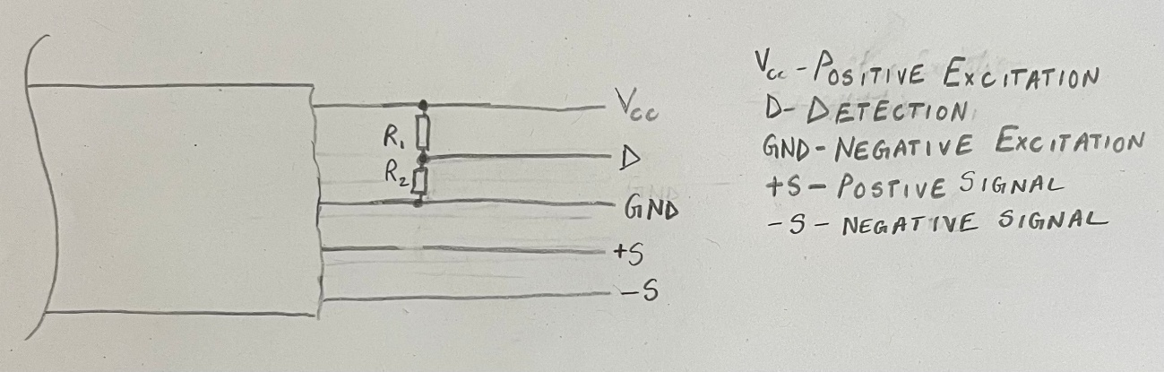

Figure 8: Load cell identification concept

For the identification of the load cell, a voltage divider can be placed between the VCC and GND, and a 5th cable can be connected to read the voltage and hence identify each load cell. When first identified, it will give it an intuitive name, based on the existing data, however the user will be given the possibility to rename it, and when the same resistance is identified in future use, that name will be displayed from the saved storage.

$$D=\frac{R_{1}}{{R_{1}+R}_{2}}×V_{CC}$$

Through the formula above the $D$ can be calculated for each load cell, so this can be saved and used to compare for load cell voltages measured in the future, allowing us to easily identify load cell if the value matches within a tolerance.

Whenever a new load cell, other than predefined one is connected and added, a random name will be given and the voltage value will be saved, this same load cell can then be identified by using the saved value.

This mechanism will be placed entirely within the M12 connector.

# Functional Structure

## Key Functions

As determined in Section 3.2, the key function of the Verificationator is acquiring, processing, and displaying force data from connected sensors. Achieving this overall function requires the following system functionalities:

* Startup: User powers on system and battery supplies power.
* User Control: User can select commands to start measurement or export measured data.
* Interface Sensor: Load cell is recognised and then interface is ready to receive raw measurement signal when force is exerted on the load cell and user initiates measurement.
* Process Sensor Signal: Internal components filter, amplify and convert signal into force measurement readings.
* Display Force Curve: Screen displays force measurements in real-time, plotting a curve.
* Log and Export Data: Data is stored internally and exported to USB when prompted by the user.
* Alert Status and Battery Level: LED alerts user of measuring status or low battery level.
* Shutdown: User switches off kit after measurement is complete, and data is exported.
* Emergency Shutdown: User can kill power to kit in case of an emergency.

## System Boundaries and Interactions

To create a structure of the system functionalities, the exact boundary of the system and its interactions with the environment must be outlined.

* System Boundary:
  + Internal electrical components that make up the filter, amplifier, ADC, microcontroller, and internal memory
  + HMI including the touchscreen, push buttons, LED, and USB A port
  + Power management system including the battery, charging circuit and USB C port
  + Interior of the carrying case housing
  + The interface port for the load cell
* External Environment:
  + User
  + Load cell
  + Hardness tester
  + USB drive
  + Source of electrical power
* Interactions:
  + User inputs commands
  + Load cell signals are sent for processing
  + Display shows measurement curve to the user
  + LED alerts the user of the system status
  + Measured data is exported to USB drive
  + External power source charges internal battery

## Functional Structure Diagram (FSD)

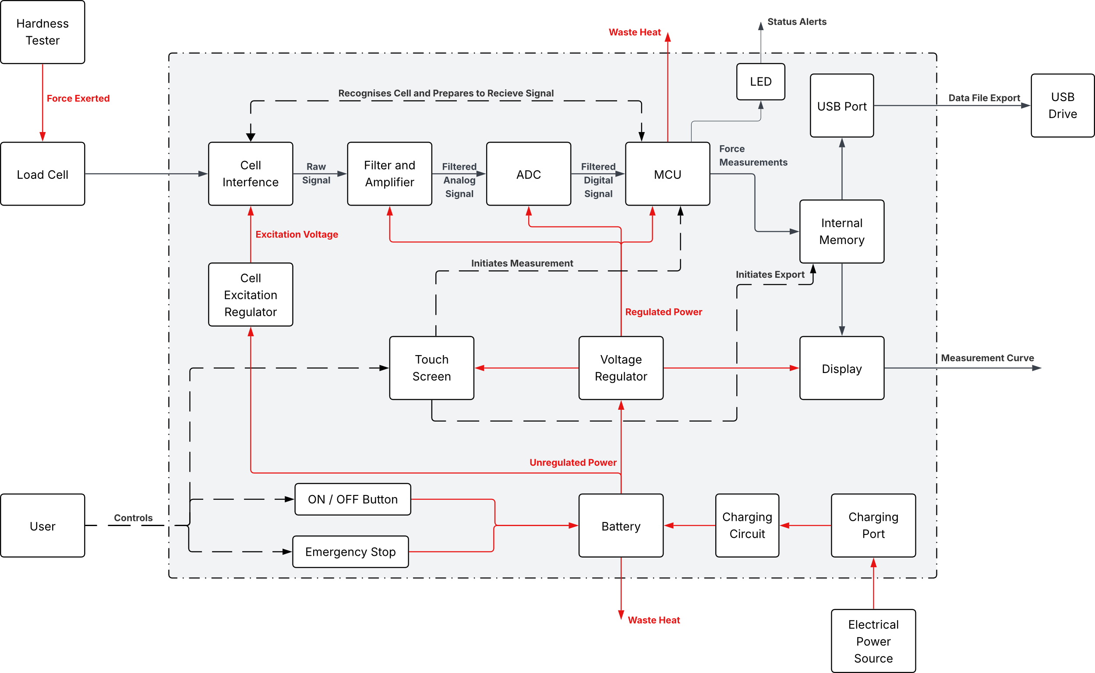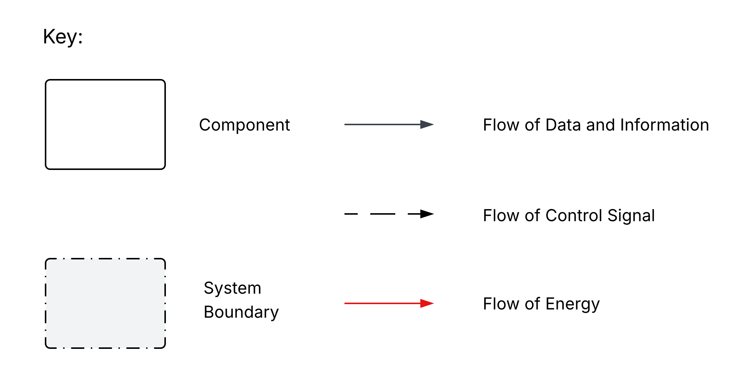

Figure 9: Functional Structure Diagram of the Product

# Human Machine Interface

## Human Machine Interface Overview

The Human Machine Interface section is a crucial part of the design process, as it converts the conceptual design of the product and functional structure into a tangible method of interaction for the end user. This must be done keeping three things in mind: clarity, simplicity, and safety.

The objective behind developing a good Human Machine Interface system is a satisfied customer, as it is the primary interaction an end user has with a system and is the basis of their opinion about the product. A good HMI system could lead to a user being able to do the same tasks successfully in a much more time efficient manner and have more focus towards the task rather than getting the system to work.

To make this a successful system, the product must fulfil all the functional requirements and functions mentioned in the sections above which specifically include managing the display operation, facilitating basic calibration of the cell, and handling data logging and export functionality. This also must be done while keeping in mind ergonomics and safety aspects of products.

## Inputs and Outputs

Based on the functions discussed in Section 4, here is a list of all the inputs and outputs interactions between the system and the user.[6]

Table 8: Input/Output Interactions of Product with User

|  |  |  |  |
| --- | --- | --- | --- |
| Interaction | Purpose | Input/Output | Character |
| Power on/off | To turn on/off the system | Input | Digital control signal |
| Battery/Power level | Display battery percentage | Output | Text |
| Critical Battery/Power alert | Alert user if battery too low, or in case of power fault | Output | Text / LED |
| Battery charging indicator | Indicate if battery is charging or full | Output | Text / LED |
| Menu navigation | Move between the different functions of the device | Input | Digital control signal |
| System status indicator | Alert user if system busy for interaction | Output | Text / LED |
| Load cell detection | Inform user if load cell detected or not | Output | Text |
| Load cell disconnection | If load cell is disconnected alert the user | Output | Text / LED |
| Load cell naming | Allow user to name individual load cell | Input | Digital control signal / Text |
| Start calibration | To get system ready for calibration/reading data | Input | Digital control signal |
| Calibration begins | Let users know calibration process is starting | Output | Text |
| Calibration status | Let user know if calibration was completed successfully or not | Output | Text |
| Start/Stop logging | Start/Stop recording data | Input | Digital control signal |
| Force signal onto load cell | Receive raw analogue signal from load cell, converted via 24-bit ADC for processing | Input | Analog variable |
| Store processed data | Confirms data is stored to the user | Output | Text |
| Display current data | Process and show data visually currently being read | Output | Text / Graph |
| Emergency cancel calibration | Cancel calibration at any point | Input | Tactile button (External interrupt) |
| Tare command | Set current force reading to zero | Input | Digital control signal |
| Storage full alert | Inform user if internal storage is full on device | Output | Text |
| Old data deletion confirmation | Ask users if older data can be deleted | Input | Digital control signal |
| USB Drive plugged in confirmation | Confirm a device being connected | Output | Text |
| Data export trigger | Get data in state to export onto a USB drive | Input | Digital control signal |
| Data export confirmation | Let user know if data was exported successfully | Output | Text |
| Error detection | Let user know in case of error with troubleshooting steps | Output | Text |
| Error reset | User clears error message | Input | Digital control signal |
| Data display format change | Allow users to customize data display format | Input | Digital control signal / Text / Numeric |
| Data display unit change | Allow user to change the unit of displaying | Input | Digital control signal / Text / Numeric |
| Current unit display | Display the currently used unit (N, kgf etc.) | Output | Text |
| USB Ejection trigger | End all tasks using USB drive | Input | Digital control signal |
| USB Ejection confirmation | Ensure no tasks are using USB drive | Output | Text |
| Peak and hold value function trigger | Record measurements and keeping only the highest measured value | Input | Digital control signal |
| Emergency peak and hold value function stop | Stop peak and hold value | Input | Tactile button (External interrupt) |
| Peak and hold value display | Show the maximum force value captured by the peak and hold function | Output | Text |
| Interaction | Purpose | Input/Output | Character |

## Control Elements

Table 9: Selection of control elements

|  |  |  |  |
| --- | --- | --- | --- |
| Control Element | Function | Type | Further consideration |
| ON/OFF button | Power on/off the device | Tactile button |  |
| Emergency Stop button | Button to cancel an operation in case of emergency | Tactile button | This button should be harder to press |
| Touch screen display | Show data, help user navigate, take inputs | LCD Resistive Touch screen | Should be usable with gloves |
| LED Status Indicator | Indicate in case of critical alert | RGB LED | Should not extrude out of the device for durability reasons |
| LED Charging indicator | Indicate if battery is charging or full | RGB LED | Should not extrude out of the device for durability reasons |
| USB A Port | Data export | USB Type A 2.0 female port |  |
| USB C port | Power supply | USB C Female port |  |
| Load cell connector port | To connect any Innovatest load cell | 5-pin M12 Circular Connector | Should not disconnect too easily |

## Safety Aspects

### Data Safety

For such devices data is crucial and losing it can mean hours of work to be repeated. So, for data safety these things are to be considered and followed:

* USB Ejection Protocol: prevent data corruption when USB Drive is removed.
* Battery/Power alert: alert user in case of low/unstable power
* Automatic data backup: periodically save data to minimize problems in case of unexpected interruptions.

### Operational Safety

This aspect of safety is necessary to be looked at to ensure user interaction with system is only under safe and valid conditions.

* System status indicator: inform user when system is busy/unsafe for interaction.
* Lockout for critical operations: reduce/remove interactions with system in case of certain critical operations such as file transfers.
* Emergency cancellation: allow user to abort both calibration and peak and hold function in case required, for instance in case of the screen hanging.

### Hardware and Environmental Safety

These measures must be taken to protect the load cells and the hardware itself from damage/misuse.

1. Overload protection: alert user as well as stop taking readings in case force exceeds load cell’s safe range.
2. Port disconnection detection: alert user and stop process in case the load cell port is disconnected or unexpected readings are read.
3. Temperature warning: alert user in case device is nearing or out of its recommended temperature range for readings.

### User Safety

Measures must be taken to protect the user within the environment as well, these include:

* Permit use with gloves: resistive touch screen has been chosen to permit use of screen with gloves, which will be required in the environment these devices are used in.
* Emergency cancel/stop button: a tactile button to cancel any process immediately in case of emergency such as evacuation of the working area. An external button permits user to cancel process even if screen freezes.

## Control Elements Arrangement

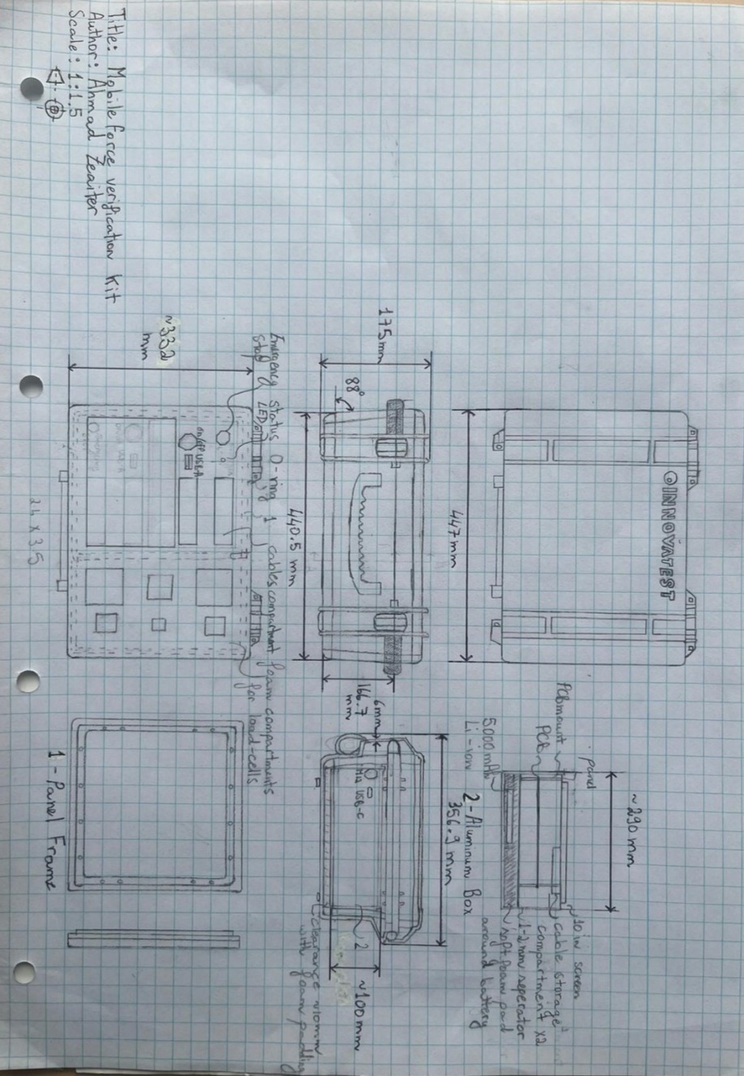

Figure 10:Arrangement of control elements (extracted from Freehand Sketch in Section 3.5)

The device has been made keeping the convenience and ergonomics of the user in mind. The power button has been placed right above the screen for easy access and has the led for telling the status of the battery on it for easy visibility. The emergency button has been placed away from all other used devices, to prevent accidental presses, but close enough for pressing in case of an emergency. The status indicator has been placed beside it to see if the device is busy or not. Keeping the similar function I/O together makes the design more intuitive for the user.

The screen has been kept closer to the opening of the case, for easy access for the user. Even in case of a USB-stick plugged into the device, it will not interrupt the user or make it uncomfortable because it is above the screen.

The charging port and M12 connector for load cells have been kept outside, so that no cables are sticking out from the inside of the case which could have also been damaged in case of the case being closed. Charging port being available while case is closed also makes it easier to charge.

## User Interface Design Description

Upon start up, the user will be met with a login screen to access the device only with valid credentials. All buttons will be big and clearly visible with high contrast.

Upon logging in, the main menu will be shown, allowing the user to go between different functions: calibration, settings, peak and hold value, data read/export, etc. At the top left of the screen, there will be permanently placed navigation buttons for back-and-forth navigation between the menus. The placement is also keeping in mind the familiarity of users with today’s software. On the top right there will be a battery percentage indicator also permanently visible again for similar reasons.

Upon going into calibration menu, the user will be asked to connect the load cell, if not already connected. Upon connection the UI will also let the user know which load cell has been connected. After confirmation from user for starting calibration, if load cell connected, the system will start the calibration process. While calibration takes place, the readings will be shown while also plotting a graph of force vs time, with units visible as well. After calibration, the data will be saved with a name by default, according to time, with an option to be modified by user.

The settings menu will allow the user to change units, adjust brightness, reset/restart device, and some other settings. Furthermore, peak-hold function will allow user to see the maximum value being displayed with its units.

Lastly, the data menu will allow user to access older saved recordings, as well an option to export the data to the USB-stick, considering one is connected and detected. Upon pressing the power button, the UI will ask user for confirmation for shutdown and close all processes before powering off.

## Ergonomics Aspects Considered

For a device to be used for hours at a stretch, its ergonomics must be considered. The device is designed keeping in mind that the user will travel with it and therefore an inbuilt handle has been provided. The handle of pelican cases is also ergonomically shaped (Mostafawi Group, 2024). The latches are made to be secure and easy to close for a secure closure of the case. The foam inside the case also prevents movement of equipment inside, which would hamper the weight distribution while carrying and affect the comfort of carrying the case.

Placing related items together, makes the experience better for the user, for example the power button right next to the main screen, as well as the USB-A port used to extract data from the device.

The system’s user interface will also be designed keeping ergonomics in mind. For easy understanding of data being read, analogue values will be read whilst also plotting a graph to visualize the data. The UI will also not be violating any stereotypes of traditional and already familiar user interface designs. This, for instance, includes placing the navigation icons on top left, and graphs being growing from left to right on x-axis and bottom to top on y-axis (European Commission, 2010).

# Design-Failure Mode and Effect Analysis (D-FMEA)

## D-FMEA Rating Scheme

FMEA is a formalised analytical method for the systematic identification of possible failures and the estimation of the related risks (Pahl, Beitz, Feldhusen & Grote, 2007). It helps quantitatively illustrate the potential failures of the product.

Three Factors must be considered:

* Severity (S) – An estimation of the effects of the failure on the customer
* Occurrence (O) – An estimation of the probability of occurrence
* Detection (D) – An estimation of the probability that the failure can be detected before delivery.

With these factors, the Risk Probability Number ($RPN$) can be calculated using Equation (1):

|  |  |
| --- | --- |
| $$RPN=S⋅O⋅D$$ | (1) |

Any $RPN$ greater than 125 is considered critical and requires action.

The rating schemes for these factors and the calculated Risk Number are as follows:

Table 10: Rating Scheme for Severity (S)

|  |  |
| --- | --- |
| **Rating** | **Effect on Customers** |
| 1 | Effects hardly noticeable |
| 2-3 | Failures not important (little trouble to the user) |
| 4-6 | Reasonably serious failure (difficult to use) |
| 7-8 | Serious failure (annoying for the user) |
| 9-10 | Failure with large negative effects (almost unusable) |

Table 11: Rating Scheme for Occurrence (O)

|  |  |
| --- | --- |
| **Rating** | **Probability of Occurrence** |
| 1 | Very low |
| 2-3 | Medium low |
| 4-6 | Medium (occasional) |
| 7-8 | Medium high |
| 9-10 | High likelihood (almost inevitable) |

Table 12: Rating Scheme for Detection (D) Probability

|  |  |
| --- | --- |
| **Rating** | **Probability of Detection** |
| 1 | High (obvious) |
| 2-5 | Medium high |
| 6-8 | Medium (detectable in quality control) |
| 9 | Medium low |
| 10 | Low (almost undetectable) |

## D-FMEA Table

Table 13: Design Failure Mode and Effect Analysis of the Product

|  |  |  |  |  |  |  |  |  |  |
| --- | --- | --- | --- | --- | --- | --- | --- | --- | --- |
| Component | Function | Failure Mode | Potential Effect | Potential Cause | S | O | D | RPN | Recommended Actions |
| Load Cell Interface | Connect sensor to electronics | No function | Device reads zero, cannot measure | Broken wiring, open bridge | 10 | 2 | 4 | 80 | Check wiring, add diagnostics |
| Underfunction | Low readings, poor precision | Connector corrosion, broken wires | 6 | 4 | 5 | 120 | Check wiring, scheduled calibration and maintenance |
| Overfunction | Overstated readings | Shorted bridge, wrong polarity | 9 | 3 | 5 | 135 | Add diagnostics, plausibility checks |
| Intermittent | Glitches or dropouts | Loose crimp, connector mismatch | 6 | 6 | 7 | 252 | Securing connectors, strain relief |
| Load Cell Excitation Regulator | Supply regulated voltage to sensor | Underfunction | Gain error, low readings | Regulator drift, battery sag | 8 | 4 | 5 | 160 | Use high precision regulator, monitor Vcc |
| Overfunction | Pegged output, sensor damage | Transient surge | 9 | 2 | 5 | 90 | TVS diodes, input protection |
| Intermittent | Temporary gain shifts | Loose connector | 7 | 3 | 6 | 126 | Monitor Vcc, secure connectors |
| Malfunction | Sensor damaged, erratic readings | Voltage spike or regulator failure | 9 | 2 | 5 | 90 | Surge protection |
| Signal Conditioning Chain | Filter & compensate signal | Underfunction | Biased readings | Missing compensation | 8 | 4 | 5 | 160 | Add temperature sensor, compensation |
| Overfunction | Slow response | Low cutoff | 6 | 4 | 4 | 96 | Tuning filters |
| Malfunction | Permanent biased readings | Faulty filter components | 8 | 3 | 4 | 96 | Add diagnostics checks |
| ADC | Convert analog to digital | Underfunction | Small loads unreadable | Wrong gain | 7 | 4 | 5 | 140 | Precise calibration |
| Overfunction | Maxed readings | Amplifer saturation | 8 | 3 | 5 | 120 | Clamping diodes |
| Malfunction | Readings always incorrect or pegged | ADC/amplifier damage | 9 | 2 | 5 | 90 | Clamping diodes and current limiting resistors |
| Microcontroller | Process & manage data | No function | Device unresponsive | Memory corruption | 9 | 3 | 4 | 108 | Watchdog, regression tests |
| Underfunction | Non-linear readings | Wrong coefficients | 7 | 4 | 5 | 140 | Validate algorithm, calibration |
| Intermittent | Missed samples | RTOS issue | 7 | 3 | 4 | 84 | Priority config, watchdog |
| Malfunction | Device unresponsive, no measurement | Firmware crash or hang | 10 | 3 | 5 | 150 | Watchdog, firmware rollback |
| Display | Show measurement | No function | No visible readings | Display driver failure | 9 | 3 | 4 | 108 | Driver check, display replacement |
| Underfunction | Truncated readings | UI bug | 5 | 4 | 4 | 80 | Check formatting, raw view |
| Overfunction | Displayed values incorrect | Unit mapping bug | 8 | 3 | 5 | 120 | End-to-end checks |
| Intermittent | Blank/flickering display | Race condition | 6 | 5 | 5 | 150 | Decouple refresh |
| Buttons | User interaction tactile buttons | No function | Buttons stuck in pressed state | Broken spring | 9 | 5 | 1 | 45 | Use good quality springs |
| Underfunction | Buttons require excessive force | Button contacts damaged | 4 | 4 | 4 | 64 | Increase buffer rating |
| Overfunction | Repeated operation for single press | Contact bouncing | 5 | 6 | 6 | 180 | Implement software debouncing |
| Intermittent | Occasionally presses unregistered | Contact contamination | 5 | 6 | 5 | 150 | Ensure a clean environment near button soldering |
| Touch Screen | User interaction with screen | No function | Unresponsive touch screen | Touch controller failure | 9 | 4 | 3 | 108 | Test screen functionality, replace controller if required |
| Underfunction | Harder press for click registering | Spacer dots are too large / too few | 5 | 6 | 5 | 150 | Ensure precision application of spacer dots |
| Overfunction | Multiple touches for same touch | Contact bouncing | 6 | 4 | 4 | 96 | Increase debounce time |
| Intermittent | Occasional touches unregistered | Prescence of conductive debris | 6 | 7 | 4 | 168 | Ensure a clean environment near panel assembly |
| Malfunction | Ghost interactions | Layers stick together due to adhesive failure | 9 | 5 | 4 | 180 | Ensure a clean environment near panel assembly |
| Internal Memory and USB Port | Record & export data | Overfunction | Data overwritten | Too frequent logs | 6 | 3 | 6 | 108 | Limit data rate, alarms |
| Intermittent | Partial file transfer | Voltage fluctuation disrupts write process | 6 | 6 | 6 | 216 | Brown-out detector |
| Malfunction | Cannot retrieve data | Flash memory corruption | 9 | 2 | 4 | 72 | CRC Checks, periodic memory dumps |
| Battery | Provide power to device | No function | Device does not power on | Battery failure | 10 | 2 | 4 | 80 | Battery test/replacement |
| Underfunction | Short operating time | Parasitic drain | 9 | 4 | 5 | 180 | Monitor battery drain |
| Overfunction | Battery damage | Faulty charger | 10 | 2 | 4 | 80 | Certified IC, thermal cutout |
| Intermittent | Unexpected resets | Loose connector | 9 | 4 | 4 | 144 | Secure connectors, brown-out |
| Malfunction | Battery swelling or fire | Overcharge or short | 10 | 2 | 2 | 40 | Overcharge alerts |
| Housing Fasteners | Provide mechanical structure | Overfunction | Overstressing the housing | Fasteners too tight | 5 | 3 | 4 | 60 | Determine precise fastening torque for material |
| Intermittent | Occasional misalignment | Loose fasteners | 6 | 4 | 6 | 144 | Retention clips, torque specification |
| Housing Protection | Protect electronics | No function | System stops working | Water ingress | 10 | 1 | 2 | 20 | Regular QA inspection |
| Underfunction | Moisture ingress, corrosion | Gasket wear | 8 | 2 | 6 | 96 | Purchasing high durability gaskets |
| Intermittent | Short, transient faults | Poor assembly | 9 | 5 | 4 | 180 | IP connectors, QA |

# 3D Model

## Protective Case

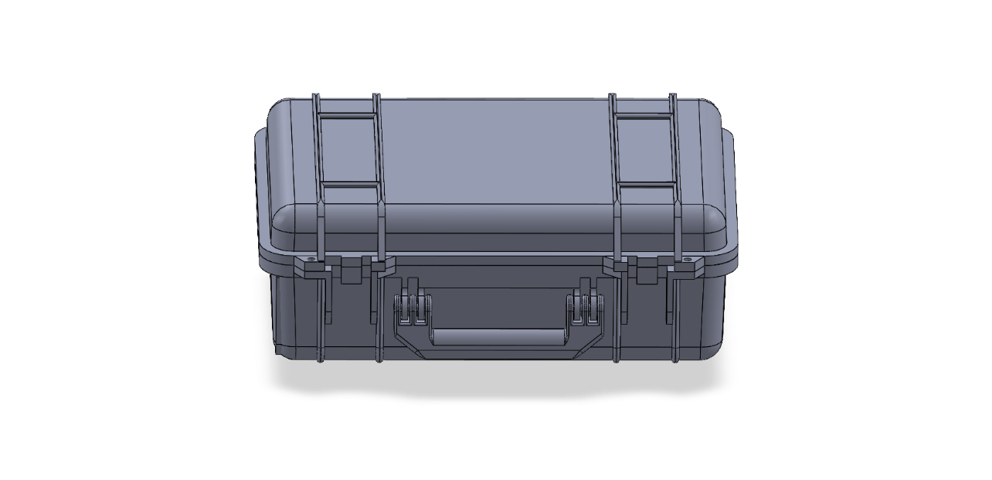

Figure 11: Protective Carrying Case Model

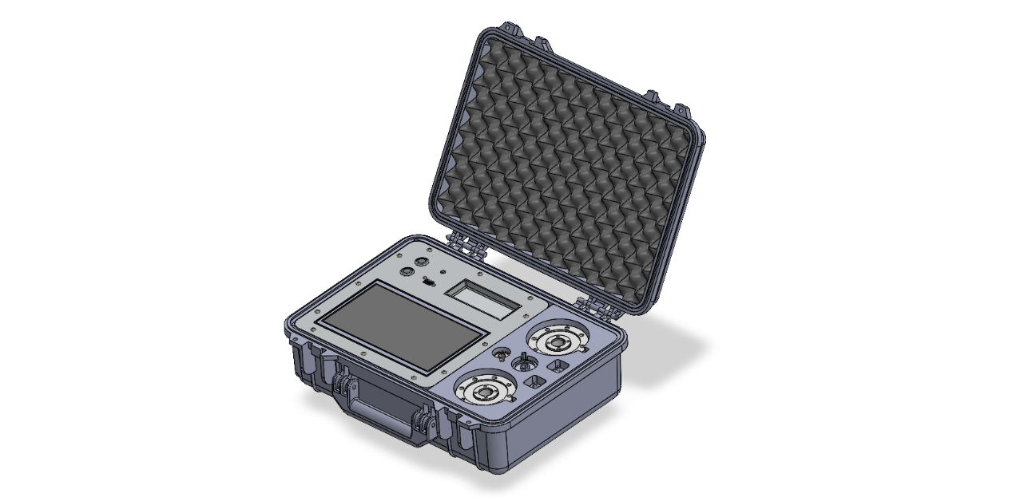

Figure 12: Isometric View of Complete 3D Model

## HMI

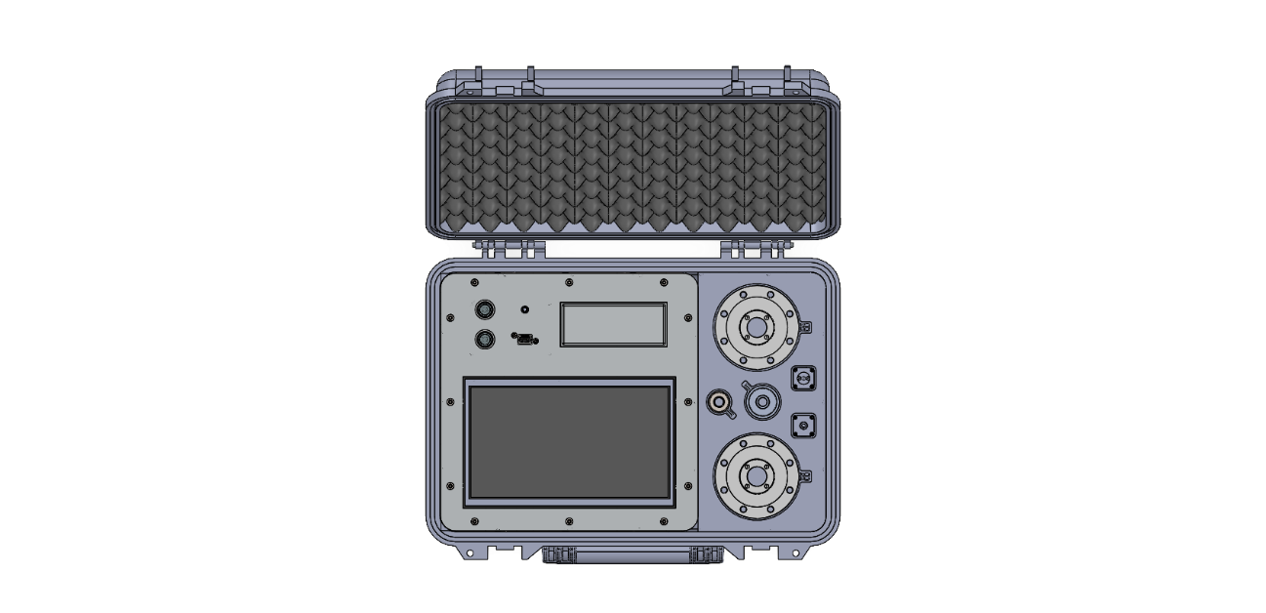

Figure 13: Top View of Complete 3D Model showing HMI

## Interior

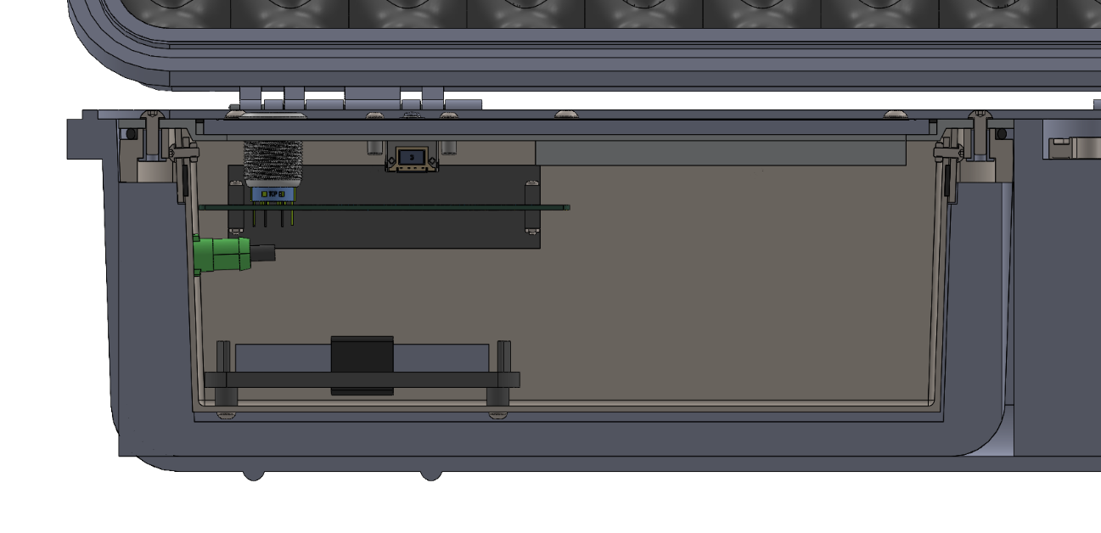

Figure 14: Interior of Complete 3D Model showing PCB, Battery and Aluminium Frame

## Load Cell Connector

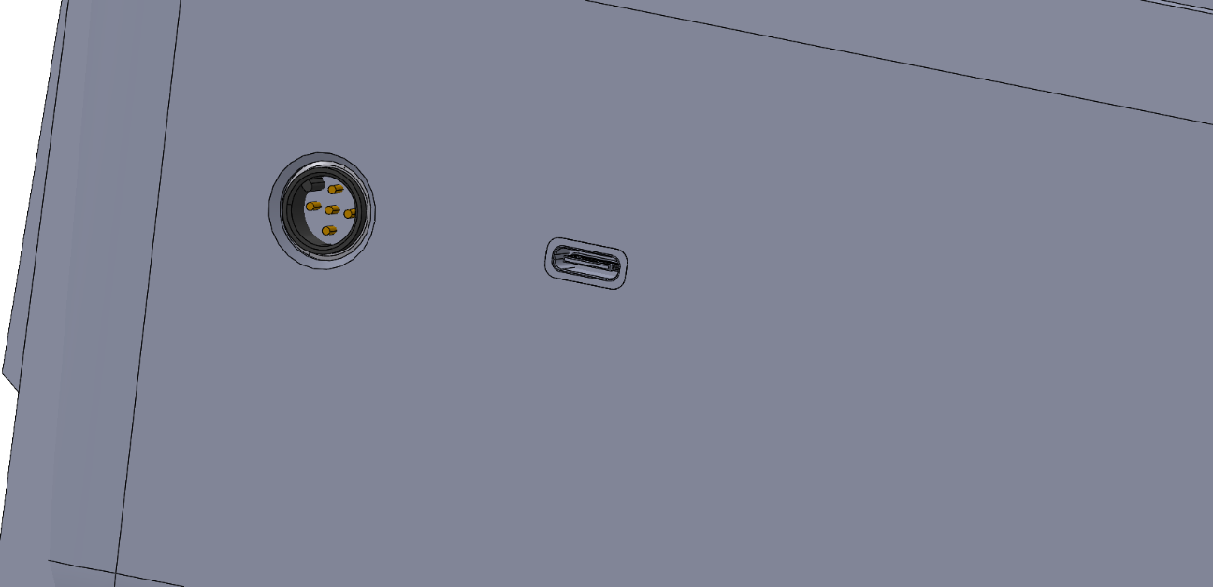

Figure 15: Connectors on the Complete 3D Model for Load Cells and Charing

# Technical Drawing of Main Assembly

Figure 16: Main Assembly Drawing

Figure 17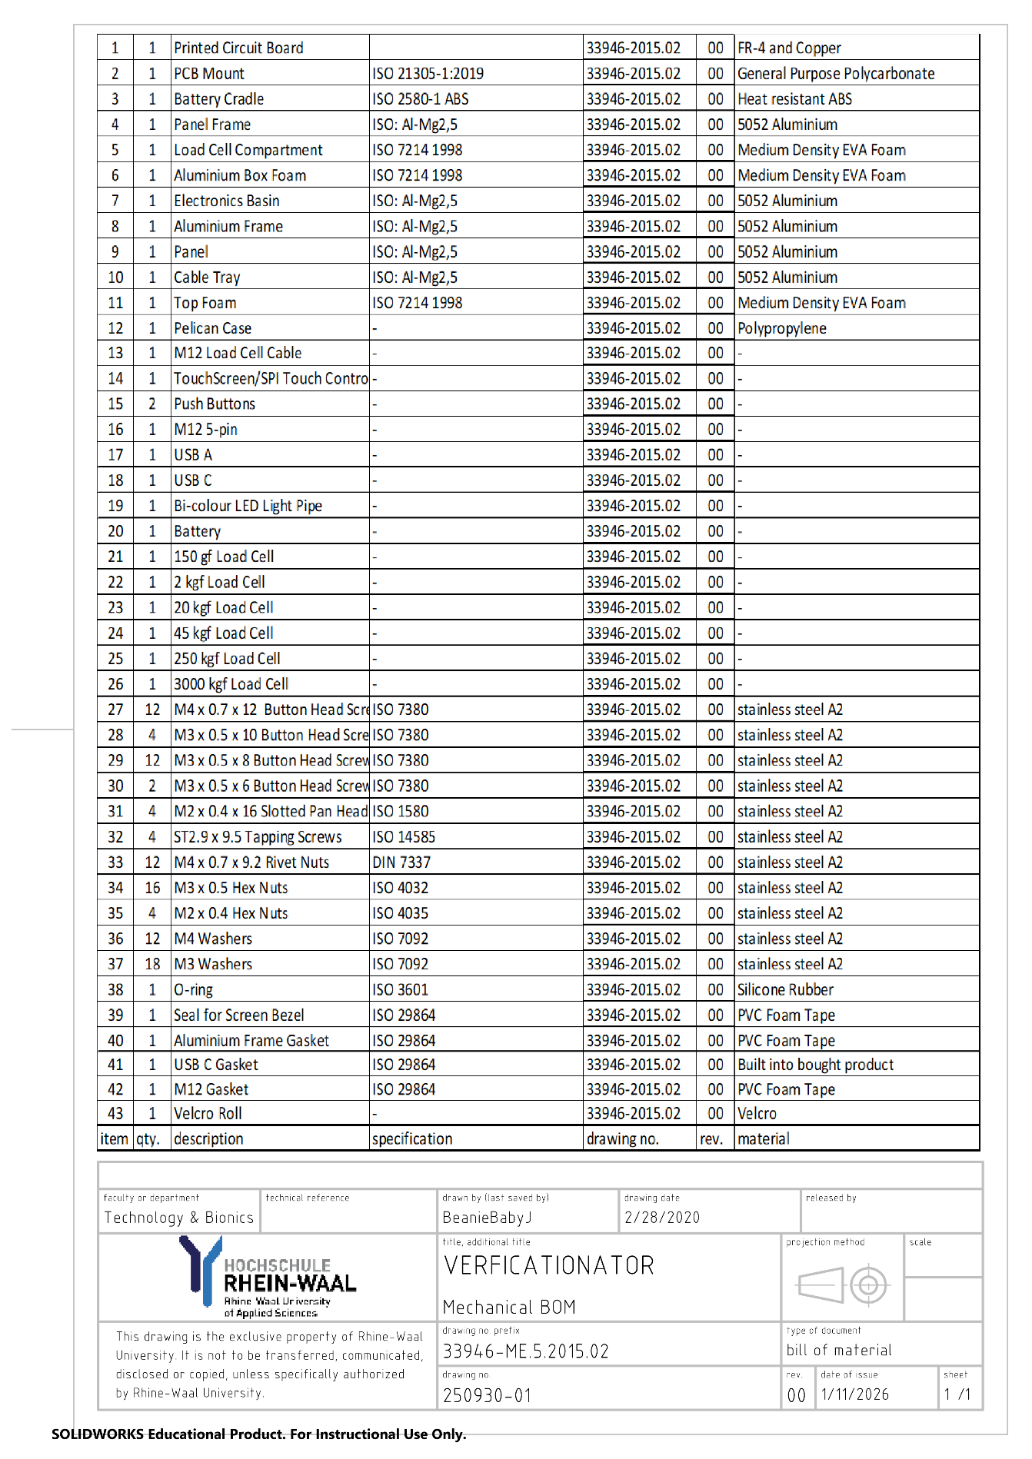: Bill of Materials for Assembly Drawing

# Measurement Chain

## Architecture

For the signal to be processed by the microcontroller, the raw signal needs to undergo the following stages of signal conditioning:

1. Excitation Conditioning
2. Passive Low Pass Filtering
3. Instrumentation Amplification
4. Precision Variable Gain Amplification
5. Analogue to Digital Conversion (ADC)
6. Digital Filtering

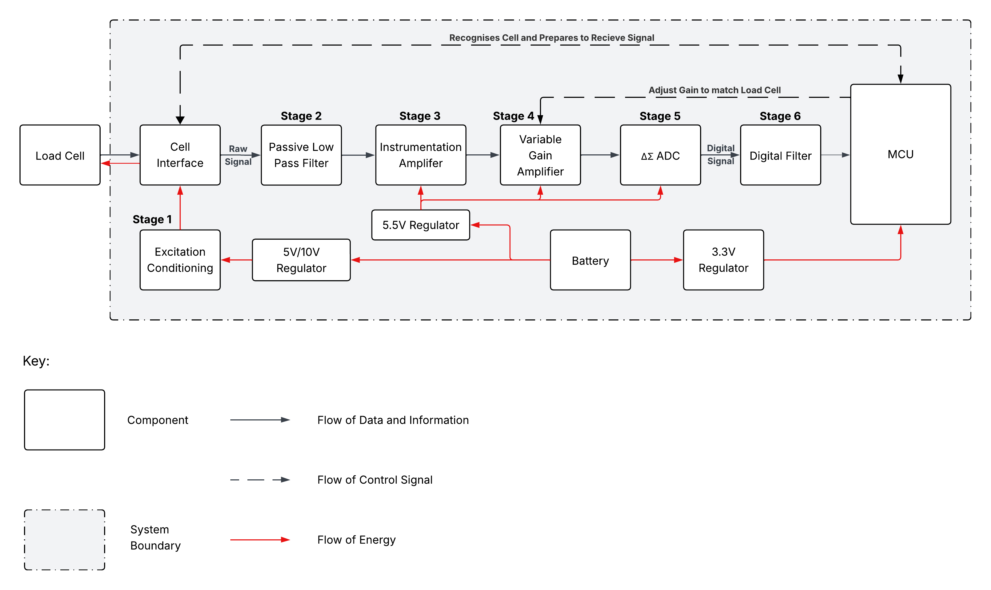

Figure 18: Functional Structure Diagram of Measurement Chain

In order to implement the measurement chain such that it can meet all the reliability and performance requirements; each stage uses dedicated integrated circuits (ICs) and passives instead of using a complete analogue front end chip like the HX711 or AD7794, as they do not allow for the functionality, precision and accuracy that is necessary for this product.

## Schematic

## Design of Signal Conditioning Stages

### Excitation Conditioning

To minimise the power fluctuation noise, the power supply for the load cells must be conditioned with low-noise boost converters and decoupling.

One of the leading noise components in many instrumentation applications is the fluctuations in the power supply. To reduce the noise introduced by battery fluctuations, low noise boost converters are used. Three of these devices are used to create three power rails: 5V, 5.5V and 10V. The 5V and 10V rails are switchable via a power MOSFET switching network and provide excitation to the load cells. The 5.5V supply powers the devices in the measurement chain. These devices ensure the mean voltage level remains relatively constant with a low voltage ripple. For the load cell excitation rails, this is incredibly important as it ensures that the measurements are consistent and application of the same force yields the same voltage response. Additionally, the switching network was configured such that one supply rail is active the other is completely cut off. This ensures that there is no overcurrent and that noise in one rail does not affect the other.

Another important process in mitigating noise is using decoupling capacitors. 10μF and 0.1μF capacitors (or a parallel combination) are used to on the supplies of each IC to ensure that they are decoupled from the ground plane. This helps to reduce interference between the ICs, especially between the analogue and digital devices.

### Passive Low Pass Filtering

To reject high frequency noise while also reducing the chances of aliasing, a series of passive low pass RC filters are to be implemented between the other stages.

Since the device is measuring only a series of static forces, the frequency of the relevant signal is effectively zero. These filters thus remove all noise components with a frequency higher than 4.98Hz. This includes noise caused by electromagnetic interference and power supply fluctuations. Additionally, for the input of the instrumentation amplifier, a differential RC filter was used with matched resistors to preserve the Common Mode Rejection Ratio (CMRR). To ensure noise is reduced across the entire measurement chain, a series of filters are used between each stage up to the ADC. These stages also have their own noise filtering properties, so, to reduce settling times, the filters get “looser” with each stage, that is the specified corner frequency increases to 7.2Hz between stages 3 and 4 and 19.86Hz between stages 4 and 5.

To dimension the RC filters, the corner frequency formula as shown in Equation (2) is used.

|  |  |
| --- | --- |
| $$f_{c}=\frac{1}{2πRC}$$ | (2) |

Detailed calculations for the relevant resistor and capacitor values as well as the corner frequencies and settling times of each filter can be found in Appendix C (19.3.1).

### Instrumentation Amplification

To amplify the signal for readability while also providing common mode rejection, an Instrumentation Amplifier (INA) is to be implemented. The two signal lines from the load cell enter the INA and the amplified differential output is sent to the next stage

The load cells output a very small differential signal of around 14mV[7] when excited with 5V and 28mV when excited at 10V. As such, they need to be amplified with minimal noise. The INA allows for high gains with very low noise and high CMRR. This means that it can amplify the signal and reject common noise from both signal lines all while adding very little device noise. However, the different load cell models have different sensitivities and thus require different gains for full utilisation. To solve this issue, the INA is used as pre-amplifier to provide most of the required gain with low noise injections and a Precision Variable Gain Amplifier is used in the following stage for the remaining gain. The INA provides a gain of 100, which is less than the minimum gain of 307.69 required any of the load cells.

### Precision Variable Gain Amplification

To compensate for the remaining gain, a precision variable gain amplifier (VGA) is to be implemented as a second stage amplifier.

After pre-amplification by the INA, the VGA provides the small remaining gain and is programmed to match the specific gain required by each load cell. To implement this precision VGA, a simple non-inverting operational amplifier (op-amp) is set up with a digital potentiometer acting as the feedback resistor.

To calculate the gain required by a load cell, the Equation (3) is used.

|  |  |
| --- | --- |
| $$G=\frac{5000mV}{SEN⋅V_{E}}$$ | (3) |

Where $SEN$ is the sensitivity of the load cell [$mV/V$], $V_{E}$ is the excitation voltage.

The remaining gain is then calculated by dividing the required gain by 100 from the INA. The gain values for 5V and 10V excitation are shown in Table 14 and Table 15 respectively.

The gain of a non-inverting amplifier can be calculated using Equation (4) and hence the resistance of the potentiometer is calculated using Equation (5).

|  |  |
| --- | --- |
| $$G=1+\frac{R_{F}}{R_{N}}$$ | (4) |
| $$R_{F}=R_{N}(G-1)$$ | (5) |

Where $G$ is gain, $R_{F}$ is the resistance of the feedback resistor and $R_{N}$ is the resistance of the resistor at the negative input of the op-amp.

Using an OPA188 op-amp, a MCP41U83 digital potentiometer and a fixed 4.99kΩ resistor (at the negative input), the required gains are achievable with a maximum gain error of 0.162%. Table 14 shows all the gains required for each load cell, the dimensioned $R_{F}$ values and the resulting gain error for 5V excitation. Table 15 shows the same for 10V excitation. The gain has an inherent error since the MCP41U83 has a precision of 1024 positions over the 20kΩ range and cannot match the gain exactly. So, to estimate the gain error, the position was first estimated by mapping the required resistance over the 20kΩ range using Equation (6) to a position and rounded down to the nearest integer. The position value was then used to find the exact resistance using Equation (7) and thus the actual gain using Equation (4). The gain error is simply the difference between the actual and remaining gain divided by the remaining gain.

|  |  |
| --- | --- |
| $$D=\left\lfloor 1024⋅\frac{R_{F}}{20kΩ}\right\rfloor$$ | (6) |
| $$R_{F}^{actual}=20kΩ⋅\frac{D}{1024}$$ | (7) |

Table 14: Required Gains and Gain Error for Each Load Cell for 5V Excitation (Using OPA188 and MCP41U83)

|  |  |  |  |  |  |
| --- | --- | --- | --- | --- | --- |
| Load Cell Model [kgf] | Sensitivity [$mV$] | Required Gain | Remaining Gain | $R_{F}$ [$kΩ$] | Gain Error |
| 0.15 | 3 | 333.33 | 3.33 | 11.64 | 0.016% |
| 2 | 2.35 | 425.53 | 4.26 | 16.24 | 0.064% |
| 20 | 2.7 | 370.37 | 3.70 | 13.49 | 0.081% |
| 45 | 3 | 333.33 | 3.33 | 11.64 | 0.016% |
| 250 | 3.25 | 307.69 | 3.08 | 10.36 | 0.080% |
| 3000 | 2.8 | 357.14 | 3.57 | 12.83 | 0.106% |

Table 15: Required Gains and Gain Error for Each Load Cell for 10V Excitation (Using OPA188 and MCP41U83)

|  |  |  |  |  |  |
| --- | --- | --- | --- | --- | --- |
| Load Cell Model [kgf] | Sensitivity [$mV$] | Required Gain | Remaining Gain | $R_{F}$ [$kΩ$] | Gain Error |
| 0.15 | 3 | 166.67 | 1.67 | 3.33 | 0.076% |
| 2 | 2.35 | 212.77 | 2.13 | 5.63 | 0.019% |
| 20 | 2.7 | 185.19 | 1.85 | 4.25 | 0.135% |
| 45 | 3 | 166.67 | 1.67 | 3.33 | 0.076% |
| 250 | 3.25 | 153.85 | 1.54 | 2.69 | 0.145% |
| 3000 | 2.8 | 178.57 | 1.79 | 3.92 | 0.162% |

### Analogue to Digital Conversion

To convert the analogue voltage into a digital signal that the microcontroller can process, a 24-bit delta-sigma ADC was used because of its high precision and low noise output.

The load cells output very small analogue voltages of at most 32.5mV. For the microcontroller to process them, the signals need to be sampled and converted into digital values with enough precision that measurement and calibration are possible at an industry standard level. A 24-bit ADC has a theoretical resolution of 298nV which means there are 16, 777, 216 possible voltage levels and thus force values that can be read. This of course doesn’t account for noise which is discussed in Section 10.6 Noise Performance. However, the 24-bit ADC is more than Sufficient to meet precision requirements. The delta-sigma architecture also employs over-sampling through the modulator which allows for a simplified anti-aliasing filter while still following the Shannon-Nyquist Theorem. This over-sampling process also spreads the quantisation noise over a much higher bandwidth than that of the signal. The oversampling ratio (OSR) can also be modified to effectively change the sampling rate. Most delta-sigma ADC chips also have an on-board digital filter which further helps to reduce noise and aliasing. This is discussed in further detail in Section 9.3.6 Digital Filtering.

For the ADC to operate with the best accuracy, a voltage reference IC is also required. This IC must be able to reliably provide 5V to the ADC reference pins. Thus, it must have low noise and a low drop-out voltage. It should also be noted that the ADC will only use 5V as a reference voltage despite the load cell excitation voltages being switchable between 5V and 10V. This is primarily a technical limitation since there are no reliable ADC ICs on the market that can handle both 5V and 10V references. The 10V excitation does still provide a higher signal-to-noise ratio however since the load cell and excitation noise do not change much between 5V and 10V while the applied voltage is doubled.

### Digital Filtering

To reduce random in-band noise and quantisation noise, a programmable finite impulse response (FIR) and infinite impulse response (IIR) filters are to be applied to the signal as substages within the ADC IC.

Even after the previous filtering stages, the signal still has some quantisation noise introduced by the ADC process and random in-band noise from environmental conditions. Digital filtering allows for removal of these random noise components as well as the flexibility to shape the noise profile. Most delta-sigma ADC ICs have built-in FIR and IIR filters which reduces the required processing load on the microcontroller.

The FIR filter performs weighted averaging across many samples where each sample is multiplied by a corresponding filter coefficient. This allows the FIR filter to effectively act as a digital low-pass filter which helps to reduce the out-of-band quantisation noise. This noise is spread across a very large bandwidth due to the oversampling of the ADC. The averaging also helps to remove some random noise. After this substage, the signal undergoes decimation whereby it is downsampled to the desired data transfer speed. It is imperative that the FIR substage occurs before the decimation because otherwise the signal may experience aliasing.

The IIR filter use a feedback structure which allows it to supress specific frequencies. This is especially effective against 50/60Hz “Hum Noise” and other known noise components. IIR filters also require less coefficients than an equivalent FIR filter so using it as a second substage to the FIR filter allows for overall lower computation for the same performance.

## Component Specifications

Table 16: List of Components and Specifications for Measurement Chain

|  |  |  |  |
| --- | --- | --- | --- |
| Stage | Component | Specifications | Potential Candidate |
| 1 | 5V Regulator | * 5V output * > 80 % efficiency to keep power losses low * ≤ 0.1 mV noise at output | TPS61099 |
| 1 | 10V Regulator | * 10V output * > 80 % efficiency to keep power losses low * ≤ 0.1 mV noise at output | TPS61170 |
| 1 | 5.5V Regulator | * 5.5V output * > 80 % efficiency to keep power losses low * ≤ 0.1 mV noise at output | TPS61089 |
| 2 | RC Filter | * Passive components to ensure reliability and lower power consumption * Around 5 to 8 to 20 Hz successively increasing corner frequency * < 5Hz Bandwidth to block all higher frequency noise | - |
| 2 | Resistors | * 0.1% tolerance for accurate corner frequency dimensioning * Thin film resistor for best precision | - |
| 2 | Capacitors | * 1% tolerance for accurate corner frequency dimensioning * 3216[8] package size for capacitors ≥ 10 μF for better bulk decoupling * 2012 package size for capacitors < 10 μF to reduce inductance of components * X7R ceramic capacitors for stable capacitance values | - |
| 3 | INA | * 100 Gain set precision resistor (0.1% tolerance) * > 124dB CMRR at Gain of 100 * > 35 V/μs slew rate for quick measurement times * > 10 Hz bandwidth at 100 gain to ensure it operates within system bandwidth. * < 0.1 μV peak-to-peak noise (input) at gain of 100 to stay within noise budget * > 5V single supply operation for compatibility with rest of measurement chain * 2– 3 mA supply current to stay within power budget * 40V overvoltage protection * < 0.3 μV/°C offset drift to minimize effects of high temperature environments * < 3 ppm/°C gain drift to minimize effects of high temperature environments | AD8421 |
| 4 | Operational Amplifier | * 1 – 5 gain range * < 0.4 μV peak-to-peak noise to stay within noise budget * >5V single supply operation for compatibility with rest of measurement chain * 0.3 – 0.6 mA supply current to stay within power budget * Zero drift | OPA188 |
| 4 | Digital Potentiometer | * 1024 steps (or 10-bit resolution) to ensure precise gain selection * 20kΩ range for easier dimensioning * Serial communication for programming of resistance * < 5 μA supply current during normal operation to stay within power budget | MCP41U83 |
| 5, 6 | ΔΣ ADC | * 24-bit resolution to ensure precision requirements are met * Programmable OSR to adjust sampling rate * On-board digital filter * Serial Peripheral Interface (SPI) for very fast data transfer speeds * 5V reference mode * Buffered inputs to reduce current draw and increase accuracy * < 7μV peak-to-peak noise at input to stay within noise budget * 1 – 3 mA supply current to stay within power budget * > 5V single analogue supply operation for compatibility with rest of measurement chain * 3.3V isolated digital supply so that level shifting is not needed * < 0.1 μV/°C offset drift to minimize effects of high temperature environments * < 1 ppm/°C gain drift to minimize effects of high temperature environments | ADS127L21 |
| 5 | Voltage Reference | * 5V reference output * ±0.02% accuracy for reliable ADC operation * < 3μV peak-to-peak noise at input to stay within noise budget * < 1mA supply current to stay within power budget * < 0.5V voltage dropout * < 1 ppm/°C voltage temperature coefficient of to minimize effects of high temperature environments | MAX6126 |
| 6 | Digital Filter | * Finite Impulse Response filter for removing quantisation and random noise * Infinite Impulse Response filter for removing specific noise components and reducing computational load * Integrated into ADC to reduce computational load of MCU * Decimation to downsample to desired data rate | ADS127L21 |

# Circuit Design

The circuit diagram was designed using specific components that were found to match the specifications required to operate and meet the requirements outlined in 3.1 Requirements List. These components are subject to change as the design is further developed, and all critical specifications are outlined in 14.1 Requirements for Electrical Parts. Note that all calculations and dimension was done using the datasheets and specifications of the chosen components.

## Simplified Schematic Diagram

Figure 19: Simplified Schemaic Diagram

## Full Schematic Diagram

Figure 20: Full Detailed Schematic Diagram

## Schematics of Subsystems

### Main Controller

Figure 21: Processing, Memory and Display System Schematic Diagram

### Power Regulation

Figure 22: Power Regulation System Schematic Diagram

### Measurement Chain

Figure 23: Measurement Chain System Schematic Diagram

### Battery Management

Figure 24: Schematic diagram of battery management

## Load Cell Identification

To make each load cell uniquely identifiable, a simple voltage divider is to be implemented into the connector cables of each load cell as shown in Figure 25. The assembly of this system is shown in Table row 13.

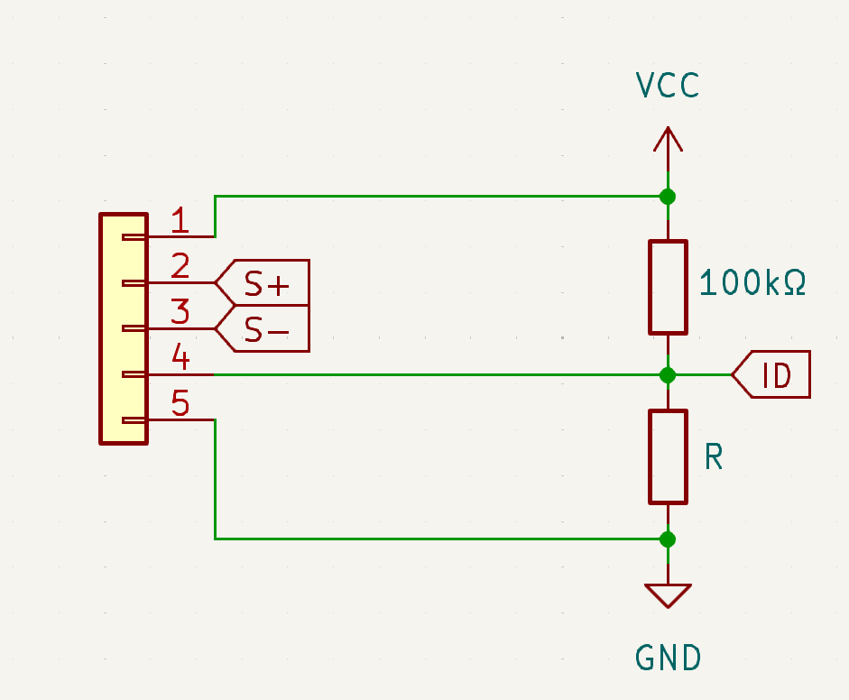

Figure 25: Schematic Diagram of Voltage Divider inside M12 Load Cell Connector

The upper resistor is chosen to be 100kΩ while the lower resistor is changed for each load cell as shown in Table 17. The resultant voltage is calibrated and stored in the MCU memory for fast identification of the load cell. Once identified, it the MCU adjusts the settings of the VGA from 9.3.4.

Table 17: Resistor Values for Each Load Cell for Identification

|  |  |
| --- | --- |
| Load Cell Model [kgf] | Resistor Value (R) [kΩ] |
| 0.15 | 10 |
| 2 | 2 |
| 20 | 20 |
| 45 | 45 |
| 250 | 200 |
| 3000 | 300 |

These resistor values were chosen so that there is sufficient distance between load cells to make them easily identifiable and with sufficient room for future load cell models to be integrated for compatibility.

## Battery Life Estimate

To update the battery life estimate in 19.2 Appendix B, the typical supply current values from the components listed in Table 20 we used to calculate a new estimate.

Table 18: Typical and Specified Supply Current Values for Electronic Components

|  |  |  |  |
| --- | --- | --- | --- |
| **Component** | $$I_{typ}$$**[mA]** | $I_{max}$**[mA]** | $I_{spec}$**[mA]** |
| Load Cell | 14.28 | 28.57 | 21.425[9] |
| INA | 2 | 2.3 | 3 |
| OPAMP | 0.45 | 0.51 | 1 |
| Digi Poti | 0.001 | 0.002 | 0.005 |
| DS ADC | 1.24 | 1.43 | 3 |
| VREF | 0.38 | 0.58 | 1 |
| MCU | 500 | 600 | 500 |
| 10 V Excitation Regulator | 2.3 | 2.8 | 2.5 |
| 5V Excitation Regulator | 0.001 | 0.0027 | 0.002 |
| 5.5 V ADC Channel | 0.101 | 0.183 | 0.15 |
| 3.3V Regulator | 0.017 | 0.03 | 0.02 |
| Optocoupler | 10 | 10 | 10 |
| Display Back light | 120 | 120 | 120 |
| USB | 2.5 | 500 | 2.9[10] |
| Total | | | 655.002 |

The typical and maximum values were considered in choosing the specified current value and this value was used to calculate the battery life using Equation (8)

|  |  |
| --- | --- |
| $$T_{dur}=\frac{Capacity}{I_{spec}^{total}⋅1.2}$$ | (8) |

Where $Capacity$ is the full capacity of the battery, $T_{dur}$ is the duration in hours, $I_{spec}^{total}$ is the sum of the specified currents and 1.2 is the safety factor.

When using the original 5000mAh battery, the estimate battery life is only 6.26 hours. The main proponent to this is the ESP32-P4 which draws an immense 500mA. So either another controller matching the requirements in Table 25 must be found, or the battery can be upgraded to 7200mAh which yields a specified battery life of 9.16 hours which matches the requirements outlined in 3.1.4 Electrical Requirements.

## Noise Performance

### Noise Components

The main contributors to the noise in the system are:

* Load cell noise caused by vibrations, hysteresis, creep and temperature fluctuations
* Electromagnetic Interference (EMI) or 50/60 Hz “Hum Noise” caused by nearby electrical equipment
* Power noise caused by fluctuations in the power supply
* Device noise caused by internal non-ideal processes of the ICs (including flicker noise)
* Quantisation noise from the ADC

The stages of the Measurement Chain have been designed to minimise and reject these noise components, however these processes are non-ideal and thus there will always be some noise in the system which limits the precision and accuracy of the measurements.

### Peak-to-Peak Noise

To estimate the noise of the system, we cannot approximate the load cell noise or the EMI noise as they are heavily dependent on the environment. So, they are assumed to be Sufficiently attenuated by the filters and estimate the peak-to-peak noise accounting for the other noise components. This estimate will also be done using the potential candidate components listed in Table 16.

The excitation conditioning outlined in 9.3.1 results in a 0.1mV voltage ripple with a frequency of approximately 1MHz that propagates into both signal lines. However, the differential RC filter at the inputs of the INA help to attenuate it.

Firstly, considering the bandwidth of 4.97Hz, the frequency gap can be found through Equation (9) to be around 5.3 dec.

|  |  |
| --- | --- |
| $$f_{GAP}=\frac{f_{noise}}{B}=\frac{1MHz}{4.97Hz}=201207≈5.3 \text{dec}$$ | (9) |

Since passive RC filters have a roll-off of -20dB/dec, we get an attenuation of approximately 106dB as shown in Equation (10).

|  |  |
| --- | --- |
| $$A=-20\frac{dB}{dec} ⋅5.3 dec≈-106dB$$ | (10) |

Thus, the attenuated peak-to-peak voltage noise from the power supply ripple is 501.187pV as shown in Equation (11).

|  |  |
| --- | --- |
| $$100μV⋅{10}^{-\frac{106}{20}}=501.187pV$$ | (11) |

The AD8421 INA also has an intrinsic peak-to-peak noise at its input of 0.07μV when the gain is 100. Thus, the total noise at the output of the INA after amplification is approximately 7.050μV as shown in Equation (12).

|  |  |
| --- | --- |
| $$\left(0.000501187μV+0.07μV\right)⋅100≈7.050 μV$$ | (12) |

The OPA188 as a typical intrinsic input noise of 0.25 μV. Hence, considering the noise from the INA and the maximum gain of 4.26 from Table 14, the peak-to-peak voltage noise at the output would be 31.098 μV as shown in Equation (13).

|  |  |
| --- | --- |
| $$\left(7.050μV+0.25μV\right)⋅4.26≈31.098 μV$$ | (13) |

|  |  |
| --- | --- |
|  | (14) |

The ADS127L21 has a typical input RMS voltage noise of around 0.969 μV[11]. To convert the RMS noise into the peak-to-peak noise, we can use the statistical factor of 6.6 to approximate it as shown in Equation (14) (Analog Devices, 2012)

The MAX6126 has a noise of 2.85 μV when the output voltage is set to 5V. This can be considered as noise at the input of the ADC.

|  |  |
| --- | --- |
| $$31.098μV+6.395μV+2.85μV=40.344μV$$ | (15) |

Hence, the total noise at the input of the ADC 40.344 μV peak-to-peak as shown in Equation (15).

### Noise Free Resolution

With a peak-to-peak voltage noise of 40.344 μV, there are 123,934 noise free counts according to Equation (16).

|  |  |
| --- | --- |
| $$\frac{U_{\text{full scale}}}{U_{\text{noise}}}=\frac{5V}{40.344μV}≈123934$$ | (16) |

Thus, the noise-free resolution is around 17 bits according to Equation (17).

|  |  |
| --- | --- |
| $$\log_{2}\left(123934\right)=16.92\text{bits}≈17\text{bits}$$ | (17) |

This essentially means that the ADC can accurately measure with 17-bit precision instead of the theoretical 24 bits. Table 19 shows the resulting measurement resolutions for each load cell.

Table 19: Noise Free Measurement Resolution of the Each Load Cell

|  |  |
| --- | --- |
| Load Cell [kgf] | Measurement Resolution [gf] |
| 0.15 | 0.0012 |
| 2 | 0.016 |
| 20 | 0.16 |
| 45 | 0.36 |
| 250 | 2.02 |
| 3000 | 24.21 |

According to The International Organization of Legal Metrology (2000, November), having over 100,000 measurable intervals classifies the load cell with accuracy class A. Additionally, it should be noted that complete analogue front-end chips such as the HX711 and the AD7794 have much lower noise-free resolutions of 14 ad 16 bit respectively.

## Component Specifications

Table 20: List of Electronic Components in the Electronic System

|  |  |  |  |
| --- | --- | --- | --- |
| Reference | Qty. | Value / Model Number | Description |
| BT1 | 1 | XT90PW | Battery connector designed for secure connection |
| C1, C23 | 2 | 100μF | Electrolytic capacitors to block voltage spikes |
| C2, C4, C5, C6, C8, C10, C13, C15, C19, C20, C27, C33, C40 | 13 | 0.1μF | X7R ceramic capacitors for decoupling ICs |
| C3 | 1 | 1μF | X7R ceramic capacitors to smoothen output of charging circuit MCP73223 |
| C7, C9, C11, C12, C24, C25, C26, C28, C34, C35, C37, C41 | 12 | 10μF | X7R ceramic capacitors for decoupling ICs |
| C14 | 1 | 3.3μF | X7R ceramic capacitor for low pass filtering |
| C16 | 1 | 4.7μF | X7R ceramic capacitor for low pass filtering |
| C17 | 1 | 0.33μF | X7R ceramic capacitor for low pass filtering |
| C18 | 1 | 0.47μF | X7R ceramic capacitor for low pass filtering |
| C21 | 1 | 10pF | multilayered ceramic capacitor for counteracting parasitic elements of digital potentiometer |
| C22 | 1 | 10nF | X7R ceramic bypass capacitor of ADS127L21 ADC |
| C29 | 1 | 3.3nF | X7R ceramic capacitor to set the internal voltage reference rise time of TPS62130 buck convert |
| C30, C31, C32, C36, C39 | 5 | 22μF | X7R ceramic capacitor for smoothing output of TPS61089 boost convert and acting as loop compensation |
| C38 | 1 | 2.2μF | X7R ceramic capacitor for decoupling TPS61089 boost converter |
| D1 | 1 | SMF5V0A | TVS Diode for overvoltage and discharge protection of the MCP73223 charging circuit |
| D2 | 1 | Bi-colour LED | Bi-colour LED to indicate charging status of battery |
| D3, D4 | 2 | Schottky | Diodes required by the TPS61170 and TPS61089 boost converters to direct the high voltage pulse during the release phase of the converter each cycle |
| IC1 | 1 | MCP73223 | Linear charge management controller used to safely charge the Li-Po battery of the device |
| IC2 | 1 | MAX6126 | Ultra-High-Precision, Ultra-Low-Noise, Voltage reference IC to ensure the ADS127L21 ADC has an accurate 5V reference for conversion |
| J1 | 1 | M12 5-pin | IP67 connector for the load cells |
| J2 | 1 | USB A | IP67 USB 2.0 port for output of measurement data |
| J3 | 1 | USB C | IP67 USB C port for charging the battery of the device |
| L1, L4 | 2 | 4.7μH | Inductors used by the switching voltage regulators for storage and release of energy |
| L2 | 1 | 2.2μH | Inductor used by the switching voltage regulators for storage and release of energy |
| L3 | 1 | 4.7μH | Inductor used by the switching voltage regulators for storage and release of energy |
| Q1 | 1 | AO3401A | P-channel Power MOSFET used to control the main supply line from the battery |
| Q2, Q5 | 2 | AO3401A | P-channel Power MOSFETs used to control the switch the excitation line between 5V and 10V |
| Q3, Q4 | 2 | AO3400A | N-channel Power MOSFETs used to drive Q2 and Q5 in switching between 5V and 10V excitation |
| Q6 | 1 | AO3400A | N-channel Power MOSFET used to drive the back light of the LCD |
| R1, R2 | 2 | 5.1kΩ | Metal oxide resistors to pull-down the Configuration Channel pins of the USB C port for 5V input. |
| R3 | 1 | 500kΩ | Metal oxide resistors to set the charging speed of the MCP73123 charging circuit |
| R4 | 1 | 24.2kΩ | Metal oxide resistor for the voltage divider to monitor the battery charge |
| R5 | 1 | 200kΩ | Metal oxide resistor for the voltage divider to monitor the battery charge |
| R6, R9, R10 | 3 | 10kΩ | Thin film low tolerance resistors for the low pass filters in the measurement chain |
| R12, R13, R20, R24, R26, R34, R35 | 7 | 10kΩ | Metal oxide pull-up resistors to set default state of various pins |
| R7 | 1 | 100 Ω | Thin film low tolerance resistor to set the gain of the AD8421 instrumentation amplifier |
| R8 | 1 | 4.7kΩ | Thin film low tolerance resistor for the low pass filters in the measurement chain |
| R11 | 1 | 4.99kΩ | Thin film low tolerance resistor to set the gain of the AD8421 instrumentation amplifier |
| R14 | 1 | 1.2kΩ | Metal oxide resistor for the voltage divider to monitor power button state |
| R15 | 1 | 10kΩ | Metal oxide resistor for the voltage divider to monitor power button state |
| R16 | 1 | 1kΩ | Metal oxide pull-up resistor to set default state of SW1 power switch |
| R17 | 1 | 100kΩ | Metal oxide resistor to separate the SW1 and Q1 nodes |
| R18 | 1 | 1MΩ | Metal oxide pull-up resistor to set default state of Q1 power MOSFET |
| R19 | 1 | 71.4 kΩ | Metal oxide resistor for the voltage divider to set voltage output for TPS61170 boost converter |
| R21 | 1 | 10 kΩ | Metal oxide resistor for the voltage divider to set voltage output for TPS61170 boost converter |
| R22 | 1 | 100kΩ | Metal oxide pull-up resistor to set default state of PG pin on TPS62130 |
| R23 | 1 | 31.25kΩ | Metal oxide resistor for the voltage divider to set voltage output for TPS62130 buck converter |
| R25 | 1 | 10kΩ | Metal oxide resistor for the voltage divider to set voltage output for TPS62130 buck converter |
| R27 | 1 | 301kΩ | Metal oxide resistor for programming the switching frequency of the TPS61089 boost converter |
| R28 | 1 | 40 kΩ | Metal oxide resistor for the voltage divider to set voltage output for TPS61099 boost converter |
| R29 | 1 | 4.87 kΩ | Metal oxide resistor for the voltage divider to set voltage output for TPS61089 boost converter |
| R30 | 1 | 10kΩ | Metal oxide resistor for the voltage divider to set voltage output for TPS61099 boost converter |
| R31 | 1 | 10kΩ | Metal oxide resistor for the voltage divider to set voltage output for TPS61089 boost converter |
| R32 | 1 | 17.4kΩ | Metal oxide resistor for loop compensation of the TPS61089 boost converter |
| R33 | 1 | 127kΩ | Metal oxide resistor for programming the switching peak current of the TPS61089 boost converter |
| R36 | 1 | 20kΩ | Metal oxide resistor to create short delay on the enabling pin of the MCU. This ensures supply lines are energised before start up |
| R37 | 6 | 100kΩ | Thin film resistor to form the voltage divider inside of the M12 connector to identify the load cell |
| R | 6 | Various  (See Table 17) | Thin film resistor to form the voltage divider inside of the M12 connector to identify the load cell |
| SW1 | 1 | Emergency Stop | IP67 button to interrupt program in case of emergency |
| SW2 | 1 | ON/OFF | IP67 button to power device on and off |
| U1 | 1 | AD8421 | Low-noise instrumentation amplifier to perform first stage amplification and noise rejection of the load cell signals |
| U2 | 1 | OPA188 | Zero-drift operational amplifier to perform second stage amplification of load cell signals |
| U3 | 1 | ADS127L21 | Delta-sigma ADC to convert analog signal into digital for processing in the microcontroller |
| U4 | 1 | MCP41U83 | 1024 position digital potentiometer for adjusting the gain of the OPA188 amplifier |
| U5 | 1 | PS9117A | Optocoupler to isolate the main power line from controlling MCU pin for latching the supply switching network |
| U6 | 1 | TPS61170 | Low noise boost converter for 10V excitation line |
| U7 | 1 | TPS62130 | Low noise buck converter for 3.3V supply line |
| U8 | 1 | TPS61099 | Low noise boost converter for 5V excitation line |
| U9 | 1 | TPS61089 | Low noise boost converter for 5.5V supply line |
| U10 | 1 | W25Q128JVS | SPI Flash memory IC to store measurement data |
| U11 | 1 | ESP32-P4 | High performance MCU to control device and perform data processing |
| U12 | 1 | TouchScreen/SPI Touch Controller | Connection to control the resistive touch screen LCD |

## Preliminary PCB Design

A PCB design was drafted as an illustration of the parts for Table 22: List of Make Parts and Manufacturing Technology. This design is not complete and is only for illustration purposes.

# Programming Flow Chart

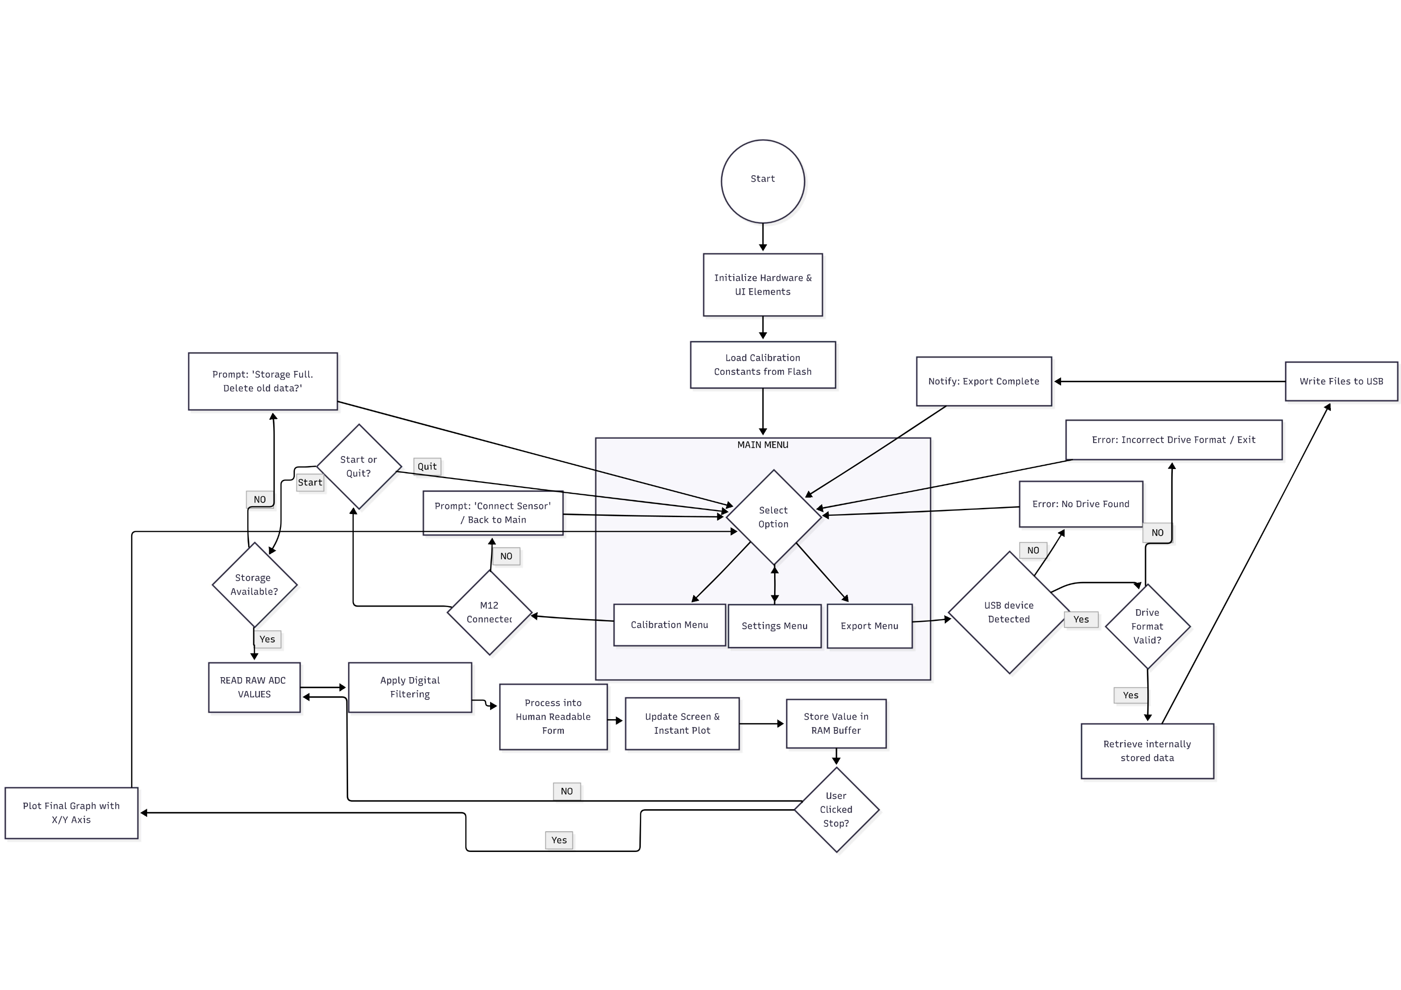

Figure 26: Full Programming Flow Chart

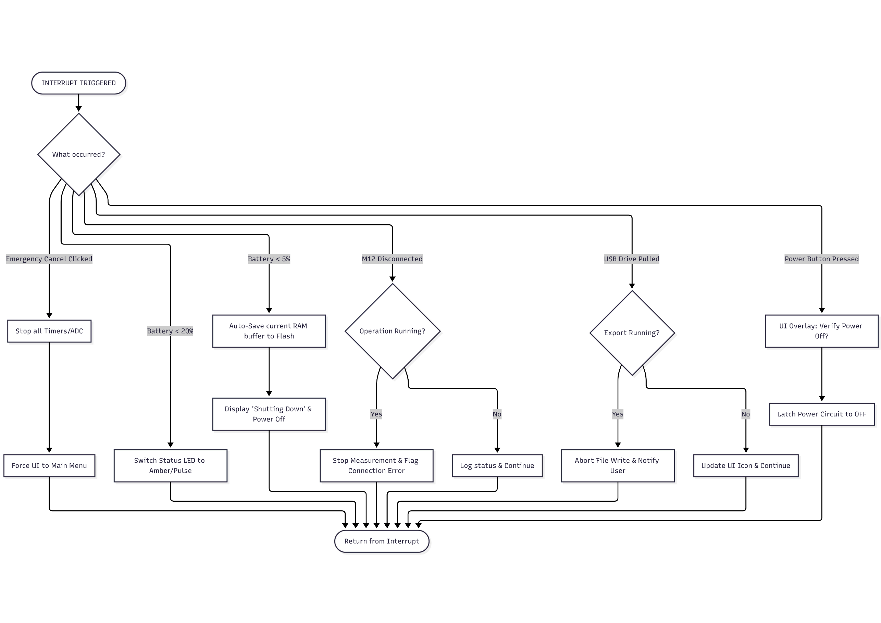

Figure 27: Interrupt Flow Chart

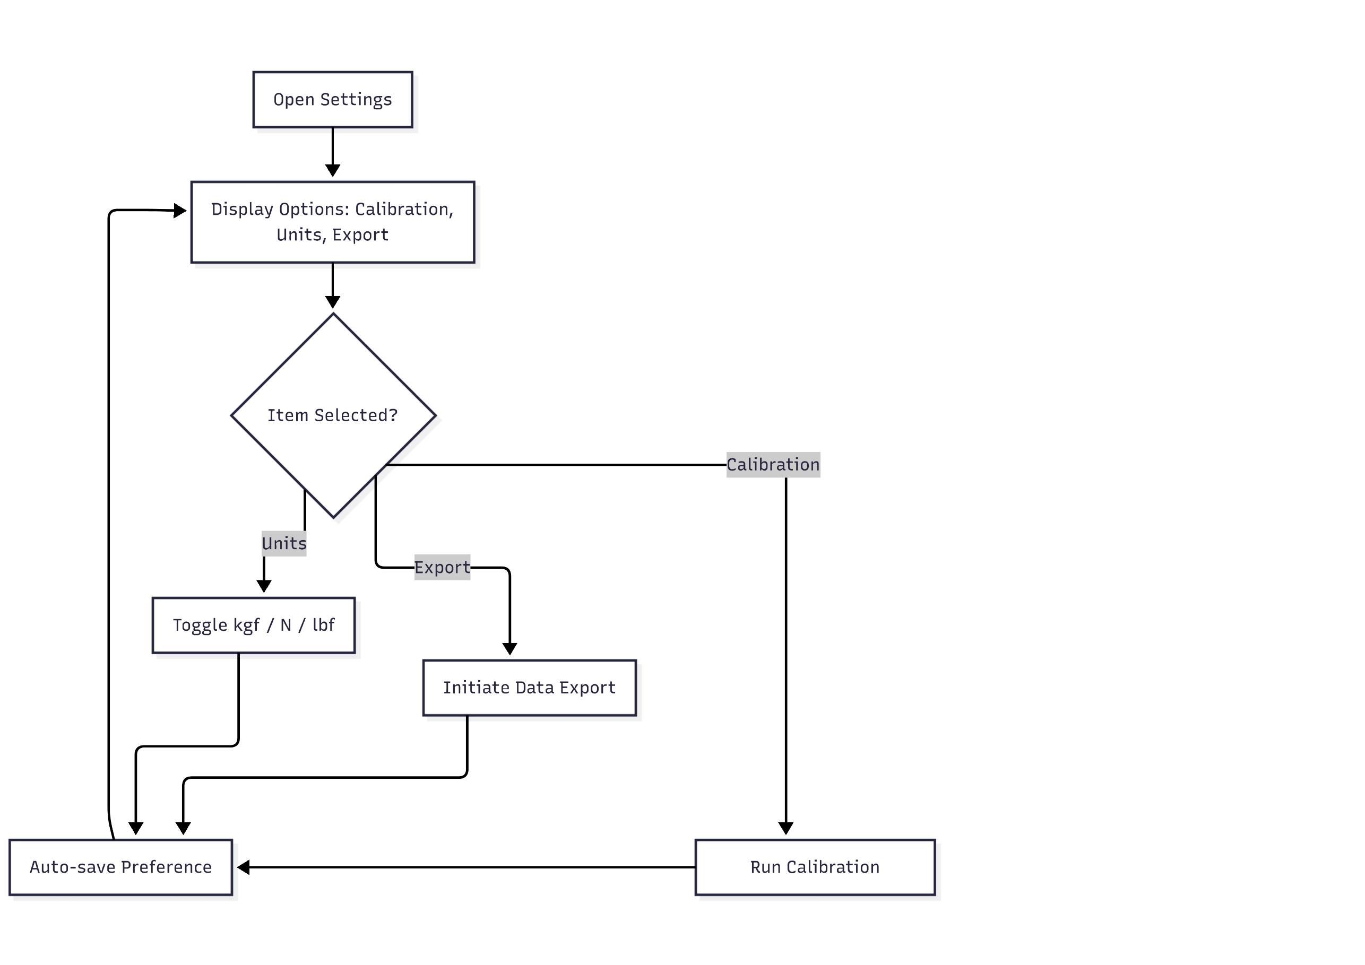

Figure 28: Settings Flow Chart

# Make or Buy Decision

## Criteria for Make or Buy Decision

A Make or Buy Decision was made for each component to determine whether it is more viable and economical to have the component custom manufactured or purchased from a vendor as a standard part or a Commercial off-the-shelf (COTS) solution. These decisions are documented in Table 21.

The details about the manufacturing process of the make parts are documented in Table 22. The requirements manuals for the buy parts are documented in Table 25 and Table 26. Some COTS parts may also need some simple modifications after purchasing and are thus classified as Buy & Modify and documented in Table 23.

This process was based on the following factors:

* Product Design Requirements
* Cost Efficiency
* Production Volume
* Design Complexity
* Project Schedule and Risk
* Quality Control
* Availability of standard parts on the market

## List of Make and Buy Parts

Table 21: Make and Buy Decisions for Each Component

|  |  |  |
| --- | --- | --- |
| **Component** | **Decision** | **Justification** |
| **Electrical** | | |
| Microcontroller (MCU) | Buy | Many COTS solutions meet the required specifications and complexity in designing an MCU is very high leading to delays. |
| Printed Circuit Board (PCB) | Make | To ensure all the design specifications are met, a PCB must be designed and manufactured. It will be based off the designs in 8. Measurement Chain and 10. Circuit Diagram. |
| Load Cell Connector | Buy & modify | To include the necessary load cell identification channel, the connector will need to be developed in house. |
| Load Cell Interface Port | Buy | There are many available COTS M12 connector ports which meet the IP67 requirements and can be attached to the PCB. |
| Noise and Low-pass Filter | Buy | All the components for the filters are available as COTS parts. Given the precision required for these components, developing such ICs in-house would add too much design complexity and require robust quality control. |
| Amplifier | Buy | COTS amplifier ICs meet requirements and are incredibly reliable, precise and cost effective. The design complexity and quality control necessary to ensure zero-drift and accurate gain are too high to justify in-house development. |
| Analog to Digital Converter (ADC) | Buy | It is more cost effective to purchase a COTS delta-sigma than develop one as they are very complex ICs. COTS ICs are also very feature rich including digital filtering and buffers. |
| Cell Excitation Regulator | Buy | COTS power regulation ICs are precise and low noise. Developing such devices in house would be too complex and time-consuming. |
| Touchscreen Display | Buy | Many COTS resistive touch screens are sufficiently robust to be used in factory and worksite conditions. Developing a custom display and touch screen layer is highly complex and unnecessary. |
| Push Button | Buy | Developing a button that meets IP67 requirements while being mechanically robust and durable is too complex and time-consuming. It is much more cost effective to purchase a COTS button. |
| LED light | Buy | COTS LED lights are incredibly cheap and reliable. |
| Internal Memory Module | Buy | COTS memory modules both on-board in the MCU and external chips are reliable and fast. |
| USB-A Port | Buy | USB-A ports are standard parts that are readily and widely available. They are compatible with USB drives that most people already have. |
| Power Regulator | Buy | COTS regulators which are low-noise and efficient are widely available. Designing such devices in-house would require too much quality control and testing. |
| USB-C Port | Buy | USB-C ports are standard parts that are readily and widely available. They are compatible with charging cables that most people already have. |
| Battery Charging Circuit | Buy | Many Li-Po charging circuits exist on the market as COTS ICs. These ICs are reliable, safe and fast. |
| Battery | Buy | Li-po battery development is highly complex and requires intricate manufacturing processes. While high-capacity batteries are readily available as COTS products. |
| Misc | Buy | Resistors, capacitors, inductors, transistors, connection terminals, wires are all widely available at Sufficient quality as COTS products. |
| **Mechanical** | | |
| Protective Carrying Case | Buy & modify | There are several COTS cases with IP67 ratings and shock absorption that can be used to house the product. Developing a custom case require extensive mechanical testing and is not cost effective. |
| Foam | Buy | The soft foam padding is a crucial for Components holding. It’s an available COTS material, providing the benefits of low cost and rapid availability. |
| 1-Panel Frame | Make | To make sure that the design meets its requirements a Panel Frame is holding the HMI interface and sealed by applying precise compression to a highly resilient gasket material..... |
| Internal Aluminium Frame | Make | Essential because aluminium’s high strength-to weight ratio provides a rigid structure to secure all internal components, including the battery and delicate electronics, protecting them from internal movement and external shock. |
| Misc | Buy | They are selected because the DIN standard ensures that every fastener and bracket is made with precise, repeatable dimensions and strength, guaranteeing consistent assembly quality across all units. |
| Load cells | Given | The Innovatest line of load cell products are already existing and their design and manufacturing are outside the scope of this project. |

# Technology Selection for Make Parts

## Make Parts Table

Table 22: List of Make Parts and Manufacturing Technology

|  |  |  |  |  |
| --- | --- | --- | --- | --- |
| Identification Number | Part | Material Details | Manufacturing Technology | Justification |
| 1 | Figure 29: **Printed** **Circuit** **Board** (PCB)    Figure 30: Routing on Front Side of PCB  Figure 31: Routing on Back Side of PCB | Material:   * Fibreglass substrate insulating dielectric * Copper foil for conductive layer * Gold pads for component footprint   Grade:   * FR-4 fibreglass * Electrodeposited copper for copper foil * Electroplated gold on component pads   Standard: IPC-2221  Reason:   * FR-4 has higher strength and durability than epoxy-based boards. It is also more cost effective than high strength Polymimide boards. * Copper has higher electrical and thermal conductivity than aluminium allowing for efficient signal transmission and heat dissipation. It is also less expensive than gold or silver and thus better for the foil which covers large surface area. * Plated gold is better for component connectors since it does not corrode or oxidize. This allows for reliable and long-lasting connections. | Blank Preparation:  The blank is a FR-4 board with deposited copper foil on both sides as well as an ultraviolet sensitive laminate. The blank is cut to size (100mmx90mm) before processing. The design only has components and tracks on the top and bottom layers of the board.  Chemical PCB Fabrication:  The blank is to undergo the following chemical processes according to IPC-2221 in this order:   1. Ultraviolet Treatment 2. Chemical Development 3. Acid Etching 4. CNC Drilling for holes 5. Electroless & Electrolytic Copper Deposition 6. Soldermask Application 7. Electroless Nickle Immersion Gold (ENIG) Surface Finish 8. Silkscreen Screen printing   The track sizes of the PCB are made to be a thickness ≥ 0.2mm to allow for the etching process to run smoothly while still not being cumbersome in routing connections.  All holes (screw holes, vias, plated through-holes) are made ≥ 0.2 mm to ensure Sufficient surface area for the copper deposition process. | FR-4 blanks with dual side copper foil and laminate are an industry standard and are available at any PCB manufacturing firm.  Chemical fabrication is chosen over traditional milling as it is faster for the given size, and it widely adopted by most PCB manufacturing firms.  Soldermask application is required to ensure the PCB to prevent oxidization of the copper tracks and prevent soldering from bridging the gaps between tracks. This is preferred over no solder mask as it will produce PCB that is longer lasting and easier to solder.  Using an ENIG surface finish over Hot Air Soldering Levelling (HASL) and Organic Solderability Preservative (OSP) allows for a more planar pads, higher performance and longevity. This justifies its use despite higher costs.  A silkscreen with component designators should be printed on so that each component can be placed in the correct footprint during assembly. |
| 2 | Figure 32: **PCB Mount** – hold the PCB in place    Figure 33: PCB Mount top view    Figure 34: PCB Mount 3D printer view with supports and bridging | Material: Polycarbonate Grade: General Purpose Polycarbonate ISO: 21305-1:2019  Reason: Higher glass transition temperature than ABS, more impact resistant than ABS, higher heat resistance, non-conductive unlike steel, lighter weight than metal counterparts. These properties are vital as this will support the PCB/Motherboard. | Additive Manufacturing: FDM 3D Printing.  For this the part must be oriented as shown in Figure 33, with the flat rectangular parallel to the surface. No supports are required, considering the small size of the part.  Because of the use of polycarbonate,  The minimum wall thickness in the part is 3 mm (The thickness of the clamp for the PCB), hence a maximum nozzle size of 1.5 mm must be used. An extrusion temperature of 260℃ - 310℃ is required.  As no bridging, no supports are used however the brim is still there to prevent warping. | This technology has been preferred over injection moulding, as considering for the projected 500 units over the 3 years, the speed is not a larger priority than the price which must be borne, which will be much higher for the mould. |
| 3 | Figure 35:**Battery Cradle** – To house the battery    Figure 36: Battery Cradle with Support for Manufacturing | Material: ABS Grade: Heat Resistant ABS ISO: 2580-1 ABS  Reason:  Does not reach glass transition temperature till 105℃. Has higher thermal shock resistance than aluminium. Much lighter than steel. Easier to print compared to Polycarbonate, or metals. | Additive Manufacturing: FDM 3D Printing.  For this the part must be oriented as shown in Figure 36, with the flat rectangular base parallel to the surface.  Because of the use of ABS, to prevent warping (corner of a print lift off the build plate) we must enclose the 3D printing chamber, to maintain a consistent temperature. Extruder temperature must be within 220℃ and 250℃.  The minimum wall thickness in the part is 1.6mm (The thickness of the hollow cylindrical legs), hence a maximum nozzle size of 0.8mm must be used. Due to the long flat base, normal supports are required, which can be seen in Figure 36. The flat area around is a brim to prevent warping. | This technology has been preferred over injection moulding, as considering for the projected 500 units over the 3 years, the speed is not a larger priority than the price which must be borne, which will be much higher for the mould. |
| 4 | Figure 37: **Panel frame**  Figure 38: Top view of panel frame      Figure 39: Orientations for 4-axis milling    Figure 40: Angled side view of side with holes | Material: Aluminium Grade: 5052 ISO: Al-Mg2,5  Lighter weight than steel, better corrosion resistance than 6061, more durable than plastic counterparts, more economical than 6061, good strengths to weight ratio.  Another motivation for using Aluminium 5052, for this part is because the “waste” cut out of this part is being used in the cable tray, which are being welded to other Aluminium 5052 parts. | CNC Milling:  The shape can be manufactured with index 4-axis milling from an aluminium box of minimum dimensions (295mmx295mmx18mm(h)). The milling will start with orientation showed in the top image in Figure39, with the side with side holes (Figure 40) parallel to axis of rotation (yellow) **.** First a square box of size 250mmx250mm, will be cut out from the centre. After this the features of the parts will be milled. After milling is completed in that orientation, the material will be rotated by 180° around the x-axis to machine the other side as shown in the top image in Figure 39. The part will also be rotated 90° and 270° to machine the holes on the sides. | 4-axis has been used over 3-axis milling, as for the 500 units the human labour cost for flipping the part manually will be higher, also because the part must be milled on 4 sides, if manual method is used it will take much longer and is also more likely to lead to errors/misalignment which will is not tolerable for the frame to maintain IP rating.  The cutout of the part has been done to reduce material wastage, and this block will be used for manufacturing 5. The 500 units is also to less to justify the mould costs, and hence no moulding method is used. |
| 5 | Figure 41: **Load Cell Compartment** – to house the load cells    Figure 42: Orientation for CNC Router (Start with orientation image on left and change to the right image orientation afterwards) | Material: EVA Foam Grade: Medium Density EVA  Shore hardness: 40-60 Shore C  Good balance of compressibility with durability, in between soft and hard foams, to remain more durable than soft foams, but more compressible than hard foams to keep the load cells safe. Lightweight  Better shock absorption than plastics. | CNC Contour cutting:  A simple 3-(primary)-axis CNC router cutting machine can be used to accurately make the cutouts for the load cells as well as the fillet corners on one side of the part from an initial foam box of dimensions minimum (95mm(w)x110mm(h)x293mm(l)) by placing it in the orientation shown in Figure 42 on the left.  For the fillets at the bottom and the draft angle the part must rotated 180° along its x-axis and placed as shown in Figure 42 on the right. | The 500 units are not enough to justify the use die cutting, which will fall to expensive. 3-axis milling with manual intervention will fall more economical. |
| 6 | Figure 43**: Aluminium Box Foam** - To keep it stable inside the case  A grey rectangular object with a black background  AI-generated content may be incorrect.  Figure 44: Aluminium Box Foam Front view  A grey rectangular object with black background  AI-generated content may be incorrect.  Figure 45: Aluminium box Side view | Material: EVA Foam Grade: Medium Density EVA  Shore hardness: 40-60 Shore C  Good balance of compressibility with durability, in between soft and hard foams, to remain more durable than soft foams, but more compressible than hard foams to keep the electronics safe. Lightweight. Better shock absorption than plastics. | CNC Contour cutting:  A simple 3-(primary)-axis CNC router cutting machine can be used to accurately make the cutouts for the load cells as well as the fillet corners on one side of the part from an initial foam box of dimensions minimum (295mm(w)x105mm(h)x295mm(l)) by placing it in the orientation shown in Figure 43.  For the fillets at the bottom and the draft angle the part must rotated 180° along its x-axis and placed as shown in Figure 44.  Finally, the foam should be placed flat with the hole seen in Figure 43 facing upwards, to remove material from the hole. | The 500 units are not enough to justify the use die cutting, which will fall to expensive. 3-axis milling with manual intervention will fall more economical. |
| 7 | Figure 46: **Basin** - to house all the electronics | Material: Aluminium  Grade: 5052  ISO: Al-Mg2,5  Lighter weight than steel, good workability for cold forming, better corrosion resistance and weldability than 6061 while remaining more economical, better durability than plastics.  The primary motivation behind using all parts with Aluminium 5052 is to have better welding between all parts. | Cold forming followed by CNC:  Backward cold forming extrusion will be used to create the open box like shape from billet of volume above the part volume of 276151.54 mm3. This may lead to minor fillets on the internal edges, which are tolerable.  4-axis index CNC milling will then be used for material removal near for the groove near the top, this with the screw through holes will be done per outside face by placing it on its side and then rotating it 90 degrees to do the next, till all 4 sides are machined. For each side the right side of basin must also be finished for better accuracy for better assembly.  The fillets on the lower external edges, if any can also be tolerated as component will be placed inside foam. | Backward cold forming has been chosen over only CNC milling, to minimize material wastage.  4-axis index CNC milling is required for the sharp groove depth and holes. The 2mm wall thickness will hard/impossible with sand casting, and 500 units is to less to justify initial costs of die casting. 4-axis is necessary over 3-axis, as the part must be machined on 4-sides. 5-axis is not necessary for the part, hence has been avoided to save costs. The tolerance of lower external edges has been made to save on cost for milling operation, as are not critical to the functionality of the product. |
| 8 | **Figure 47: Aluminium Frame** Figure **48**: Side view for manual cutting | Material: Aluminium  Grade: 5052  ISO: Al-Mg2,5  Better weldability and formability than 6061, more durable than plastic, lighter than steel.  The primary motivation behind using all parts with Aluminium 5052 is to have better welding between all parts. | Laser cutting, Welding:  2mm thick sheet of aluminium 5052, will be laser cut into 4 identical parts as shown in Figure **48**. The draft angle of 2 degree must be made. The laser will also make the holes for screws.  The 4 parts will then be welded using tig welding at the corners to make the frame as seen in Figure **47**. The areas to weld have been circled in red. Welding will be on the exterior. The welds will then be with ER5356, and after welding they will have manual finishing (grinding, sanding, etc) for a better surface finish. | CNC has been avoided, as too much material wastage, and the costs with laser cutting method will be much cheaper than CNC or even water jet cutting. 500 units is not enough to justify costs for a mould. TIG Welding is superior for thin sheets. Manual finishing is more economical. |
| 9 | Figure 49: **Panel**    Figure 50: Front view of Panel      Figure 51: Top View (Above) and Bottom view (Below) | Material: Aluminium  Grade: 5052  ISO: Al-Mg2,5   More corrosion resistant than and economical than 6061, better machinability than 3003. More durable than ABS, lighter weight than steel.  The primary motivation behind using all parts with Aluminium 5052 is to have better welding between all parts. | CNC Milling:  3-axis CNC milling will be used on some aluminium sheet of minimum dimensions 290mm(l)x290mm(w)x7mm(h). This will be first milled clamped in the orientation in Figure 51 (image on top). After completion of this face, it will be rotated 180 degrees along its longitudinal axis and milled clamped in orientation shown in same figure on the bottom. | CNC Milling was preferred over casting, as 500 units are not enough to justify cost of a die, and laser cutting has been avoided due to the presence of 3D cuts. CNC Milling will also give us high quality, for the part which is going to be exposed to the user. |
| 10 |   Figure52**: Cable tray**    Figure 53:Cable tray side view | Material: Aluminium  Grade: 5052  ISO: Al-Mg2,5  Better weldability than 6061, more economical than 6061, better machinability than 3003, more durable than plastic, lighter than steel.  The primary motivation behind using all parts with Aluminium 5052 is to have better weldability between all parts. | CNC Milling:  The block used here will be the block removed in 4. Out of that one block, 8 cable trays can be made by cutting that into half through, and each half into 4 equal length blocks. This will give us an aluminium block of 125mm(l)x62.5mm(w)x18mm(depth minimum) which is larger than this part (120mm(l)x50mm(w)x15mm(d)).  3-axis CNC milling will be used for this part, keeping the part vertically flat as shown in Figure 53 with the hollowing done from the top. | CNC Milling has been chosen, as the existing aluminium block removed from 4 can be shaped easily and precisely. |
| 11 |   **Figre 54: Foam Cut-out for the Top of Case** | Material: EVA Foam Grade: Medium Density EVA  Shore hardness: 40-60 Shore C  Good balance of compressibility with durability, in between soft and hard foams, to remain more durable than soft foams, but more compressible than hard foams to keep the load cells safe and screen. Lightweight.  Better shock absorption than plastics. | CNC Contour cutting:  A simple 3-(primary)-axis CNC router cutting machine can be used to accurately make the cutouts for the load cells as well as the fillet corners on one side of the part from an initial foam box of dimensions minimum. (295mm(w)x40mm(h)x295mm(l)).  A blank of convoluted foam should be used. | The 500 units are not enough to justify the use die cutting, which will fall to expensive. 3-axis milling with manual intervention will fall more economical.  Using convoluted foam allows for pressure distribution on the sensitive load cells and HMI components inside of the case. |

## Modifications to Buy Parts

Table 23: Modifications to Buy Parts

|  |  |  |  |
| --- | --- | --- | --- |
| Identification No. | Part | Modification technology | Justification |
| 12 | A grey plastic container with black background  AI-generated content may be incorrect.  Figure 55: **Lower Pelican Case** modifications  A white object with a black background  AI-generated content may be incorrect.  Figure 56: Side view of modifications | First mark both the ports precisely. M12 Pin connector - Drilling and reaming:  The hole will be drilled using a drill bit of maximum diameter of 11.75 mm. (Closer to 11.75 mm will save costs, but standard bit available can be used). This will be followed by reaming with reamer of 12mm diameter.  Slower drilling and reaming speeds should be used to avoid melting of Polypropylene.  USB-C Port – Drilling and filing Drill small holes in the corners of the USB-C port. Use hand nibbler tool to remove the excessive material between the holes.  Needle files will be used to get the shape precisely, by needling and testing the part fit to see if dimension is correct. | Drilling followed by reaming, allows us to have very precise holes for maintaining the IP ratings sound. Laser cutting has been avoided, as polypropylene (the material of the case) tends to melt and fuse during laser cutting, causes residues to overheat and smoke. Filing is required after material removal to maintain the IP rating sound. Filing allows us with more control while also remaining economical. |
| 13 | Figure 57: Drawing shown modification of **M12** | Soldering:  The SMD resistors will be soldered between the pins. One between 1 and 4, then another between 4-5. To get access to the pins the M12 connector will be opened. | Provides a strong mechanical and reliable electrical connection. |

## Assembling Individual Parts

Table 24: Assembly of Individual Parts

|  |  |  |  |
| --- | --- | --- | --- |
| Identification Number | Image | Parts | Assembling Procedure |
| A1 | PCB Assembly    THT Components  PCB  SMT Components  Figure 58: PCB and Components Exploded View | * PCB (1) * Electronic Components (See Table 20) | Steps:   1. Place the PCB (1) into a secured frame. 2. Using a stencil from the PCB manufacturing firm, spread solder paste across all of the pads on the PCB. (Using Sn96.5Ag3Cu0.5 solder paste) 3. Place the SMT electronic components on the top plane of the carefully using the designators and the silkscreen as a guide. 4. Place the PCB and its components into a reflow oven. 5. Heating phase 1: preheating up to 150°C at around 3°C/s 6. Heating phase 2: holding 150°C for around 100 seconds 7. Heating phase 3: heating to above the liquidus line at 217°C for around 60 seconds 8. Heating phase 4: cooling at around 3°C/s 9. Remove the PCB from the oven. 10. Hand solder the through-hole components (J3, BT1, C1 and C23 from Table 20) |
| A2 | Battery Cradle Assembly  A black and white object with a black band  AI-generated content may be incorrect.  2  Velcro  Figure 59: Battery Cradle Assembly Exploded View (left), assembled with Battery Ghost View(right) | * Battery Cradle (3) * Velcrow | Steps:   1. Insert the Velcro underneath the cradle through the longitudinal holes (parallel to long side of battery) 2. Wrap the Velcro around the cradle through the holes for it shown in Figure 59 on the left.   Battery will be placed afterwards as shown in Figure 59 on the right, with battery in ghost view to visualize. The battery will be stuck to the base with minimal glue.  Reasons:  The idea behind combination of glue and Velcro comes to prevent the battery from experiencing too much mechanical stress and while also so that it does not wobble causing stress from side panels if collided with the walls and noise. The motivation behind the minimal glue is also so that replacement is easy in case of degradation. |
| A3 | PCB Mount Assembly  2    M2 Screws x 4  1  Figure 60: Screwing PCB in PCB Mount    Figure 61: **PCB Mount Assembly** - Completed | * Assembled PCB (A1) * PCB Mount (2) * 4 x ISO 1580 M2 x 16 – 16 N Screws * 4 x ISO 4035 M2 – N Nuts | Steps:   1. Slide PCB into the frame, with the components side facing upwards. 2. Screw the PCB through the 4 holes into the mount   Reasons:  Easy replace if PCB faces issue, 4 x screw restrict movements of PCB within frame, else could lead to wear of the components faster. The open frame keeps ventilation, hence helping keep the components cooler. |
| A4 | Top panel and Tray Assembly    10  2  Figure 62: Welding assembly (Left), Welded Assembly (Right) | * Top panel (9) * Cable tray (10) | Steps:   1. Clean all surfaces to be welded thoroughly before beginning. In case of heavy contaminants use sanding paper. Else use only acetone. 2. 9 will be placed upside down as shown in Figure 62 (left) 3. 10 shall be placed within its designated area upside down as shown in Figure 62 (left). 4. TIG welding will be used to filet weld (radius 2mm) the 2 parts together 5. Manual grinding method, abrasive grinding to remove excess material.   Reasons:  TIG Welding is used instead of MIG, as it is better for thinner parts, reduces risk of porosity which is essential to keep the IP rating sound. |
| A5 | Top Panel Assembly    IP67 USB A  A4  Push Buttons  Figure 63: Insertion of Buttons, LED and USB-A Port  A computer screen with buttons and a square window  AI-generated content may be incorrect.  Figure 64: Completed Top Panel Assembly top view (left) and bottom view (right) | * Top panel and Tray Assembly (A4) * 2 x Buttons Threaded (with bolt) * USB-A port * 2 x M3x6 Screws * 2 x ISO 7092 Washer * LED threaded (with bolt) | Steps:   1. 2 x buttons, the LED and the USB A port will be screwed onto the board as seen in Figure 63.   Final assembly top and bottom view are visible in Figure 64 for a better understanding. |
| A6 | Basin and Battery Cradle Assembly  A2    4 x M3 Washers  2  4 x  M3 Screws  Figure 65: Section Isometric View for Battery Cradle Assembly (Cradle made translucent for visibility)  A grey box with a black object on it  AI-generated content may be incorrect.  Figure 66: Battery cradle assembled | * Basin (7) * Battery Cradle Assembly (A2) * 4 x ISO 7380 – M3 x 10 – 10N * 4 x ISO 4032 – M3 – W - N | Steps:   1. Place A2 on to the basin, 2. Put the M3 – W – N Nuts from the top into the respective holes and screw from underneath as shown in Figure 65.   Reasons: For battery no movement is tolerable hence screws are used. |
| A7 | Basin and PCB Mount Assembly  A6    A3  3M VHB 5952  Figure 67: PCB Mount Assembly, Isometric    Figure 68: Full Basin Assembled | * PCB Mount (A3) * Basin and battery cradle assembly (A6) * 3M VHB 5952 | Steps:   1. Place the 3M VHB 5952 on the basin side panel as shown in Figure after cleaning it with acetone 2. Place A3 on the 3M VHB 5952**,** press firmly and hold for a few seconds for the adhesive to properly stick as shown in Figure. Again, the contact surface PCB assembly must also be cleaned before placing.   Reasons:  As the PCB is very light weight, tape can be used instead of screws to save on weight. |
| A8 | Basin and Port assembly  13    M12 Gasket  A7  Figure 69: Assembly of M12 port into the Basin (PCB Mount hidden for clarity)    Figure 70: Assembled port - Basin made translucent for better view (PCB Mount hidden for clarity) | * Basin and PCB mount Assembly (A7) * Modified M12 Port (13) * M12 Gasket | Steps:  Place in the Gasket for the M12 port, followed by the M12 port as shown in to get an interference fit.  Reasons:  The gasket is required for an interference fit to remain an IP rating. |
| A9 | Basin and Gasket Assembly    Figure 71: Battery into the cradle    A8  Gasket  Figure 72: Gasket assembly | * Basin and Port Assembly (A8) * Battery * PVC Foam tape (Gasket) | Steps:   1. A7 will be placed flat with opening facing upwards and the battery will now be placed inside the battery cradle into the A2 (Battery Cradle) with some drops of glue placed onto the cradle surface, this final appearance can be seen in Figure 71. 2. PVC Foam tape will be placed around the basin exterior inside the grooves as shown in Figure 72.   Reasons:  The PVC Foam tape acts as an interference fit, helping maintain IP rating, |
| A10 | Basin and Frame Assembly  12 x M3 Washers    12 x M3 Screws  A9  2  Figure 73: Exploded view of assembling 8 and A8 together | * Aluminium frame (8) * Basin and Gasket Assembly (10) * 12 x ISO 7380 – M3 x 10 – 10N   12 x M3 Nuts   * 12 x ISO 7092 – M3 * 12 x ISO 4032 – M3 – W – N | Step:  8 will now be screwed into A9 as shown in Figure 73. |
| A11 | Assembled basin and panel    A5  A10  Figure 74: Assembling A10 onto A5 – Through TIG welding    Figure 75: Correct Orientation of A5 to be welded onto A10 | * Top panel Assembly (A5) * Basin and Frame Assembly (A10) | Step:  A5 will be placed flat upside down, and A10 will be welded onto its upside with a fillet weld of 2mm as shown in **Error! Reference source not found.**. The buttons should be in the corner with M12, the orientation can be seen in **Error! Reference source not found.**. You must align the things in the red circle.  Reasons: TIG Welding is preferred over MIG, as better for thin-walled parts such as here. |
| A12 | Final Electronics Housing Assembly  EDPM Foam Tape    LCD Screen  A11  Figure 76: Assembly the Screen and Seal onto Basin and Panel    Figure 77: Section view to show LCD Screen Orientation for assembl from bottom viewy | * Assembled basin and panel (A11) * EDPM Foam Tape * LCD Screen | Steps:   1. Plug the cables through the designated holes, as shown in Figure 77, onto the PCB 2. Place the LCD screen in its designated indent, as shown in **Error! Reference source not found.** and **Error! Reference source not found.**. 3. EDPM Foam tape will be added all around the screen as shown in **Error! Reference source not found.**.   Reasons: THE EDPM Foam tape allows for an interference fit to help maintain the IP rating. |
| A13 | Pelican case ports assembly  A grey plastic container with a black background  AI-generated content may be incorrect.  USB-C Port  12  Figure 78: Assembly of USB C port into Pelican Case (Hidden top panel and handle for simplicity)  A computer screen shot  AI-generated content may be incorrect.  Figure 79: Zoomed Front View USB-C Port | * Pelican case lower modified (12) * USB-C Port | Steps: |
| A14 | Panel Frame with Rivets  2  A square object with screws  AI-generated content may be incorrect.  12 x M4 x 10 Rivets  Figure 80: Panel frame and Rivets assembly | * Panel frame (4) * 12 x – M4 x 10 Rivet | Steps:  Place the rivets into the panel frame from below in the orientation shown in Figure 80. The inner cavity should face downwards. |
| A15 | Pelican Case with foams  11  A grey box with a square object  AI-generated content may be incorrect.  A13  P6  2  Glue here  Figure 81: Foam Assembly into Pelican case ports assembly | * Load Cell Compartment (5) * Aluminium Box Foam (6) * Pelican Case Ports Assembly (A13) * Foam for Top (11) | Steps:   1. Place 5 and 6 into the bottom of pelican case. The hole on 2 must align with hole in A13 2. Place 11 in the orientation as shown Figure 81 and glue it to the sealing of the box. |
| A16 | Panel frame and rivets into Pelican Case    4 x ST2.9 x 9.5 – C – N  A14  A15  Figure 82: Assembly of Panel Frame with rivets  A grey rectangular object with a black background  AI-generated content may be incorrect.  Figure 83: Top view of assembly | * Panel Frame with Rivets (A14) * Pelican case with foam (A15) * 4 x ISO 14585 ST2.9 x 9.5 – C – N | Steps:   1. Place A14 into A15 as shown in Figure 82. 2. Use ST2.9 to screw the A14 into A15 as shown in Figure 83. |
| A17 | Final electronics housing into the Pelican Case  A computer generated image of a machine  AI-generated content may be incorrect.  12 x ISO 7380 M4 x 12 - 12 N  O-Ring  A16  A12  Figure 84: Exploded view of final electronics assembly into pelican case | * Lower pelican case assembly (A16) * O-ring * 12 x ISO 7380 M4 x 12 – 12 N | Steps:   1. Place the O-ring and A12 into the panel frame as shown in Figure 84. |
| A18 | Final Assembly  A video game console with a screen  AI-generated content may be incorrect.  Figure 85: Final assembly with load cells | * Final electronics housing in pelican case (A17) * Load cells | Steps:  Place the load cells into the designated spots in the case. |

## Assembly of Entire Product

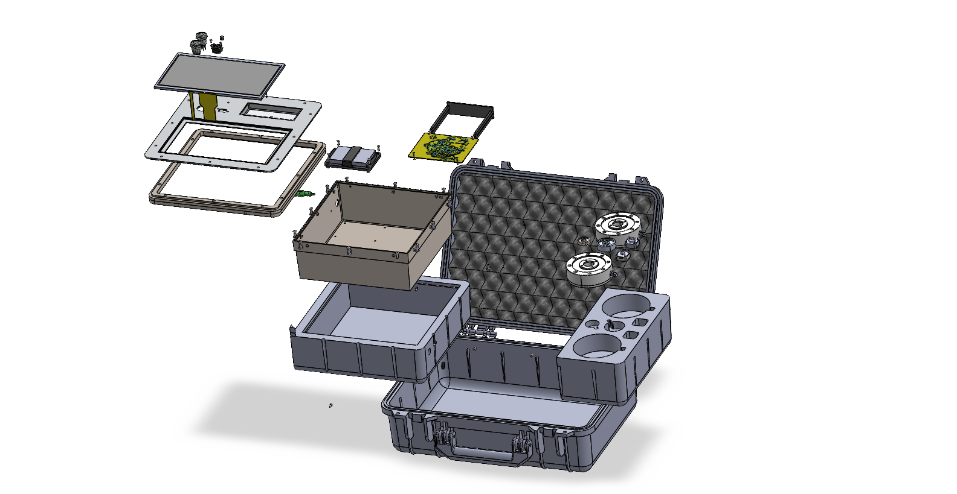

Figure 86: Exploded View of Entire Assembly

# Requirements Manuals for Buy Parts

## Requirements Manual for Electrical Parts

Table 25: Requirements Manual for Electrical Parts

|  |  |  |  |
| --- | --- | --- | --- |
| **Part** | **Qty.** | **Requirements** | **Justification** |
| Microcontroller (MCU) | 1 | 1. ≥ 28 GPIOs 2. ≥ 160 MHz clock speed 3. ≥ 1 ADC GPIOs and ≥ 1 ADC controller 4. 3.3 V operation 5. ≥ 32 kB SRAM 6. SPI interface 7. I²C interface 8. ≥ two 54-bit general purpose timers 9. USB 2.0 peripheral and USB boot mode 10. −40…85 °C operating temperature | 1. Enough interfaces to control all components (see 10) 2. Sufficient speed to process data, control systems, drive LCD in real-time. 3. To handle battery monitoring 4. To match digital power supply (see 10.3.1) 5. To run program with Sufficient speed 6. To communication with ADC, SPI flash memory and LCD 7. To communication with digital potentiometer 8. To handle timing operations in program 9. To be programmable via USB and ease in interface with USB A for data export 10. To operate in industrial factory conditions |
| Load Cell Connector | 1 | 1. 5-pins 2. M-12 A-coded 3. Shielded cable. 4. compatible with Innovatest load-cell wiring. 5. PVC/PUR jacket. 6. −25…80 °C temperature rating. 7. low-resistance copper conductors | 1. Sufficient for all load cell lines 2. IP67 rating and standardized 3. To reduce EMI noise 4. For product to be useable with Innovatest load cells 5. Suitable for harsh environments 6. To operate in industrial factory conditions 7. To reduce power loss and signal attenuation |
| Load Cell Interface Port | 1 | 1. Panel-mount 5-contact connector 2. IP67 rating 3. Rated current ≥ 1 A 4. screw-lock interface. | 1. Compatibility with load cell connector 2. To operate in industrial factory conditions 3. Safe margin for operating with load cells (10 - 30mA) 4. Secure mechanical connection |
| Noise and Low-pass Filter | 3 | 1. RC/passive low-pass filter. 2. Cutoff frequency 5–20 Hz. 3. 0.1% tolerance resistors and 1% tolerance capacitors | 1. Passive to ensure reliability and low power consumption 2. Aggressive filtering since signal is static 3. Accurate dimensioning of corner frequency |
| Amplifier  (Pre-amplifier + noise filtering) | 1 | 1. Resistor set gain (100) 2. > 124dB CMRR at Gain of 100 3. > 35 V/μs slew rate 4. > 10 Hz bandwidth at 100 gain 5. < 0.1 μV peak-to-peak noise (input) at gain of 100 6. > 5V single supply operation 7. 0.3 – 0.6 mA supply current 8. < 0.3 μV/°C offset drift 9. < 3 ppm/°C gain drift | 1. For pre-amplification (see 9.3.3) 2. To Sufficiently attenuate common noise from the load cell signals 3. Ensures quick measurement times 4. To ensure it operates within system bandwidth. 5. To stay within noise budget (see 10.6) 6. For compatibility with rest of measurement chain 7. To stay within power budget (see 10.4) 8. To minimize effects of high temperature environments 9. To minimize effects of high temperature environments |
| Amplifier (Variable Gain) | 1 | 1. 1 – 5 gain range 2. < 0.4 μV peak-to-peak noise 3. >5V single supply operation 4. 0.3 – 0.6 mA supply current 5. Zero-drift 6. 1024 step digital potentiometer | 1. To match load cell sensitivity 2. To stay within noise budget (see 10.6) 3. For compatibility with rest of measurement chain 4. To stay within power budget (see 10.4) 5. Sufficient precision to vary gain to match load cells with minimal error |
| Analog to Digital Converter (ADC) Chip | 1 | 1. 24-bit resolution 2. Programmable OSR 3. On-board digital filter 4. SPI 5. 5V reference mode 6. Buffered inputs 7. < 7μV peak-to-peak noise 8. 1 – 3 mA supply current 9. > 5V single analogue supply operation 10. 3.3V isolated digital supply 11. < 0.1 μV/°C offset drift 12. < 1 ppm/°C gain drift | 1. To ensure precision requirements are met 2. To adjust sampling rate (see 3.1.5) 3. To reject in-band noise and remove quantization noise (see 9.3.6) 4. For very fast data transfer speeds 5. To have Sufficient reading resolution 6. To reduce current draw and increase accuracy 7. To stay within noise budget (see 10.6) 8. To stay within power budget (see 10.4) 9. For compatibility with rest of measurement chain 10. So that level shifting the output is not needed 11. To minimize effects of high temperature environments 12. To minimize effects of high temperature environments |
| Cell Excitation Regulator | 2 | 1. One with 5V output and one with 10V output 2. > 80 % efficiency to keep power losses low 3. ≤ 0.1 mV noise at output 4. ≥ 30mA output current | 1. To be able to switch between 5V and 10V excitation 2. To keep power losses low 3. To stay within noise budget (see 9.5) 4. Sufficient current to excite load cells at both excitation voltages |
| Touchscreen Display | 1 | 1. 10.1″ TFT; 1024×600 resolution; ≥100 cd/m² brightness 2. 4-wire resistive touch. 3. ≥ 3.3 V supply 4. SPI/parallel interface. | * 1. Guarantees visibility in different lighting conditions during field use   2. Allows for precise control even with gloves   3. Compatibility with digital supply   4. High speed communication with MCU for good reactivity on display |
| Push Button | 2 | 1. Panel-mount 2. IP67 3. ≥1 A @ 5 VDC. 4. ≥30 000 electrical cycles 5. ≥30 000 mechanical cycles 6. RGB ring LED | * 1. To ensure it is secure in panel (see A4 in Table 24)   2. Suitable for harsh factory environments and to not compromise IP rating of the rest of the product   3. To handle complete battery load   4. To last 8-year service life   5. To last 8-year service life   6. To indicate power status to user |
| Non-volatile Memory Module | 1 | 1. ≥8 MB SPI Flash. 2. 3.3 V operation 3. ≥100k P/E cycles 4. ≥ 8 years data retention | 1. Sufficient storage and speed for data logging and export 2. For compatibility with digital supply 3. To last 8-year service life 4. To last 8-year service life |
| USB-A Port | 1 | 1. USB-A female 2. Panel mount 3. USB 2.0 compliant. 4. Insertion life ≥1500 cycles. 5. IP67 | 1. Standard and common connector for USB drives 2. To ensure it is secure in panel (see A4 in Table 24) 3. To allow for faster data transfer rate 4. To last 8-year service life 5. To operate in factory environment and not compromise IP rating of the rest of the product |
| Power Regulator | 2 | 1. 5.5 V and 3.3 V outputs. 2. ≤ 0.1 mV ripple for 5.5V 3. < 20 mV ripple for 3.3V 4. ≥500 mA continuous output | * 1. Dedicated regulators maintain stable 5.5 V and 3.3 V rails for analog and digital devices (respectively)   2. Low noise injection into sensitive measurement chain components (see 10.6)   3. Low noise, but less sensitive than analogue components   4. To ensure sufficient power output to drive all devices (see 10.4) |
| USB-C Port | 1 | 1. USB-C receptacle. 2. 5 V input. 3. mechanical retention ≥8 N. 4. IP67 housing and coating | 1. Compatibility with modern charging cables 2. Sufficient voltage to charge the Li-Ion battery 3. To ensure charging cable does not disconnect accidentally 4. To operate in factory environment and not compromise IP rating of the rest of the product |
| Battery Charging Controller | 1 | 1. 3.7V charging option designed for Li-Po 2. Charge current up to 1 A 3. Integrated OV/OC/OT protection | 1. Compatible with 3.7V Li-Po battery 2. For faster charging 3. To handle fluctuations and spikes from external power source |
| Battery | 1 | 1. Li-Po battery ≥7000 mAh. 2. Discharge capability ≥2 A. 3. IEC-compliant cell pack. | 1. High energy cell with Sufficient capacity to operate for 8 hours of measurements (see 10.4) 2. To ensure Sufficient output of power to supply entire circuit 3. For safety and regulatory concerns |
| Battery Terminal | 1 | 1. ≥2 A current rating 2. ≥10 mm2 wire size 3. ≥60N separation force | 1. To handle required output current 2. Low resistance and thus low power loss 3. To ensure connector does not come loose after assembly |
| LED | 1 | 1. Bi-colour 2. ≥ 50,000 hours life span 3. IP67 4. 4 mm diameter | 1. To indicate 2 states; charging and discharging (see 10.3.4) 2. To last 8-year service life 3. To operate in factory environment and not compromise IP rating of the rest of the product 4. For compatibility with product top panel (see A4 in Table 24) |
| Transistors (MOSFETs) | 6 | * 1. 3 N-Channel and 3 P-Channel   2. ≥ 5 V maximum drain-source voltage   3. ≥ 2 A maximum current   4. ≤ 10ns on-delay | 1. To ensure switching network is configured correctly (see 10.3.1) 2. To ensure MOSFETs can block the battery voltage effectively 3. To ensure MOSFET does not burn out from battery current 4. To ensure switching happens quickly and does not delay the circuit operations |
| Diodes | 3 | * 1. ≥ 2 A maximum forward current  1. ≥ 5V peak inverse voltage 2. < 1.0V voltage drop | 1. To ensure power can flow without burning out the diode 2. To ensure the diode can block main supply lines from reverse polarity 3. To ensure there is fewer potential losses |
| Optocoupler | 1 | * 1. ≥ 10V isolation voltage   2. ≥ 5Mbps speed | * 1. Sufficient isolation between MCU pin and power line   2. Sufficient speed for the circuit to power up quickly |
| Capacitors | 41 | 1. X7R ceramic capacitors 2. 3216[12] package size for capacitors ≥ 10 μF 3. 2012 package size for capacitors < 10 μF 4. Various values (see 10.7) for values | 1. Greater stability of nominal capacitance 2. Larger package size is better for bulk decoupling 3. Smaller package size is better for low inductance 4. Capacitance values chosen for specific purposes as described in 10. Circuit Design and 10.7 Component Specifications |
| Resistors | 30 | 1. Metal oxide resistors (or bet 2. Various values (see 10.7) for values | * + Better for higher current and voltage but lower precision   + Resistor values chosen for specific purposes as described in 10. Circuit Design and 10.7 Component Specifications |
| Precision Resistors | 18 | * 1. Thin film   2. ≤ 0.1% tolerance   3. Various values (see 9.7) for values | * 1. Have more precision than metal oxide resistors   2. Sufficiently precise for measurement chain   3. Resistor values chosen for specific purposes as described in 10. Circuit Design and 10.7 Component Specifications |
| Inductors | 4 | * 1. ≥ 2 A current rating   2. ≤ 10 % tolerance   3. Various values (see 9.7) for values | * 1. Sufficient current to handle power delivery   2. Inductances values is not required to be as precise as capacitors and resistors   3. Inductance values chosen for specific purposes as described in 10. Circuit Design and 10.7 Component Specifications |
| Wires | - | 1. ≥2 A current rating 2. ≥10 mm2 wire size | * 1. Sufficient current to handle power and signal for connections of M12, USB A, USB C and LED to the PCB.   2. Low resistance and thus low power loss |

## Requirements Manual for Mechanical Parts

Table 26: Requirements Manual for Mechanical Parts

|  |  |  |  |
| --- | --- | --- | --- |
| **Part** | **Qty.** | **Requirements** | **Justification** |
| Protective Carrying Case | 1 | * Polypropylene copolymer case. * IP67 rating. * pressure equalization valve. * internal dimensions ≥420×280×150 mm. * impact-resistant hinges and latches. | A rugged IP67 case protects the entire system from dust, water, shock, and transport damage during field deployment. |
| Button Head Screws | 12 | * M4 x 0.7 x 12 * ISO 7380 | Button head screws were selected because they provide Sufficient clamping force to securely fasten components while also applying uniform pressure to gaskets and O-rings, improving the overall IP sealing performance. M4 screws were used on the panel plate interface because this region has greater aluminium thickness and requires higher structural rigidity, making the larger fastener size more appropriate |
| 4 | * M3 x 0.5 x 10 * ISO 7380 |
| 12 | * M3 x 0.5 x 8 * ISO 7380 |
| 2 | * M3 x 0.5 x 6 * ISO 7380 |
| Slotted Pan Head Screws | 4 | * M2 x 16 * ISO 1580 | Slotted head screws were used to mount the PCB into the PCB Mount as they can easily thread into the 3D printed PLC. |
| Tapping Screws | 4 | * ST2.9 x 9.5 * ISO 14585 | Tapping screws were used to connect the panel frame to the case, as they can create threads directly in the plastic. |
| Rivet Nuts | 12 | * M4 x 10 * Length 9-10 mm | Rivet nuts were used to allow the head screws to clamp the panel plate securely, without having to tap the threads into the aluminium frame, this has the advantage of keeping the joints serviceable for longer. |
| Hex Nuts | 16 | * M3 x 0.5 * ISO 4032 | Hex nuts were used as they provide reliable, removable fastening where aluminium is too thin to be threaded. |
| 4 | * M2 x 0.4 * ISO 4035 |  |
| Washers | 12 | * M4 * ISO 7092 | Washers were used to distribute the load from the screws, preventing local deformations. They also help maintain the IP rating by ensuring even compression. |
| 16 | * M3 * ISO 7092 |
| Velcro Roll | 1 | * 20mm Wide | A Velcro strap will be used to secure the battery to the cradle while still allowing for it to expand without over constraining it. |
| PVC Foam Tape | 1 | * 10mm Wide * 2mm thick | PVC foam tape was used to seal small gaps around the screen because it compresses well, and provides good water and dust resistance. |
| 3M Scotch-Weld Epoxy DP420 | 1 | * 1 mm Thickness | A 1 mm layer of DP420 was used as it bonds well to aluminium and ABS, and provides great shear and peel strength. |

# Bill of Materials

## Electrical Bill of Materials

Table 27: Electrical Bill of Materials

|  |  |  |  |  |
| --- | --- | --- | --- | --- |
| Reference | Part Name  (Model No.) | Brand | Qty. | Specifications |
| BT1 | Battery Terminal (XT90PW) | AMASS | 1 | * 3.7V charging option designed for Li-Po * Charge current up to 1 A * Integrated OV/OC/OT protection |
| C1, C23 | Voltage Blocking Capacitor (ECA-1HM101B) | Panasonic | 2 | * 100μF * Aluminium electrolytic capacitors |
| C2, C4, C5, C6, C8, C10, C13, C15, C19, C20, C27, C33, C40 | Decoupling Capacitor (GRT21BR71H104KE01L) | Murata | 13 | * 0.1μF * X7R ceramic capacitors * 2012 package size |
| C3 | Filter Capacitor (GRM21BR71C105KA01K) | Murata | 1 | * 1μF * X7R ceramic capacitors * 2012 package size |
| C7, C9, C11, C12, C24, C25, C26, C28, C34, C35, C37, C41 | Decoupling Capacitor (GCJ31CR71C106KA15K) | Murata | 12 | * 10μF * X7R ceramic capacitors * 3216 package size |
| C14 | Filter Capacitor (GCM21BR71C335KA73L) | Murata | 1 | * 3.3μF * X7R ceramic capacitors * 2012 package size |
| C16 | Filter Capacitor (GRM21BR71C475KE51L) | Murata | 1 | * 4.7μF * X7R ceramic capacitors * 2012 package size |
| C17 | Filter Capacitor (GRM21BR71C334JA01L) | Murata | 1 | * 0.33μF * X7R ceramic capacitors * 2012 package size |
| C18 | Filter Capacitor (GRM219R71C474JA01D) | Murata | 1 | * 0.47μF * X7R ceramic capacitors * 2012 package size |
| C21 | Capacitor (GCQ0335C1H100JB01D) | Murata | 1 | * 10pF * MLCC * 0603 package size |
| C22 | Capacitor (GRJ21AR72E102KWJ1D) | Murata | 1 | * 10nF * X7R ceramic capacitors * 2012 package size |
| C29 | Capacitor (GRM21AR7LU332KW01D) | Murata | 1 | * 3.3nF * X7R ceramic capacitors * 2012 package size |
| C30, C31, C32, C36, C39 | Capacitor (GRM31CZ71C226ME15K) | Murata | 5 | * 22μF * X7R ceramic capacitors * 3216 package size |
| C38 | Capacitor (GRT21BR71C225KE01L) | Murata | 1 | * 2.2μF * X7R ceramic capacitors * 2012 package size |
| D1 | ESD Diode (SMF5V0A) | Vishay | 1 | * 50 A maximum forward current * 7.1V peak inverse voltage * 0.7V voltage drop |
| 19  (D2 in 10.3.1 Schematic) | Bi-colour LED Light Pipe  (PLTR5-8MM-PR1) | Bivar | 1 | * Bi-colour LED * IP67 |
| D3, D4 | Schottky Diode  (STPS340S) | STMicro-electronics | 2 | * 3A maximum forward current * 40V peak inverse voltage * 0.52V voltage drop |
| IC1 | Charging Controller (MCP73223) | Microchip | 1 | * 3.7V charging option designed for Li-Po * Charge 0.130 to 1.1 A * Integrated OV/OC/OT protection |
| IC2 | Voltage Reference (MAX6126) | Maxim Integrated | 1 | * 5V reference output * ±0.02% accuracy * 1.3μV peak-to-peak noise * 380 μA supply current * 0.4V voltage dropout at 5V reference * 3ppm/°C voltage temperature coefficient |
| L1, L3, L4 | Inductor  (8532R-09K) | Delevan | 3 | * + 4.7μH   + 4.01 A current rating   + 10 % tolerance |
| L2 | Inductor  (RLB0913-2R2K) | Bourns | 1 | * + 2.2μH   + 5.6 A current rating   + 10 % tolerance |
| Q1, Q2, Q5 | P-Channel MOSFET (AO3401A) | Alpha & Omega | 3 | * + P-channel   + 30V maximum drain-source voltage   + 4A maximum current   + 6.5ns on-delay |
| Q3, Q4, Q6 | N-Channel MOSFET (AO3400A) | Alpha & Omega | 3 | * + N -channel   + 30 V maximum drain-source voltage   + 5.7 A maximum current   + 3ns on-delay |
| R1, R2 | Resistor (TNPW08055K10FETA) | Vishay | 2 | * + 5.1kΩ   + Thin film resistors |
| R3 | Resistor (ROX050500KFKLB) | Vishay | 1 | * + 500kΩ   + Metal oxide resistors |
| R4 | Resistor  (271-24.3K-AP-RC) | Xicon | 1 | * + 24.3kΩ   + Metal film resistors |
| R5 | Resistor  (RSF200JR-52-200K) | YAGEO | 1 | * + 200kΩ   + Metal oxide resistors |
| R6, R9, R10 | Precision Resistor  (ERA-3AEB103V) | Panasonic | 3 | * + 10kΩ   + Thin film resistors   + 0.1% Tolerance |
| R12, R13, R15, R20, R21, R24, R25, R26, R30, R31, R34, R35 | Resistor  (RSF50SJT-52-10K) | YAGEO | 11 | * + 10kΩ   + Metal oxide resistors |
| R7 | Precision Resistor  (ERA-3AEB101V) | Panasonic | 1 | * + 100Ω   + Thin film resistors   + 0.1% Tolerance |
| R8 | Precision Resistor  (ERA-3ARB472V) | Panasonic | 1 | * + 4.7kΩ   + Thin film resistors   + 0.1% Tolerance |
| R11 | Precision Resistor  (ERA-3AEB4991V) | Panasonic | 1 | * + 4.99kΩ   + Thin film resistors   + 0.1% Tolerance |
| R14 | Resistor (RSPF12JT1K20) | SEI Stackpole | 1 | * + 1.2kΩ   + Metal oxide resistors |
| R16 | Resistor  (RSF100JT-73-1K) | YAGEO | 1 | * + 1kΩ   + Metal oxide resistors |
| R17, R22 | Resistor (RNF14BBE100K) | SEI Stackpole | 2 | * + 100kΩ   + Metal film resistors |
| R18 | Resistor  (RSF100JB-73-1M) | YAGEO | 1 | * + 1MΩ   + Metal oxide resistors |
| R19 | Resistor  (MFR-25FBF52-71K5) | YAGEO | 1 | * + 71.5kΩ   + Metal film resistors |
| R23 | Resistor (PTF6531K250BZWF) | Vishay | 1 | * + 31.25kΩ   + Metal film resistors |
| R27 | Resistor  (MFR-25FBF52-301K) | YAGEO | 1 | * + 301kΩ   + Metal oxide resistors |
| R28 | Resistor (PTF6540K000FZBF) | Vishay | 1 | * + 40kΩ   + Metal film resistors |
| R29 | Resistor  (MFR-25FBF52-4K87) | YAGEO | 1 | * + 4.87kΩ   + Metal film resistors |
| R32 | Resistor (MF1/4DC1742F) | KOA Speer | 1 | * + 17.4kΩ   + Metal film resistors |
| R33 | Resistor  (MFR-25FRF52-127K) | YAGEO | 1 | * + 127kΩ   + Metal film resistors |
| R36 | Resistor  (RSF-50JT-52-20K) | YAGEO | 1 | * + 20kΩ   + Metal oxide resistors |
| R37 | Precision Resistor  (ERA-3AEB104V) | Panasonic | 6 | * + 100kΩ   + Thin film resistors   + 0.1% Tolerance |
| R | Precision Resistor  (ERA-3AEBxxxV) | Panasonic | 6 | * + See Table 17 for values   + Thin film resistors   + 0.1% Tolerance |
| U1 | Instrumentation Amplifier (AD8421) | Analog Devices | 1 | * Resistor set gain (100) * 124dB CMRR at Gain of 100 * 35 V/μs slew rate * 10 Hz bandwidth at 100 gain * 0.07 μV peak-to-peak input noise at gain of 100 * 5V single supply operation * 2 – 2.3 mA supply current * 0.2 μV/°C offset drift * 1 ppm/°C gain drift |
| U2 | Operational Amplifier (OPA188) | Texas Instruments | 1 | * 1 – 5 gain range * 0.25 μV peak-to-peak noise * 2V to 18V single supply operation * 0.51 mA supply current * Zero-drift (0.03 μV/°C) |
| U3 | Delta-Sigma Analogue to Digital Converter (ADS127L21) | Texas Instruments | 1 | * 24-bit resolution * Programmable OSR * On-board digital filter (sinc, FIR and IIR chain) * SPI * 5V reference mode * Buffered inputs * ~6.395μV peak-to-peak noise * 1.24 – 1.43 mA supply current * 5V single analogue supply operation * 3.3V isolated digital supply * 0.05 μV/°C offset drift * 0.5 ppm/°C gain drift |
| U4 | Digital Potentiometer (MCP41U83) | Microchip | 1 | * 1024 steps * 20kΩ range * SPI communication * 2 μA supply current in standby * 15 mA supply current when being programmed |
| U5 | Optocoupler (PS9117A) | Renesas | 1 | * 3750V insolation voltage * 10 Mbps |
| U6 | 10V Voltage Regulator (TPS61170) | Texas Instruments | 1 | * 10 V output * ~0.1 mV ripple * Up to 300 mA continuous output * 90% efficiency at 10V output |
| U7 | 3.3V Voltage Regulator (TPS62130) | Texas Instruments | 1 | * 3.3 V output * 18 mV ripple at 3.3V and 0.7A * Up to 3A continuous output * 94% efficiency at 3.3V and 0.7A |
| U8 | 5V Voltage Regulator (TPS61099) | Texas Instruments | 1 | * 5V output * ~0.1mV ripple * Up to 300mA continuous output * 95% efficiency at 3.3V and 30mA output |
| U9 | 5.5V Voltage Regulator (TPS61089) | Texas Instruments | 1 | * 5.5 V output * ~0.1 mV * Up to 10A continuous output * 94% efficiency at 5.5V and 0.7A output |
| U10 | Non-volatile Memory (W25Q128JVS) | Winbond | 1 | * 16 MB SPI Flash. * 2.7 to 3.6 V operation * >100k P/E cycles * > 20 years data retention |
| U11 | Microcontroller  (ESP32-P4) | Espress-if | 1 | * 55 GPIOs * 360 MHz clock speed * 25 ADC GPIOs and 2 ADC controller * 3.3 V operation * 32 kB SRAM * SPI interface * I²C interface * Four 54-bit general purpose timers * USB 2.0 peripheral and USB boot mode * −40…85 °C operating temperature |
| 1 | Printed Circuit Board | Würth Elektronik | 1 | * FR-4 substrate * Copper foil * ENIG finish * Solder mask and silkscreen lamination |
| 13 | M12 Load Cell Cable (77 2529 0000 50705-0200) | Binder | 6 | * 5-pins * M-12 A-coded * Shielded cable * Four wires available to connect to Innovatest load cells * PVC/PUR jacket. * −25…80 °C temperature rating. * low-resistance copper conductors * 28 AWG |
| 14  (U12 in 10.3.1 Schematic) | TouchScreen/SPI Touch Controller  (ER-TFT101-1) | EastRising | 1 | * 10.1″ TFT; 1024×600 resolution * 150 cd/m² brightness * 4-wire resistive touch. * 3.3 V supply * SPI/parallel interface. * 120mA backlight current |
| 15  (SW1, SW2 in 10.3.1 Schematic) | Push Buttons (P19TFRGBPOWER) | Metzler | 2 | * Panel-mount * IP67 * Up to 3A @ 250 V * >100,000 electrical cycles * >1,000,000 mechanical cycles * RGB ring LED |
| 16 (J1 in 10.3.1 Schematic) | M12 5-pin  (ABQEHI) | Phoenix Contact | 1 | * 5-pins * M-12 A-coded * Shielded terminal * −25…80 °C temperature rating. * low-resistance copper conductors |
| 17 (J2 in 10.3.1 Schematic) | USB A  (SS-52200-001) | Stewart Connector | 1 | * USB-A female * Panel mount * USB 2.0 compliant. * Insertion life 1500 cycles. * IP67 |
| 18 (J3 in 10.3.1 Schematic) | USB C  (SS-52400-012) | Stewart Connector | 1 | * USB-C receptacle. * 5 V input. * mechanical retention 9 N. * IP67 housing and coating |
| 20 | Battery  (YDL866898) | YDL | 1 | * Lithium Polymer * 3.7V * 7200mAh * Up to 2.5A discharge current * IEC-compliant |
| 21 | 150 gf Load Cell  (A151) | Innovatest | 1 | * 3.0 mV/V @ 150gf * 350Ω bridge resistance * ≥500MΩ insulation resistance |
| 22 | 2 kgf Load Cell  (C202) | Innovatest | 1 | * 2.35 mV/V @ 2kgf * 350Ω bridge resistance * ≥500MΩ insulation resistance |
| 23 | 20 kgf Load Cell  (E20K) | Innovatest | 1 | * 2.7 mV/V @ 20kgf * 175Ω bridge resistance * ≥500MΩ insulation resistance |
| 24 | 45 kgf Load Cell  (D45K) | Innovatest | 1 | * 3.0 mV/V @ 45kgf * 350Ω bridge resistance * ≥500MΩ insulation resistance |
| 25 | 250 kgf Load Cell  (F250K) | Innovatest | 1 | * 3.25 mV/V @ 250kgf * 175Ω bridge resistance * ≥500MΩ insulation resistance |
| 26 | 3000 kgf Load Cell  (F3000K) | Innovatest | 1 | * 2.8 mV/V @ 3000kgf * 175Ω bridge resistance * ≥500MΩ insulation resistance |

## Mechanical Bill of Materials

Table 28: Mechanical Bill of Materials

|  |  |  |  |  |
| --- | --- | --- | --- | --- |
| Position Number | Part Name | Material | Qty | Standard[13] |
| 2 | PCB Mount | General Purpose Polycarbonate | 1 | ISO 21305-1:2019 |
| 3 | Battery Cradle | Heat resistant ABS | 1 | ISO 2580-1 ABS |
| 4 | Panel Frame | 5052 Aluminium | 1 | ISO: Al-Mg2,5 |
| 5 | Load Cell Compartment | Medium Density EVA Foam | 1 | ISO 7214 1998 |
| 6 | Aluminium Box Foam | Medium Density EVA Foam | 1 | ISO 7214 1998 |
| 7 | Electronics Basin | 5052 Aluminium | 1 | ISO: Al-Mg2,5 |
| 8 | Aluminium Frame | 5052 Aluminium | 1 | ISO: Al-Mg2,5 |
| 9 | Panel | 5052 Aluminium | 1 | ISO: Al-Mg2,5 |
| 10 | Cable Tray | 5052 Aluminium | 1 | ISO: Al-Mg2,5 |
| 11 | Top Foam | Medium Density EVA Foam | 1 | ISO 7214 1998 |
| 12 | Pelican Case | Polypropylene | 1 | - |
| 27 | M4 x 0.7 x 12 Button Head Screws | stainless steel A2 | 12 | ISO 7380 |
| 28 | M3 x 0.5 x 10 Button Head Screws | stainless steel A2 | 4 | ISO 7380 |
| 29 | M3 x 0.5 x 8 Button Head Screws | stainless steel A2 | 12 | ISO 7380 |
| 30 | M3 x 0.5 x 6 Button Head Screws | stainless steel A2 | 2 | ISO 7380 |
| 31 | M2 x 0.4 x 16 Slotted Pan Head Screw | stainless steel A2 | 4 | ISO 1580 |
| 32 | ST2.9 x 9.5 Tapping Screws | stainless steel A2 | 4 | ISO 14585 |
| 33 | M4 x 0.7 x 9.2 Rivet Nuts | stainless steel A2 | 12 | DIN 7337 |
| 34 | M3 x 0.5 Hex Nuts | stainless steel A2 | 16 | ISO 4032 |
| 35 | M2 x 0.4 Hex Nuts | stainless steel A2 | 4 | ISO 4035 |
| 36 | M4 Washers | stainless steel A2 | 12 | ISO 7092 |
| 37 | M3 Washers | stainless steel A2 | 18 | ISO 7092 |
| 38 | O-ring | Silicone Rubber | 1 | ISO 3601 |
| 39 | Seal for Screen Bezel | PVC Foam Tape | 1 | ISO 29864 |
| 40 | Aluminium Frame Gasket | PVC Foam Tape | 1 | ISO 29864 |
| 41 | USB C Gasket | Built into bought product | 1 | ISO 29864 |
| 42 | M12 Gasket | PVC Foam Tape | 1 | ISO 29864 |
| 43 | Velcro Roll | Velcro | 1 | - |

# Production Planning

## Production Inputs

### Production Assumptions

Some assumptions have been made regarding the calculations in this section, these include:

1. No major technical failure, with machines or powers (which can cease production for extended periods of time) in the manufacturing and assembly process
2. No human failure, such as failed production (e.g. incorrectly welded, damage)
3. 100% human resource availability (no employee holiday etc.)
4. 100% production yield rate – no make parts are incorrectly manufactured
5. No shipment time – shipment is instantly available
6. All machines are ideally available for the same time as employees minus a 30-minute break.
7. A single worker can only work one shift per day

### Production Target

The production target for the first 3 years is set as 500, this distribution will not be even, and will be as such:

Table 29: Production targets for three years

|  |  |  |  |
| --- | --- | --- | --- |
| Year | Production Target | Accumulated Units | Reasoning |
| 1 | 150 | 150 | For the first two years, production has been kept relatively low, so in case of problems with manufacturing the process can be improved, or in case of poor response from market, production halted to minimize losses. |
| 2 | 150 | 300 |
| 3 | 200 | 500 | By year three, the company has a better picture of the product so can start ramping up production. |

### Working days

Naturally, each year has holidays, which should be accounted for production planning, to estimate how many units must be produced per time unit, here is an overview of how many working days there are in a year where production can continue and how many products must be produced per week.

In Germany three general working structures can be considered, 2-day weekends, 1-day weekends or continuous production with no holidays, however that is only permitted legally for products which technically require uninterrupted production, which is not the case for the product hence calculations omitted.

Numbers of days in a year (assuming non-leap year): 365 days

Table 30: Target production per unit time calculations

|  |  |  |
| --- | --- | --- |
| Field | Considering 2-day weekends | Considering 1-day weekend |
| Weekend holidays | 52 weeks x 2 days/weeks  = 104 days | 52 weeks x 1 day/weeks  = 52 days |
| Public holidays[14] | 9 days | 9 days |
| Working days (Dyear) | 365 days – (104 days+9 days)  = 252 days | 365 days – (52 days+9 days)  = 304 days |
| Target production per day  (years 1 and 2) | 150 units / 252 days = 0.5952 units/day | 150 units / 304 days = 0.4934 units/day |
| Target production per week  (years 1 and 2) | 0.5952 units/day x 5 days/weeks  = 2.976 units/week ≈ 3 units/week | 0.4934 units/day x 6 days/weeks  = 2.96 units/week ≈ 3 units/week |
| Target production per day  (year 3) | 200 units / 252 days = 0.7937 units/day | 200 units / 304 days = 0.6579 units/day |
| Target production per week  (year 3) | 0.7937 units/day x 5 days/weeks  = 3.968 units/week ≈ 4 units/week | 0.6579 units/day x 6 days/weeks  = 3.947 units/week ≈ 4 units/week |

Considering the minimal change in units produced per day or week in 5 or 6 working days, it is best to go for 5 days working, to save on costs of another day on employees and machinery (variable costs). Thus, we will use a 5-day work week.

### Takt Time

Considering the working shifts and production target, the Takt Time can now be calculated using the Equation (18):

|  |  |
| --- | --- |
| $$T_{takt}=\frac{D_{year}⋅N_{shift}⋅t_{shift}}{U_{year}^{total}}$$ | (18) |

Where $T_{takt}$ is the takt time [seconds], $D_{year}$ working days in a year [days/year], $N_{shift}$ is the number of shifts in a working day [shifts/day], $t_{shift}$ is the shift working time [seconds/shift] and $U_{year}^{total}$ is the production volume target [units/year]

Together, the working days, shifts and time per shift make the yearly working time ($t_{w}$).

For the 5-day work week, we get $D_{year}=252\frac{days}{year}$. We also assume there to be 1 shift in a day ($N_{shift}=3\frac{shifts}{day}$) of around 7.5 hours each ($t_{shift}=27000\frac{s}{shifts}$) accounting for 30-minute break.

Hence, we get the following takt times for each production year:

* 1. Year 1: or $756\frac{min}{unit}$
  2. Year 2: $45360\frac{s}{unit}$ or $756\frac{min}{unit}$
  3. Year 3: $34020\frac{s}{unit}$ or $567\frac{min}{unit}$

For more details on the calculations, see Appendix D: Production Planning Calculations.

## Equipment Outline

### List of Machinery

Table 31: Machine Selection for Production

|  |  |  |  |
| --- | --- | --- | --- |
| Machine | Technical Requirements | Cost per Unit (Euros) | Selected Machine |
| 3D Printer | |  |  | | --- | --- | | Printing Technology | FDM | | Build Volume | 250 × 210 × 220 mm | | Layer Resolution | 0.05–0.3 mm adjustable | | Nozzle Diameter | 0.4 mm (standard) | | Materials | ABS | | Heated Bed | 100–120°C bed | | Tolerances | ±0.2–0.4 mm | | Filament Diameter | 1.75 mm (standard) | | Slicing Software | Must support rafts, supports and custom infill | | 800 | **Prusa i3 MK4** |
| 4-Axis CNC Milling Machine | |  |  | | --- | --- | | Axes | 4-axis simultaneous interpolation  (X/Y/Z + rotary A) | | Work Envelope | ≥ 300 × 300 × 200 mm | | Spindle Speed | 10,000–24,000 rpm | | Spindle Power | 2–7 kW | | Tool Changer | 6–12 ATC minimum | | Accuracy | Positioning: ±0.01 mm, Repeatability: ±0.005 mm | | Materials | Aluminium 5052 | | Table | T-slot or vacuum | | Coolant | Flood or minimum-quantity lubrication (MQL) | | 70000 | **Haas Automation**  **4-Axis CNC** |
| 3-Axis CNC Contour Machine | |  |  | | --- | --- | | Axes | X/Y/Z with contouring capability | | Work Envelope | ≥ 400 × 400 × 100 mm | | Cutting Speed | Suitable for foam cutting at 5,000–20,000 mm/min | | Spindle Speed | 10,000–20,000 rpm | | Tooling | Ball-end mills, foam cutters, V-bits | | Accuracy | ±0.1 mm (foam tolerances are low) | | Dust Management | Vacuum extraction required | | 50000 | **Datron neo** |
| 3-Axis CNC Milling Machine | |  |  | | --- | --- | | Axes | X/Y/Z | | Spindle Speed | 8,000–15,000 rpm | | Spindle Power | 1.5–5 kW | | Tool Capacity | 6–10 tool turret | | Work Envelope | ≥ 250 × 250 × 150 mm | | Accuracy | Positioning ±0.02 mm, repeatability ±0.01 mm | | Materials | Aluminium 5052 | | Coolant | Flood coolant or MQL | | Fixturing | Vise, clamps, soft jaws | | 9000 | **Tormach PCNC 440** |
| Extrusion Press | |  |  | | --- | --- | | Press Tonnage | 300–1,000 tons for aluminium 5052 profiles | | Die Compatibility | Standard extrusion dies, up to 150 mm diameter | | Output Speed | 1–5 m/min | | Heating | Billet heater: 400–500°C | | Puller | Automatic profile puller | | Cooling | air-cooled table | |  | Outsourced to SMS Group |
| Drill | |  |  | | --- | --- | | Drill Type | Hand drill | | Diameter Range | 2mm and 11.75mm | | Material | Polypropylene | | 150 | **Bosch UniversalImpact 18V** |
| Reamer | |  |  | | --- | --- | | Reamer Type | Hand reamer | | Diameter Range | 12mm | | Material | Polypropylene | | Tolerance | H7 hole finishes | | 30 | **Gühring H7** |
| Laser Cutter | |  |  | | --- | --- | | Laser Type | Fiber Laser (1064nm wavelength) | | Bed Size | ≥ 600 × 400 mm | | Supported Materials | Aluminum 5052 | | Cutting Speed | 10–50 mm/s (2mm thickness) | | Cooling | Integrated water cooling | | Ventilation | Fume extractor | | Precision | ±0.1 mm | | 40000 | **HPC Minim PRO Fibre Metal Cutter** |
| Welding Plant | |  |  | | --- | --- | | Welding Process | TIG | | Current Range | 80–200 A | | Current Type | AC/DC | | Torch | Air-cooled torch | | Gas | Argon 99.99% | | High Frequency Start | Required (clean arc start) | | Foot Pedal | Recommendation for precision | | Filler Material | ER5356 | | 500 | **Stahlwerk AC/DC TIG 200 Puls ST** |
| Automated Pick-and-Place Machine | |  |  | | --- | --- | | Placement Rate | **>** 5,000 CPH | | Feeder Count | **≥** 30 feeders | | Component Types | Min 0603 components | | Vision System | Bottom camera + fiducial alignment | | Board Size | ≥ 120 × 150 mm | | Accuracy | ±0.05–0.1 mm | | 3500 | **NEODEN YY1** |
| Reflow Oven | |  |  | | --- | --- | | Zones | 2–3 heating zones | | Throughput | > 2 boards/hour | | Max Temp | 225–260°C | | Profile Control | PID-controlled multi-zone ramp/soak/spike | | Conveyor Type | Mesh or edge-rail | | 360 | **iTECH RF‑A350** |
| Hand Soldering Station | |  |  | | --- | --- | | Power | 60–120 W | | Temp Range | 150–450°C | | Tips | Variety: conical, chisel, knife | | ESD Safe | Required | | Stand & Cleaning | Brass wool + sponge | | Hot Air Tool | Option for rework | | Magnifier | 3–5× inspection lens or microscope | | 200 | **Weller WE 1010 Löstation** |

### Machinery Calculations

Table 32: Machine Efficiencies and Available Time

|  |  |  |  |  |
| --- | --- | --- | --- | --- |
| Machine | OEE | Ideal Machine Availability [minutes/day] | Real Machine availability [minutes/day] | Real Machine availability [minutes/year] |
| 3D Printer | 55% | 450 | 247.5 | 62370 |
| 4-Axis CNC Milling Machine | 70% | 450 | 315 | 79380 |
| 3-Axis CNC Contour Machine | 65% | 450 | 292.5 | 73710 |
| 3-Axis CNC Milling Machine | 70% | 450 | 315 | 79380 |
| Extrusion Press | 90% | 450 | 405 | 102060 |
| Drill | 60% | 450 | 270 | 68040 |
| Reamer | 50% | 450 | 225 | 56700 |
| Laser Cutter | 70% | 450 | 315 | 79380 |
| Welding Plant | 50% | 450 | 225 | 56700 |
| Automated Pick-and-Place Machine | 75% | 450 | 337.5 | 85050 |
| Reflow Oven | 85% | 450 | 382.5 | 96390 |
| Hand Soldering Station | 35% | 450 | 157.5 | 39690 |

The values of the Overall Equipment Efficiencies (OEE) were selected based on factors such as set-up time and complexity, reliability, performance and operation. The largest factor causing low OEE is manual processes such as drilling, reaming welding and hand soldering.

## Part Production Time

Table 33 shows the estimate production times for each part accounting for both processing time as well as setup. The total production time for each piece was then expanded to get the total production time for the first year.

This table also shows that all parts have a production time much smaller than the calculated Takt Time. However, the sum of all production times (assuming parts manufactured in series) is 1032 min/unit which is larger than the 756 min/unit takt time. This means that parts should be manufactured in parallel.

All calculations can be found in Appendix D: Production Planning Calculations.

Table 33: Production Times per Part

|  |  |  |  |  |  |  |
| --- | --- | --- | --- | --- | --- | --- |
| Part | Process(s) | Processing Time [min/unit] | Setup Time [min/unit] | Production Time Per Unit [min/unit] | Production Volume [units/year] | Total Production Time [min/year] |
| Printed Circuit Board | Etching, Screen printing | 102 | 15 | 117 | 150 | 17550 |
| PCB Mount | 3D Printing | 193 | 2 | 195 | 150 | 29250 |
| Battery Cradle | 3D Printing | 202 | 5 | 207 | 150 | 31050 |
| Panel Frame | 4-axis CNC Milling | 30 | 16 | 46 | 150 | 6900 |
| Load Cell Compartment | 3-axis CNC Contour | 35 | 10 | 45 | 150 | 6750 |
| Aluminium Box Foam | 3-axis CNC Contour | 60 | 15 | 75 | 150 | 11250 |
| Electronics Basin | Backward Extrusion and 4-axis CNC Milling | 74 | 60 | 134 | 150 | 20100 |
| Aluminium Frame | Fiber Glass Laser cutting and Manual Welding | 40 | 30 | 70 | 150 | 10500 |
| Panel | 3-axis CNC Milling | 40 | 25 | 65 | 150 | 9750 |
| Cable Tray | 3-axis CNC Milling | 20 | 10 | 30 | 150 | 4500 |
| Top Foam | 3-axis CNC Contour | 8 | 5 | 13 | 150 | 1950 |
| Lower Pelican Case | Manual Drilling and Reaming | 10 | 10 | 20 | 150 | 3000 |
| M12 Load Cell Cable | Soldering | 10 | 5 | 15 | 150 | 2250 |

## Machine Allocation

The number of machines necessary to meet the Production Target can be calculated using Equation (19).

|  |  |
| --- | --- |
| $$No. of Machines=\frac{Required Production Time}{Machine Availability}$$ | (19) |

To determine the required production time, the production times for relevant parts were summed up. Special care was taken when estimating the required production time for the welding plant, automated pick-and-place machine, reflow oven and hand soldering station as they are used during the assembly process and hence assembly times from Table 35 were included. The results are shown in Table 34.

Table 34: Machine Number Estimation

|  |  |  |  |
| --- | --- | --- | --- |
| Machine | Required Production Time [min/year] | Machine Availability [min/year] | No. of Machines |
| 3D Printer | 60300 | 62370 | 1 |
| 4-Axis CNC Milling Machine | 24450 | 79380 | 1 |
| 3-Axis CNC Contour Machine | 19950 | 73710 | 1 |
| 3-Axis CNC Milling Machine | 14250 | 79380 | 1 |
| Extrusion Press | 2550 | 102060 | 1 |
| Drill | 2100 | 68040 | 1 |
| Reamer | 2400 | 56700 | 1 |
| Laser Cutter | 3750 | 79380 | 1 |
| Welding Plant | 11550 | 56700 | 1 |
| Automated Pick-and-Place Machine | 1650 | 85050 | 1 |
| Reflow Oven | 3075 | 96390 | 1 |
| Hand Soldering Station | 3750 | 39690 | 1 |

## Assembly

### Assembly Stations

The product consists of 13 individual make/modify parts and various buy parts. All these must be assembled step by step, in an efficient procedure to keep the cost at a minimum, thus process has been split up into these assembly stations. The assemblies can be seen in more detail in Section 13.3. The timings must be kept underneath the takt time calculated in Section 16.1.4. Some assemblies are interdependent; these dependencies are seen in Figure 87.

Table 35: List of Assembly Stations

|  |  |  |  |  |  |
| --- | --- | --- | --- | --- | --- |
| Assembly Station | Sub assembly station | Parts assembly[15] | Assembly Process | No. of Machines | Total Time (mins) |
| Line 1 – Basin Assembly | Line 1.1 – PCB Assembly (A1) | Part 1 and all electrical components (Table 27, except USB C and M12 port) | Place solder paste using stencil  Place all components (Automated pick and place machine)  Solder (Reflow oven) | 1 | 50 |
|  | Line 1.2 – PCB mount assembly (A3) | 1, 2, 16 and 22 | Screw PCB into Mount | - | 1 |
|  | Line 1.3 – Battery Cradle Assembly (A2) | 3 and 25 | Strap Velcro onto cradle | - | 1 |
|  | Line 1.4 –  Battery cradle into basin (A6) | 2, 7, 17 and 21 | Screw the battery cradle in | - | 1 |
|  | Line 1.5 – M12 Port Modification | 13, R37 and R according to Table 17 | Solder resistors to M12 port | - | 15 |
|  | Line 1.6 – M12 port into basin (A8) | 7, 16 and 42 | Insert M12 port into the basin | - | 1 |
|  | Line 1.7 – PCB Mount into basin (A7) | 2, 7 and 45 | Tape the PCB mount onto the wall | - | 2 |
|  | Line 1.8 – Frame and gasket onto basin (A9 & A10) | 7, 8, 20, 17, 21, 24 and 26 | Place in the battery, then place gasket and screw frame on to the basin | - | 2 |
| Line 2 – Top Panel Assembly | Line 2.1 – Top Panel welding (A4) | 9 and 10 | Weld cable tray onto top panel | 1 | 14 |
|  | Line 2.2 – Buttons and ports insertion | SW1, SW2, J2, D2, 9, 18 and 24 | Screw the buttons, LEDs and USB A port into the top panel | - | 4 |
| Line 3 – Electronics interior assembly | Line 3.1 – Top panel and basin assembly (A11) | 7 and 9 | Weld top panel and basin together | 1 | 18 |
|  | Line 3.2 – Screen insertion (A12) | 7, 39 and U12 | Insert screen and tape for sealing | - | 1 |
| Line 4 – Panel frame assembly | (A14) | 4 and 20 | Insert rivets into panel frame | - | 3 |
| Line 5 – Pelican case assembly | Line 5.1 – Modify Pelican Case | 12 | Drill holes and ream for USB C and M12 port | 1 | 15 |
|  | Line 5.2 – USB C port insertion (A13) | J3, 12 and 41 | Insert USB – C port | - | 1 |
|  | Line 5.3 – screw in panel frame (A15 & A16) | 4, 5, 6, 11, 12 and 19 and glue | Insert foam into case, then screw in panel frame | - | 4 |
|  | Line 5.4 – electronics insertion (A17) | 7, 12 and 38 | Screw in electronics with O-ring | - | 2 |
| Line 6 – Load Cells Assembly | Line 6.1 - Connect | 13 and 21-26 | Solder the cable of loads | - | 5 |
| Line 7 – Final assembly | A18 | 12 and 21-26 and cables | Keep the load cells and cables in and close the box | - | 2 |
| Total time (Ttot) | | | | | 142 minutes |

Total time is 142 minutes which is much less than the takt time of 756 minutes/unit. The number of lines required for assembly can also be calculated using formula (20)

|  |  |
| --- | --- |
|  | (20) |

* 1. Year 1: 0.188 ≈ 1 (rounded up to nearest integer)
  2. Year 2: 0.188 ≈ 1 (rounded up to nearest integer)
  3. Year 3: 0.250 ≈ 1 (rounded up to nearest integer)

Hence only 1 line is required to meet the target production quantity for all years.

### Assembly Line

Below is a flow chart showing the assembly sequence. This flow chart assumes all make, modified and bought parts are available and ready for usage.

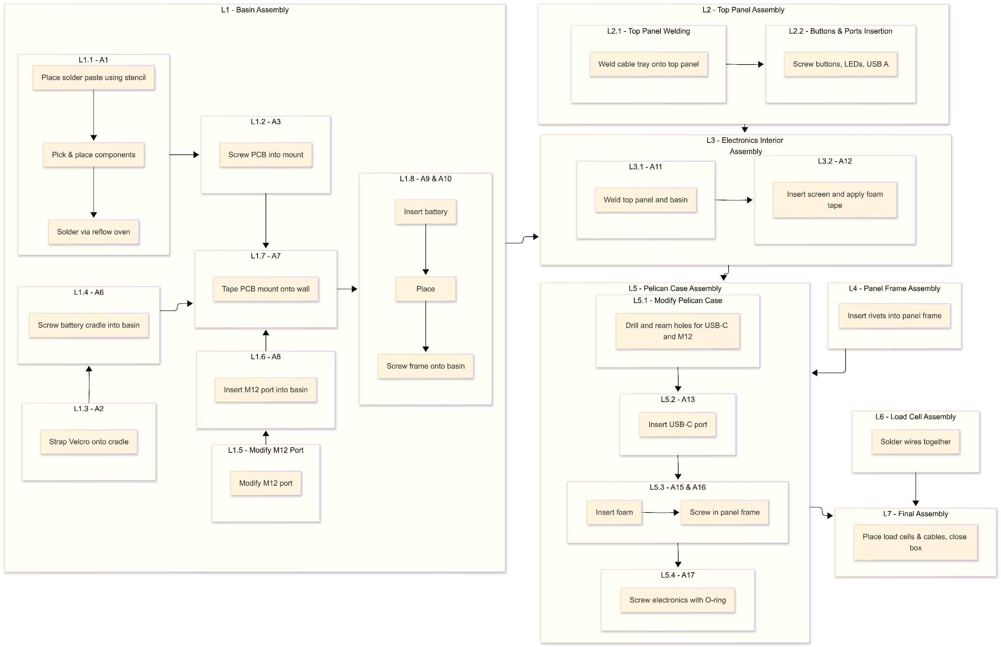

Figure 87: Assembly sequence flowchart

## Workforce Requirements

To calculate the daily required working hour, the required production times for each machine in the production processes were considered for each day by dividing the values in Table 34 (converted into hours) by the number of working days (252). The daily required working hours were then divided by 7.5 $\frac{h}{shift}$ to determine the required shifts for each machine. The results are shown in Table 36. Note that the automated pick-and-place machine and reflow oven are excluded since they are part of the assembly process.

Table 36: Workforce Requirements for Production Processes

|  |  |  |  |  |
| --- | --- | --- | --- | --- |
| Machine | No. of Machines | Required Production Time [h/year] | Required Working Hours [h/day] | Required Shifts [shifts/day] |
| 3D Printer | 1 | 1005.0 | 6.7 | 0.893 |
| 4-Axis CNC Milling Machine | 1 | 407.5 | 2.7 | 0.362 |
| 3-Axis CNC Contour Machine | 1 | 332.5 | 2.2 | 0.296 |
| 3-Axis CNC Milling Machine | 1 | 237.5 | 1.6 | 0.211 |
| Extrusion Press | 1 | 42.5 | 0.3 | 0.038 |
| Drill | 1 | 35.0 | 0.2 | 0.031 |
| Reamer | 1 | 40.0 | 0.3 | 0.036 |
| Laser Cutter | 1 | 62.5 | 0.4 | 0.056 |
| Welding Plant | 1 | 192.5 | 1.3 | 0.171 |
| Hand Soldering Station | 1 | 27.5 | 0.2 | 0.024 |

To account for the assembly process, the same process was repeated using the values from Table 35 and shown in Table 37.

Table 37: Workforce Requirements for Assembly Processes

|  |  |  |  |
| --- | --- | --- | --- |
| Assembly Station | Required Assembly Time [h/year] | Required Working Hours [h/day] | Required Shifts [shifts/day] |
| Line 1 – Basin Assembly | 183 | 0.72 | 0.0966 |
| Line 2 – Top Panel Assembly | 45 | 0.18 | 0.0238 |
| Line 3 – Electronics interior assembly | 47.5 | 0.19 | 0.0251 |
| Line 4 – Panel frame assembly | 7.5 | 0.03 | 0.0040 |
| Line 5 – Pelican case assembly | 55 | 0.22 | 0.0291 |
| Line 6 – Load Cells Assembly | 13 | 0.05 | 0.0066 |
| Line 7 – Final Assembly | 5 | 0.02 | 0.0026 |

This gives the daily shift requirement of being around 2.31 shifts per day. However, it should be noted that the 3D printer does not have to be operated at all times like the other machines. It also has very long production times due to the nature of additive manufacturing. So, the approximate daily shift requirement for the 3D printer is neglected, giving a daily shift requirement of 1.41 shifts per day.

Since shifts cannot be paid in part, the shift requirement is rounded up to 2 shifts per day. Thus, with 7.5 $\frac{h}{shift}$ and 252 working days a year. The total paid working hours per year is 3780 paid hours per year.

# Cost Calculations

To get a final offer price for the product, the cost calculation was performed using the following scheme of equations:

Material Costs = Direct Material Costs + Raw Material Costs + Material Overhead

Manufacturing Costs = Labour Costs + Machinery Costs + Utility Costs + Factory Rent

Production Costs = Material Costs + Manufacturing Costs

Cost of Goods Sold (COGS) = Production Costs + Overhead

Final Offer Price = COGS + Profit + Distributor Commission

## Material Costs

Table 38: Direct Material Costs of Buy Parts

|  |  |  |  |
| --- | --- | --- | --- |
| **Subsystem** | **Key Components** | **Function** | **Cost [€]** |
| **Processing & Control** | MCU, Flash Memory | System control & communication | 5 |
| **Measurement Chain** | ADC, Amplifiers, Filters | Precision force measurement | 15 |
| **HMI** | Touchscreen, LEDs, Buttons | User interaction & status indication | 30 |
| **Power System** | Battery, Regulators | Portable power supply | 10 |
| **PCB & Passives** | PCB, resistors, capacitors | Electrical integration | 14 |
| **Protective Case** | Pelican Case | Structural Housing | 220 |
| **Miscellaneous Mechanical Components** | Screws, fasteners, glue, O-rings | Mechanical securing and sealing | 10 |
| **Load Cells** | 6 Innovatest load cells | Force measurement | 2844 |
| **Total Direct Material Cost:** | | | **3148** |

Table 39: Raw Material Costs for Make Parts

|  |  |  |  |
| --- | --- | --- | --- |
| **Material** | **Quantity [kg]** | **Cost per kg [€/kg]** | **Cost [€]** |
| **Polycarbonate** | 0.12 | 3.5 | 0.42 |
| **ABS** | 0.08 | 2.5 | 0.2 |
| **5052 Aluminium** | 6.6 | 4 | 26.4 |
| **EVA/PU Foam** | 0.96 | 2 | 1.92 |
| **Total Raw Material Cost:** | | | 28.94 |

To find the material overhead, we assume an overhead rate of 5% and use the values from Table 38 and Table 39.

Material Overhead Costs = 5% * (Direct Material Costs + Raw Material Costs)

= 5% * (€3148 + €28.94) = €158.85/unit

Therefore, the total material costs:

Material Costs = €3148 + €28.94 + €158.85 = €3335.79/unit

## Manufacturing Costs

### Labour Costs

Assuming an average hourly wage of €20/h, the labour costs can be calculated using the total working hours found in Section 16.6 Workforce Requirements:

Annual Labor Costs = Yearly Working Hours * Hourly Wage

= 3780h/year * €20/h = €75 600/year

Unit Labor Cost = Annual Labour Cost ÷ Production Target

= €75 600/year ÷150 unit/year = €504.00/unit

### Machinery Costs

To calculate the machine costs, the annual depreciation rate had to be considered to find the depreciation per year. The machines are ideally available for 2016 h/year (8 h/day * 252 day/year). Thus, the machine hourly rates were found by divinding the yearly depreciation by the available hours. Finally, the required machine hours per unit taken from Table 34: Machine Number Estimation, were used to calculate the machinery costs per unit. The results are shown in Table 40.

Table 40: Machinery Depreciation Costs

|  |  |  |  |  |  |  |
| --- | --- | --- | --- | --- | --- | --- |
| Machine | Total Cost [€] | Annual Depreciation Rate | Depreciation Per Year [€/year] | Machine Hourly Rate [€/h] | Machine Hours per Unit [h/unit] | Machine Cost per Unit [€/unit] |
| 3D Printer | 800 | 20% | 160 | 0.0794 | 6.7 | 0.53 |
| 4-Axis CNC Milling Machine | 70000 | 10% | 7000 | 3.4722 | 2.72 | 9.43 |
| 3-Axis CNC Contour Machine | 50000 | 10% | 5000 | 2.4802 | 2.22 | 5.50 |
| 3-Axis CNC Milling Machine | 9000 | 10% | 900 | 0.4464 | 1.58 | 0.707 |
| Extrusion Press | 100000 | 10% | 10000 | 4.9603 | 0.28 | 1.41 |
| Drill | 150 | 10% | 15 | 0.0074 | 0.23 | 0.00174 |
| Reamer | 30 | 10% | 3 | 0.0015 | 0.27 | 0.0003968 |
| Laser Cutter | 40000 | 10% | 4000 | 1.9841 | 0.42 | 0.827 |
| Welding Plant | 500 | 10% | 50 | 0.0248 | 1.28 | 0.0318 |
| Automated Pick-and-Place Machine | 3500 | 10% | 350 | 0.1736 | 0.18 | 0.03183 |
| Reflow Oven | 360 | 5% | 18 | 0.0089 | 0.34 | 0.00305 |
| Hand Soldering Station | 200 | 5% | 10 | 0.0050 | 0.42 | 0.00207 |
| Total Machine Costs Per Unit | | | | | | 18.47 |

### Utility Costs

The energy usage of the machines also needed to be considered. The power and cost per kWh were found and then multiplied by the required machine hours per unit to find the utility costs per unit as shown in Table 41.

Table 41: Machine Utility Costs

|  |  |  |  |  |
| --- | --- | --- | --- | --- |
| Machine | Power [kW] | Cost per kWh [€/kWh] | Machine Hours per Unit [h/unit] | Utility Cost per Unit [€/unit] |
| 3D Printer | 0.15 | 0.04 | 6.70 | 0.04 |
| 4-Axis CNC Milling Machine | 8 | 2.1 | 2.72 | 45.64 |
| 3-Axis CNC Contour Machine | 2.7 | 2 | 2.22 | 11.97 |
| 3-Axis CNC Milling Machine | 1 | 2 | 1.58 | 3.17 |
| Extrusion Press | 10 | 0.8 | 0.28 | 2.27 |
| Drill | 0.05 | 0.02 | 0.23 | 0.00023 |
| Reamer | 0 | 0 | 0.27 | 0 |
| Laser Cutter | 4.5 | 1.17 | 0.42 | 2.19 |
| Welding Plant | 2.5 | 0.65 | 1.28 | 2.09 |
| Automated Pick-and-Place Machine | 0.2 | 0.05 | 0.18 | 0.00183 |
| Reflow Oven | 1.2 | 0.31 | 0.34 | 0.13 |
| Hand Soldering Station | 0.07 | 0.02 | 0.42 | 0.00058 |
| Total Utility Costs per Unit | | | | 67.49 |

### Factory Rent

Based on the requirements, the facility size needed is estimated to be around 100 m2 and estimated rent is € 7/m2. As such, the factory rent calculations go as follows:

Monthly Base Rent = 100 m2 * € 7/m2 = €700/month

Yearly Base Rent = €700/month * 12 month/year = €8400/year

Additional Costs = €8400/year * 15% = €1260/year

Total Annual Rent = €8400/year + €1260/year = €9660/year

Rent per Unit = €9660/year ÷ 150 unit/year = €64.40/unit

## Production Costs

Therefore, the total manufacturing costs were be found to be:

Manufacturing Costs = €504.00/unit **+** €18.47/unit + €67.49/unit + €64.40/unit

= €654.36/unit

Therefore, the total production costs were found to be:

Production Costs = €3335.79/unit + €654.36/unit = €3990.15/unit

This production cost is within the budget specified in Section 3.1.7.

## Overheads

To account for administrative and marketing and sales overhead, a portion of the production costs was calculated as 8% and 15% respectively:

Admin Overhead = 8% * €3990.15/unit = €319.21/unit

Marketing overhead = 15% * €3990.15/unit = €598.52/unit

## Cost of Goods Sold (COGS)

Therefore, the costs of goods sold can be calculated:

COGS = €3990.15/unit + €319.21/unit + €598.52/unit = €4907.89/unit

## Offer Price

### Profit and Selling Price

Finally, to calculate a reasonable selling price, a 30% profit margin is assumed:

Proft = 30% * COGS

= 30% * €49.7.89/unit = €1472.37/unit

Cash Selling Price = COGS + Profit

= €4907.89/unit + €1472.37/unit = €6380.25/unit

### Commission

Assuming a distributor commission of around 10%,

Commission = 10% * Cash Selling Price

= 10% * €6380.25/unit = €638.02/unit

### Final Offer Price

Therefore, the final offer price for the Verificationator:

Final Offer Price = Cash Selling Price + Commission

= €6380.25/unit + €638.02/unit = **€7018.28/unit**

## Cost Calculation Summary

Table 42: Summary of Cost Calculation

|  |  |
| --- | --- |
| **Item** | **Value** |
| **Material Costs** | €3335.79 |
| **Manufacturing Costs** | €654.36 |
| **Production Costs** | €3990.15 |
| **COGS** | €4907.89 |
| **Cash Selling Price** | €6380.25 |
| **Proft** | €1472.37 |
| **Final Offer Price** | **€7018.28** |

# Bibliography

3D Jake. (n.d.). *Prevent warping – You can do it*! <https://www.3djake.com/info/guide/prevent-warping-you-can-do-it> Accessed: November 28, 2025

Analog Devices. (2012, May 7). Understanding Noise, ENOB, and Effective Resolution in Analog-to-Digital Converters. Analog Devices. <https://www.analog.com/en/resources/technical-articles/noise-enob-and-effective-resoluition-in-analog-to-digital-converter-circuits--maxim-integrated.html>. Accessed: November 2, 2025.

Analog Devices. (2017, February). Circuits from the Lab Reference Designs Instrumentation Anthology. Analog Devices. <https://www.analog.com/media/en/reference-design-documentation/reference-designs/instrumentation_anthology_circuits_from_the_lab.pdf>. Accessed: November 10, 2025.

Analog Devices. (2020, October). *AD8421* [Device Datasheet]. Analog Devices.

Andrews, R. (2015, October 2). The delta-sigma advantage to anti-aliasing filters. Texas Instruments. <https://e2e.ti.com/blogs_/archives/b/precisionhub/posts/the-delta-sigma-advantage-to-anti-aliasing-filters>. Accessed: November 10, 2025

Binder. (2025, November). *M12 77 2529 0000 50705-0200* [Device Datasheet]. Binder.

CloudNC. (n.d.). *CNC best practices #3: What’s the difference between 3-axis, 4-axis & 5-axis milling?* <https://www.cloudnc.com/blog/cnc-best-practices-3-whats-the-difference-between-3-axis-4-axis-5-axis-milling>. Accessed: November 28, 2025

Curbell Plastics. (2016). *Plastic material selection guide*.

Damao Tech. (n.d.). *Understanding EVA foam density & hardness (Shore A & C explained)*. <https://damao-tech.com/understanding-eva-foam-density-hardness-shore-a-c-explained/>. Accessed: November 28, 2025

Danjou, S. (2018). *Engineering Drawing and Design: Design Methodology*.

Dlesauvage. (2023, August 3). *Embracing Efficiency and Convenience: The Advantages of M12 Connections over Traditional Wiring - ICON Process Controls*. ICON Process Controls. <https://iconprocon.com/blog-post/embracing-efficiency-and-convenience-the-advantages-of-m12-connections-over-traditional-wiring/>

EcoFlow. (n.d.). *Lithium-Ion vs NiMH Batteries:* *Which One Fits Your Needs Best?*. <https://www.ecoflow.com/us/blog/lithiumion-vs-nimh-batteries>

Espressif. (2025, October 23). *ESP32-P4 Chip* (V1.3) [Device Datasheet]. Espressif.

European Commission. (2010, July). *Guidance on the application of the essential health and safety requirements on ergonomics set out in section 1.1.6 of Annex I to the Machinery Directive 2006/42/EC*. European Commission. <https://www.ibf-solutions.com/fileadmin/Dateidownloads/application-guide-ergonomic-health-and-safety-requirements.pdf>

Facturee. (n.d.). *Material selection for sheet metal working: Your comprehensive guide*. <https://www.facturee.de/en/material-selection-for-sheet-metal-working-your-comprehensive-guide/>. Accessed: November 28, 2025

Fischer, U., Gomeringer, R., & Heinzler, M. (2010). *Mechanical and metal trades handbook* (2nd ed.). Verlag Europa-Lehrmittel.

FoamOrder. (n.d.). *Foam types: Information and comparison*.

Formlabs. (n.d.). *Guide to Manufacturing processes for plastics*. [https://formlabs.com/blog/guide-to-manμFacturing-processes-for-plastics/](https://formlabs.com/blog/guide-to-manufacturing-processes-for-plastics/). Accessed: November 28, 2025

Future Market Insights (2025, October 6). *Hardness Testing Machine Market Size and Share Forecast Outlook 2025 to 2035*. <https://www.futuremarketinsights.com/reports/hardness-testing-machine-market>

German Federal Ministry of Labour and Social Affairs. (n.d.) *Working Time*. <https://www.zoll.de/EN/Businesses/Work/Foreign-domiciled-employers-posting/Minimum-conditions-of-employment/General-conditions-of-employment/Working-time/working-time.html#vt-sprg-9> Accessed: December 12, 2025

Horowitz, P., Hill W. (2015, April 9). The Art of Electronics (3rd ed.). Cambridge University Press.

Industrial Metal Supply. (n.d.). *Aluminum 6061 vs. aluminum 6063*. <https://www.industrialmetalsupply.com/aluminum-6061-vs-aluminum-6063>

Intel Market Research. (2025, October 25). *Hardness testing machine market growth analysis, dynamics, key players and Innovations, Outlook and Forecast 2025-2032*. <https://www.intelmarketresearch.com/hardness-testing-machine-market-16431>

International Organization of Legal Metrology. (2000, November). *Metrological regulation for load cells OIML R 600 2000 (E)*. International Organization of Legal Metrology

Juran. (2024, March 7). *Guide to Failure Mode and Effect Analysis - FMEA*. Juran Institute, an Attain Partners Company. https://www.juran.com/blog/guide-to-failure-mode-and-effect-analysis-fmea/

MarketsandMarkets. (2025, September). *Material Testing Market by Type (Universal Testing Machine, Servohydraulic Testing Machine, Hardness Testing Equipment), Material (Meta, Plastic, Rubber & Elastomer), End User (Automotive, Construction), & Region – Global Forecast to 2030*. <https://www.marketsandmarkets.com/Market-Reports/material-testing-market-207231755.html>

Maxim Integrated. (2019, September). *MAX6126* [Device Datasheet]. Maxim Integrated.

Microchip. (2009, July). *MCP73123* [Device Datasheet]. Microchip.

Microchip. (2025, October). *MCP41U83* [Device Datasheet]. Microchip.

Mostafawi Group. (2024, April 24). *How Pelican Cases Provide Limitless Protection for Fragile Gear*. <https://www.mostafawi.ae/blogs/how-pelican-cases-provide-limitless-protection-for-fragile-gear/>

Pahl, G., Beitz, W., Feldhusen, J., & Grote, K.-H. (2007). *Engineering design: A systematic approach* (3rd ed.). Springer.

Pelican. (n.d.). *CAD downloads Protector and Storm Case*. Pelican. <https://www.pelican.com/ca/en/professional/cad-downloads/>

Phoenix Contact. (2025, November 17). *SACC-DSIV-FS-5CON-L90 SCO* [Device Datasheet]. Pheonix Contact.

Project Management Inst. (2013). *A Guide to the Project Management Body of Knowledge: PMBOK Guide*. (5th ed.). Project Management Inst.

Public Holidays Global. (2025). *Public Holidays: Germany*. <https://publicholidays.de/>. Accessed: December 12, 2025

Scherz, P., Monk, S. (2016). *Practical Electronics for Inventors*. (4th ed.). Mc Graw Hill Education.

Senfeng Laser USA. (n.d.). Fiber laser cutter for aluminum: What you should know. <https://www.senfenglaserusa.com/news/fiber-laser-cutter-for-aluminum-what-you-should-know/>. Accessed: November 28, 2025

Sharma, R. (n.d.). *Portable Hardness Testers Market*. Data Intelo. <https://dataintelo.com/report/global-portable-hardness-testers-market>

Simplify3D. (n.d.). *Material properties table (ABS, polycarbonate)*. <https://www.simplify3d.com/resources/materials-guide/properties-table/?filas=abs,polycarbonate>. Accessed: November 28, 2025

Texas Instruments. (2007, November). *TPS61170* [Device Datasheet]. Texas Instruments.

Texas Instruments. (2016, July). *TPS61089* [Device Datasheet]. Texas Instruments.

Texas Instruments. (2016, September). *TPS61099* [Device Datasheet]. Texas Instruments.

Texas Instruments. (2020, January). *OPA188* [Device Datasheet]. Texas Instruments.

Texas Instruments. (2021, November). *TPS62130* [Device Family Datasheet]. Texas Instruments.

Texas Instruments. (2025, August). *ADS127L21* [Device Datasheet]. Texas Instruments.

TouchWo. (2025, May 22). *Capacitive vs. Resistive Screens: Which is Better?* <https://touchwo.com/capacitive-screen-vs-resistive-screen/>

Wikifactory. (n.d.). *Ultimate guide: How to design for 3D printing*. <https://wikifactory.com/+wikifactory/stories/ultimate-guide-how-to-design-for-3d-printing>. Accessed: November 28, 2025

Xometry. (n.d.). *Sheet metal materials*. <https://xometry.pro/en-eu/articles/sheet-metal-materials/>. Accessed: November 28, 2025

YDL. (n.d.). *YDL 3.7V 7200mAh 866898 Rechargeable Lithium Polymer Battery*. <https://ydlbattery.com/en-de/products/3-7v-7200mah-866898-lithium-polymer-ion-battery>. Accessed: November 28, 2025

YesWelder. (n.d.). *MIG vs. TIG: Aluminum welder comparison*. <https://yeswelder.com/blogs/yeswelder/mig-vs-tig-aluminum-welder>. Accessed: November 28, 2025

# Appendices

## Appendix A: Work Breakdown Structure

|  |  |  |  |  |  |  |
| --- | --- | --- | --- | --- | --- | --- |
| WBS Number | Task name | Assigned to | Start | End | Predecessor | Type |
| 1 | Concept Design |  | 10/5/2025 | 10/28/2025 |  | phase |
| 1.1 | Project Plan |  | 10/5/2025 | 10/14/2025 |  | deliverable |
| 1.1.1 | Breakdown all deliverables and identify sequence | Justin, Okan, Ahmad, Abhinav, Wasim | 10/5/2025 | 10/9/2025 |  | task |
| 1.1.2 | Create Responsibility assignment matrices | Justin | 10/9/2025 | 10/10/2025 | 1.1.1 | task |
| 1.1.3 | Draft a schedule | Justin | 10/10/2025 | 10/12/2025 | 1.1.2 | task |
| 1.1.4 | Create Gantt chart | Justin | 10/12/2025 | 10/13/2025 | 1.1.3 | task |
| 1.1.5 | Approve of Project Plan | Justin, Okan, Ahmad, Abhinav, Wasim | 10/13/2025 | 10/14/2025 | 1.1.4 | task |
| 1.2 | Market Analysis |  | 10/13/2025 | 10/18/2025 |  | deliverable |
| 1.2.1 | Perform preliminary Market Analysis | Okan | 10/13/2025 | 10/14/2025 | 1.1.5 | task |
| 1.2.2 | Create Financial Estimates | Okan | 10/14/2025 | 10/16/2025 | 1.2.1 | task |
| 1.2.3 | Perform Detailed Market Analysis | Okan | 10/16/2025 | 10/17/2025 | 1.2.2 | task |
| 1.2.4 | Approve Market Analysis Report | Justin | 10/17/2025 | 10/18/2025 | 1.2.3 | task |
| 1.3 | Overall Product Concept |  | 10/13/2025 | 10/28/2025 |  | deliverable |
| 1.3.1 | Creating Requirements List | Ahmad | 10/13/2025 | 10/14/2025 | 1.1.5 | task |
| 1.3.2 | Abstract the Problem and Identify Functions | Justin, Ahmad | 10/13/2025 | 10/15/2025 | 1.3.1 | task |
| 1.3.3 | Approve Key Functions | Wasim | 10/15/2025 | 10/16/2025 | 1.3.2 | task |
| 1.3.4 | Developing Working Structures and Morphological Box | Justin, Ahmad, Abhinav, Wasim | 10/15/2025 | 10/16/2025 | 1.3.3 | task |
| 1.3.4.1 | Adjust Solution according to Market Analysis | Ahmad | 10/17/2025 | 10/18/2025 | 1.2.3, 1.3.4 | task |
| 1.3.4.2 | Adjust Solution according to FMEA | Wasim | 10/25/2025 | 10/26/2025 | 1.6.3, 1.3.4 | task |
| 1.3.5 | Drawing Concept Sketch | Ahmad | 10/18/2025 | 10/22/2025 | 1.3.4.1 | task |
| 1.3.6 | Compile preliminary bill of materials | Justin | 10/26/2025 | 10/27/2025 | 1.3.4.2 | task |
| 1.3.7 | Approve Overall Product Concept | Wasim | 10/27/2025 | 10/28/2025 | 1.3.6 | task |
| 1.4 | Functional Structure |  | 10/18/2025 | 10/27/2025 |  | deliverable |
| 1.4.1 | Create preliminary product FSD | Justin | 10/18/2025 | 10/21/2025 | 1.3.4.1 | task |
| 1.4.2 | Adjust FSD according to FMEA | Justin | 10/25/2025 | 10/26/2025 | 1.6.3 | task |
| 1.4.3 | Approve product FSD | Abhinav | 10/26/2025 | 10/27/2025 | 1.4.2 | task |
| 1.5 | Human Machine Interface |  | 10/21/2025 | 10/27/2025 |  | deliverable |
| 1.5.1 | Create table of I/O Interactions | Abhinav | 10/21/2025 | 10/22/2025 | 1.4.1 | task |
| 1.5.2 | Define and Arrange Control Elements | Abhinav | 10/22/2025 | 10/23/2025 | 1.5.1, 1.3.5 | task |
| 1.5.3 | Adjust HMI according to FMEA | Abhinav | 10/25/2025 | 10/26/2025 | 1.6.3 | task |
| 1.5.4 | Approve HMI | Ahmad | 10/26/2025 | 10/27/2025 | 1.5.3 | task |
| 1.6 | D-FMEA |  | 10/22/2025 | 10/27/2025 |  | deliverable |
| 1.6.1 | Create Basis for Failure Analysis | Wasim | 10/22/2025 | 10/23/2025 | 1.5.2 | task |
| 1.6.2 | Identify Preliminary Failure Modes | Wasim | 10/23/2025 | 10/24/2025 | 1.6.1 | task |
| 1.6.3 | Create Draft of D-FMEA Table | Ahmad, Wasim | 10/23/2025 | 10/24/2025 | 1.6.2 | task |
| 1.6.4 | Create Final D-FMEA Report | Justin, Abhinav | 10/25/2025 | 10/26/2025 | 1.6.3 | task |
| 1.6.5 | Approve D-FMEA Report | Okan | 10/26/2025 | 10/27/2025 | 1.6.4 | task |
| 1.7 | Concept Design Close-out | Justin, Okan, Ahmad, Abhinav, Wasim | 10/28/2025 | 10/28/2025 | 1.6.5, 1.2.4, 1.5.4, 1.4.3, 1.3.7 | milestone |
| 2 | Product Design |  | 10/29/2025 | 12/2/2025 |  | phase |
| 2.1 | Complete 3D Model |  | 10/29/2025 | 12/2/2025 |  | deliverable |
| 2.1.1 | Design the Housing and Internal Structure | Ahmad | 10/29/2025 | 11/19/2025 | 1.7 | task |
| 2.1.2 | Approve of General Structure | Wasim | 11/19/2025 | 11/20/2025 | 2.1.1 | task |
| 2.1.3 | Integrate PCB and Connectors into 3D Model | Ahmad, Wasim | 11/20/2025 | 11/22/2025 | 2.3.5, 2.1.2 | task |
| 2.1.4 | Perform Assembly & Interference Check | Ahmad | 11/22/2025 | 11/24/2025 | 2.1.3 | task |
| 2.1.5 | Adjust 3D Model based on results of Assembly test | Ahmad | 11/24/2025 | 11/25/2025 | 2.1.4 | task |
| 2.1.6 | Assign Material | Ahmad | 11/25/2025 | 11/26/2025 | 2.1.5 | task |
| 2.1.7 | Adjust 3D Model According to Manufacturability | Ahmad, Wasim | 11/28/2025 | 11/27/2025 | 2.1.6, 2.4.3 | task |
| 2.1.8 | Adjust 3D Model According to Part Availability | Okan, Ahmad | 11/29/2025 | 11/28/2025 | 2.1.7, 2.5.2 | task |
| 2.1.9 | Approve 3D Model | Wasim | 12/1/2025 | 12/2/2025 | 2.1.8 | task |
| 2.2 | Measurement Chain |  | 10/29/2025 | 11/11/2025 |  | deliverable |
| 2.2.1 | Identify necessary Signal Conditioning | Justin | 10/29/2025 | 10/30/2025 | 1.7 | task |
| 2.2.2 | Design Schematics for Signal Condition | Justin | 10/30/2025 | 11/3/2025 | 2.2.1 | task |
| 2.2.3 | Adjust Signal Conditioning according to Feedback from Circuit Design | Justin, Wasim | 11/6/2025 | 11/8/2025 | 2.3.3 | task |
| 2.2.4 | Create detailed Measurement Chain FSD | Justin | 11/8/2025 | 11/10/2025 | 2.2.3 | task |
| 2.2.5 | Approve the Measurement Chain Design | Abhinav | 11/10/2025 | 11/11/2025 | 2.2.4 | task |
| 2.3 | Circuit Diagram |  | 10/29/2025 | 12/2/2025 |  | deliverable |
| 2.3.1 | Draw Electrical System Block Diagram | Wasim | 10/29/2025 | 10/31/2025 | 1.7 | task |
| 2.3.2 | Create Draft Circuit Schematic | Wasim | 10/31/2025 | 11/4/2025 | 2.3.1 | task |
| 2.3.3 | Integrate Signal Processing Schematics | Justin, Wasim | 11/4/2025 | 11/6/2025 | 2.3.2, 2.2.2 | task |
| 2.3.4 | Design Detailed Circuit Schematic | Abhinav, Wasim | 11/6/2025 | 11/11/2025 | 2.3.3 | task |
| 2.3.5 | Design PCB | Abhinav, Wasim | 11/11/2025 | 11/19/2025 | 2.3.4, 2.2.3 | task |
| 2.3.6 | Perform Electrical Safety Checks | Wasim | 11/19/2025 | 11/21/2025 | 2.3.5 | task |
| 2.3.7 | Adjust PCB according to Manufacturability | Wasim | 11/27/2025 | 11/28/2025 | 2.4.3, 2.3.6 | task |
| 2.3.8 | Adjust PCB according to Availability | Wasim | 11/28/2025 | 11/29/2025 | 2.5.2 | task |
| 2.3.9 | Create Final Electrical Documentation Package | Wasim | 11/29/2025 | 12/1/2025 | 2.3.7, 2.3.8 | task |
| 2.3.10 | Approve Final Circuit Diagram | Justin | 12/1/2025 | 12/2/2025 | 2.3.9, 2.2.5 | task |
| 2.4 | Technology Selection for “Make” Parts |  | 11/21/2025 | 12/2/2025 |  | deliverable |
| 2.4.1 | Identify all necessary “make” parts | Justin | 11/21/2025 | 11/22/2025 | 2.3.5, 2.1.3 | task |
| 2.4.2 | Approve list of “Make” + “Buy” parts | Okan | 11/23/2025 | 11/24/2025 | 2.4.1, 2.5.1 | task |
| 2.4.3 | Assess Manufacturability of Parts | Wasim | 11/24/2025 | 11/27/2025 | 2.4.2 | task |
| 2.4.4 | Select Manufacturing Process and Materials for each part | Wasim | 11/26/2025 | 11/27/2025 | 2.4.3 | task |
| 2.4.5 | Approve of material and manufacturing processes of “make” parts | Justin | 11/27/2025 | 11/28/2025 | 2.4.4 | task |
| 2.4.6 | Define the Assembly Technology (Area by Area) | Justin, Wasim | 11/28/2025 | 12/1/2025 | 2.4.5 | task |
| 2.4.7 | Approve Manufacturing and Assembly Guide Package | Okan | 12/1/2025 | 12/2/2025 | 2.4.6 | task |
| 2.5 | Requirements Manual for “Buy” Parts |  | 11/21/2025 | 12/2/2025 |  | deliverable |
| 2.5.1 | Identify all necessary “buy” parts | Okan | 11/21/2025 | 11/22/2025 | 2.1.3, 2.3.5 | task |
| 2.5.2 | Assess availability of "buy" Parts | Okan | 11/24/2025 | 11/27/2025 | 2.4.2 | task |
| 2.5.3 | Create part requirements sheets for each “buy” part | Okan, Ahmad | 11/27/2025 | 12/1/2025 | 2.5.2 | task |
| 2.5.4 | Approve requirement sheets | Justin | 12/1/2025 | 12/2/2025 | 2.5.3 | task |
| 2.6 | Product Design Close-out | Justin, Okan, Ahmad, Abhinav, Wasim | 12/2/2025 | 12/2/2025 | 2.5.4, 2.4.7, 2.3.10, 2.1.9 | milestone |
| 3 | Project Documentation |  | 10/29/2025 | 1/12/2026 |  | phase |
| 3.1 | Technical Drawings for Main Assembly |  | 12/3/2025 | 1/4/2026 |  | deliverable |
| 3.1.1 | Create Assembly Drawing with Section and Detail Views | Ahmad | 12/3/2025 | 12/17/2025 | 2.6 | task |
| 3.1.2 | Verify drawings for electrical components | Wasim | 12/17/2025 | 12/19/2025 | 3.1.1, 3.4.3 | task |
| 3.1.3 | Verify Compliance with DIN 406 Drawing Standards | Abhinav | 12/20/2025 | 12/22/2025 | 3.1.2 | task |
| 3.1.4 | Approval of technical drawing | Wasim | 1/3/2026 | 1/4/2026 | 3.1.3 | task |
| 3.2 | Program Flow Chart |  | 12/3/2025 | 12/18/2025 |  | deliverable |
| 3.2.1 | Draw Main structural flowchart | Abhinav | 12/3/2025 | 12/7/2025 | 2.6 | task |
| 3.2.2 | Draw User interaction flowchart | Abhinav | 12/7/2025 | 12/9/2025 | 3.2.1 | task |
| 3.2.3 | Draw Calibration menu flowchart | Abhinav | 12/8/2025 | 12/10/2025 | 3.2.2 | task |
| 3.2.4 | Draw Data handling flowchart | Abhinav | 12/10/2025 | 12/11/2025 | 3.2.3 | task |
| 3.2.5 | Draw Error and Internal Interrupt handling flowchart | Abhinav | 12/11/2025 | 12/12/2025 | 3.2.4 | task |
| 3.2.6 | Approve program flowcharts | Ahmad | 12/19/2025 | 12/18/2025 | 3.2.5 | task |
| 3.3 | Bill of Material |  | 12/3/2025 | 1/4/2026 |  | deliverable |
| 3.3.1 | Create master BOM spreadsheet | Justin | 12/3/2025 | 12/4/2025 | 2.6 | task |
| 3.3.2 | Itemize all Mechanical Components |  | 12/4/2025 | 12/10/2025 |  | tasks group |
| 3.3.2.1 | Identify norm spec for each standard mechanical component | Justin | 12/4/2025 | 12/7/2025 | 3.3.1 | task |
| 3.3.2.2 | Verify all specifications of all mechanical components | Wasim | 12/7/2025 | 12/10/2025 | 3.3.2.1 | task |
| 3.3.3 | Itemize all Electrical Components |  | 12/10/2025 | 12/16/2025 |  | tasks group |
| 3.3.3.1 | Add technical specs for all electrical components | Justin | 12/10/2025 | 12/13/2025 | 3.3.2.2 | task |
| 3.3.3.2 | Verify all specifications of all electrical components | Ahmad | 12/13/2025 | 12/16/2025 | 3.3.3.1 | task |
| 3.3.4 | Add cost to all components | Justin | 12/16/2025 | 12/19/2025 | 3.3.3.2 | task |
| 3.3.5 | Verify Part Numbers according to Drawings | Justin | 12/20/2025 | 12/22/2025 | 3.1.2 | task |
| 3.3.6 | Approve final BOM | Abhinav | 1/3/2026 | 1/4/2026 | 3.3.5 | task |
| 3.4 | Production Planning |  | 12/3/2025 | 1/8/2026 |  | deliverable |
| 3.4.1 | Estimate Number of Required Machines | Wasim | 12/3/2025 | 12/5/2025 | 2.6 | task |
| 3.4.2 | Estimate Manufacturing and Assembly Time per Part | Wasim | 12/5/2025 | 12/11/2025 | 3.4.1 | task |
| 3.4.3 | Create Assembly Sequence and Flowchart | Abhinav, Wasim | 12/11/2025 | 12/15/2025 | 3.4.2 | task |
| 3.4.4 | Estimate Workforce Requirements | Wasim | 12/15/2025 | 12/17/2025 | 3.4.3 | task |
| 3.4.5 | Optimize Assembly Sequence Costs | Abhinav, Wasim | 12/20/2025 | 12/23/2025 | 3.5.3 | task |
| 3.4.6 | Approve of Assembly Sequence and Flowchart | Justin | 1/3/2026 | 1/4/2026 | 3.4.5 | task |
| 3.4.7 | Create Production Planning Summary | Wasim | 1/4/2026 | 1/7/2026 | 3.4.6 | task |
| 3.4.8 | Approve Production Plan | Okan | 1/7/2026 | 1/8/2026 | 3.4.7 | task |
| 3.5 | Cost Calculation |  | 12/5/2025 | 1/6/2026 |  | deliverable |
| 3.5.1 | Estimate Fixed Costs | Okan | 12/5/2025 | 12/11/2025 | 3.4.1 | task |
| 3.5.2 | Estimate Variable Costs |  | 12/11/2025 | 12/16/2025 | 3.5.1 | tasks group |
| 3.5.2.1 | Perform Initial Variable Cost Estimation | Okan | 12/11/2025 | 12/16/2025 | 3.4.2 | task |
| 3.5.2.2 | Perform Final Variable Cost Estimate | Okan | 12/19/2025 | 12/22/2025 | 3.5.2.1, 3.4.4, 3.3.4 | task |
| 3.5.3 | Estimate Overheads and Miscellaneous | Okan | 12/16/2025 | 12/19/2025 | 3.5.2.1 | task |
| 3.5.4 | Summary Costs and Revenue Projection | Okan | 1/3/2026 | 1/5/2026 | 3.5.2.2, 3.5.3 | task |
| 3.5.5 | Approve Cost Calculation Report | Justin | 1/5/2026 | 1/6/2026 | 3.5.4 | task |
| 3.6 | Specification sheet |  | 10/29/2025 | 1/4/2026 |  | deliverable |
| 3.6.1 | Outline Functional specifications | Abhinav | 10/29/2025 | 10/31/2025 | 1.7 | task |
| 3.6.2 | Outline Physical and Mechanical Specifications | Ahmad, Abhinav | 11/20/2025 | 11/22/2025 | 2.1.2, 3.6.1 | task |
| 3.6.3 | Outline Electrical Specifications | Abhinav, Wasim | 11/23/2025 | 11/27/2025 |  | task |
| 3.6.4 | Adjust Specification on Final Design | Abhinav | 12/12/2025 | 12/17/2025 | 3.6.3, 3.6.2, 2.6 | task |
| 3.6.5 | Approve specifications sheet | Justin | 1/3/2026 | 1/4/2026 | 3.6.4 | task |
| 3.7 | User manual |  | 11/21/2025 | 1/4/2026 |  | deliverable |
| 3.7.1 | Write Safety Disclaimers | Justin | 11/21/2025 | 11/23/2025 | 2.3.6 | task |
| 3.7.2 | Write Functional Instructions | Okan | 12/10/2025 | 12/15/2025 | 3.2.2, 3.7.1 | task |
| 3.7.3 | Explain troubleshooting steps | Abhinav | 12/17/2025 | 12/23/2025 | 3.7.2 | task |
| 3.7.4 | Approve user manual | Ahmad | 1/3/2026 | 1/4/2026 | 3.7.3 | task |
| 3.8 | Interactive brochure |  | 11/11/2025 | 1/12/2026 |  | deliverable |
| 3.8.1 | Create first draft of Brochure | Justin, Ahmad, Abhinav | 11/11/2025 | 12/1/2025 | 1.7 | task |
| 3.8.2 | Create Interactive Media for brochure | Justin, Ahmad, Abhinav | 12/17/2025 | 12/22/2025 | 3.8.1, 2.1.9 | task |
| 3.8.3 | Design Final Brochure | Justin, Ahmad, Abhinav | 1/4/2026 | 1/11/2026 | 3.8.2 | task |
| 3.8.4 | Approve brochure | Okan, Wasim | 1/11/2026 | 1/12/2026 | 3.8.3 | task |
| 3.9 | Project Documentation Closeout | Justin, Okan, Ahmad, Abhinav, Wasim | 1/12/2026 | 1/12/2026 | 3.1.4, 3.5.5, 3.4.8, 3.3.6, 3.6.5, 3.7.4, 3.8.4, 3.2.6 | milestone |
| 4 | Project Close-out | Justin, Okan, Ahmad, Abhinav, Wasim | 1/13/2026 | 1/13/2026 | 3.9 | milestone |

## Appendix B: Preliminary Battery Life Calculations

Assumed current draw rates:

* Microcontroller: 200 mA
* Signal Conditioning Circuit: 10 mA
* ADC: 5 mA
* Display: 150 mA
* Peripherals: 5 mA
* USB: 2.5 mA (suspended) or 500 mA (data transfer)

Assumed operating times:

* USB Data Transfer: 5s
* Working Period: 8h

Additional assumptions:

* Safety Factor: 1.2
* Number of USB Transfers in a Working Period: 4

Within a single working period, the average USB data transfer current:

$$I_{USB}^{avg}=500mA⋅\frac{5s}{8h⋅3600\frac{s}{h}}⋅4=0.347 mA$$

The total average current in a working period:

$$I^{avg}=200mA+10mA+5mA+150mA+5mA+2.5mA+0.347mA=372.847mA$$

Hence, the expected battery life:

$$T_{dur}=\frac{5000mAh}{372.847mA⋅1.2}=11.175h$$

## Appendix C: Dimensioning of Measurement Chain

### Low Pass RC Filters

Firstly, we consider the filter at the inputs of the INA. Using AD8421, we dimension the resistors first based on the bias error at the inputs. The AD8421 has maximum bias current of 500pA. So, designing for a maximum error of 0.1mV.

$$R≤\frac{V_{bias}}{I_{bias}}=\frac{0.1⋅{10}^{-3}V}{500⋅{10}^{-9}mA}=200kΩ$$

This gives a large range for R, but to keep thermal noise low we use $R=10kΩ$.

Designing for $f=5Hz$:

$$C=\frac{1}{2π⋅\left(2R\right)⋅f_{c}}=\frac{1}{2π⋅20kΩ⋅5Hz}≈1.59μF$$

We must use $2R$ since the filter is symmetric.

We select a standard capacitor such that $C=1.5μF$ with $0.1μF$ for decoupling.

With this set up we get the following results:

* Corner frequency: $f_{c}=4.97Hz$
* Bias Error: $V_{bias}=0.005 mV$
* Settling Time: $τ=32ms$

Next, the filter between the INA and VGA. The OPA188 has a max bias current of 18nA.

$$R≤\frac{V_{bias}}{I_{bias}}=\frac{0.1⋅{10}^{-3}V}{18⋅{10}^{-6}mA}=5.55kΩ$$

Hence, using $R=4.7kΩ$ and designing for $f_{c}=8Hz$,

$$C=\frac{1}{2π⋅R⋅f_{c}}=\frac{1}{2π⋅4.7kΩ⋅8Hz}≈4.233μF$$

Hence, we select $C=4.7μF$.

With this set up we get the following results:

* Corner frequency: $f_{c}=7.20Hz$
* Bias Error: $V_{bias}=0.0846 mV$
* Settling Time: $τ=22ms$

Finally, the filter before the ADC. For this filter, we primarily aim to reduce the device noise, so a corner frequency of 20Hz is chosen and since the bias error is a minor component here, we just choose a 10kΩ resistor.

$$C=\frac{1}{2π⋅R⋅f_{c}}=\frac{1}{2π⋅10kΩ⋅20Hz}≈0.796μF$$

So, we can use $0.33μF$ and $0.47μF$ in parallel.

With this set up we get the following results:

* Corner frequency: $f_{c}=19.89Hz$
* Settling Time: $τ=8ms$

### Amplification Gain

Ensuring each load cell could be amplified to meet its specific sensitivity was a bit of a challenge. At first, just the INA was used, and the gain set resistor was dimensioned to the average of the required gains. But this yielded large gain errors of up to 17.5%. So, an approach was taken from Analog Devices (2017, February) where a VGA could be designed with an Op-Amp and a digital potentiometer to allow for continuous gain control.

Firstly, the INA was dimensioned to have gain of 100 so that it provides most of the amplification. Using the AD8421, the gain resistor is calculated using the formula:

$$R_{G}=\frac{9.9kΩ}{G-1}$$

Hence for a gain of 100, we get $R_{G}=100Ω$.

Then to dimension the resistance for each load cell, an excel spreadsheet was used to calculate the required gain, remaining gain after pre-amplification, the required VGA resistance ($R_{F}$), the required step on the digital potentiometer ($D$), the rounded step, the actual VGA gain and the gain error. The VGA setup uses a 4.99kΩ resistor and the equations as described in 9.3.4 were used. The excel spreadsheet can be found here:

These calculations are in the sheet titled “Gain INA + VGA”.

## Appendix D: Production Planning Calculations

All calculations for 0. Production Planning were done in the attached spreadsheet titled ‘Group 02_WS_25-26 M3 Production Planning’.

# Statement of Originality

We hereby declare that this report and its contents were written, created and designed by the members of Group Project WS25/26 Group 02 as listed below. All sources of information utilised in the making of this report are referenced in Section 7. Bibliography. Any special tools used in the making of this report are referenced in the footnotes in the section in which they have been used.

**Kleve, 28.10.25

*Abhinav Kothari*



*Ahmad Zeaiter*

**

*Justin Julius Chin Cheong*



*Okan Can Meral*



*Wasim Ahmed Mohammed Al Asbahi*

**Project Supervisors:**

| **Supervisor** | **Main Support Topics** |
| --- | --- |
| Christian Berendonk | Production and Manufacturing, Product quality |
| Maryam Bolouri | Science communication, Report writing, Product Interactive Brochure and Spec Sheet |
| Thorsten Brandt | Mechatronics, System analysis, Controls |
| Jure Cubelic | Electrical Design, Automation, Drives |
| Martin Hellwig | Electrical Design, Automation, Drives |
| Angelika Michel | Mechanical design, Technical drawings and documentation |
| Martin Schlösser | Mechanical design, Technical drawings and documentation |
| Dirk Untiedt | Economics, Market analysis |

1. The Gantt chart was created using trial version of the Gantt Pro Software <https://app.ganttpro.com/>
2. The link to the file on Sciebo is <https://hochschule-rhein-waal.sciebo.de/f/197025147>
3. (Dlesauvage, 2023)
4. (TouchWo, 2025)
5. (EcoFlow, n.d.)
6. Some I/O interaction ideas taken from ChatGPT
7. This saturated voltage output of all six load cells averaged and rounded to the nearest mV
8. Package sizes provided in metric (mm)
9. An average of the two load cell currents
10. See 19.1 for estimate considering data transfer rate as well
11. This is when using the FIR filter with an OSR of 2048 and low speed data transfer
12. All package sizes are referred to in metric units (mm)
13. For custom “Make” parts, the ISO standard refers to the material while for “Buy” parts it is the design of the machine element itself
14. These vary state-by-state (usually 10-13), however 9 are nationwide hence assumed for the calculations
15. Part numbers are in reference to Section 15